**functional requirements document**

|  |  |  |  |  |  |
| --- | --- | --- | --- | --- | --- |
| **Project Name** | : | MoSA Portal | **Date** | : | 01/Jul/2019 |
| **Requirement #** | : |  | **Created by** | : | Shakboua Zaid |

Requirement Title

Extranet – Service Catalog (Service Information Cards)

Detailed Description

A full descriptive service information card. Extranet (public) users can find all information about MOSA services in this catalog, it’ll be categorized by department in the mega-menu, and it should show the current location via breadcrumbs on top of this information card.

A service information card is a content page with all information metadata [service name, department, etc…] about department’s services.

Requirements

Service information card is a custom service, it represents a site studio element based on a content profile displayed in a content presenter at the portal.

**Service Cards Profile Information Fields (Service Cards Attributes)**:

|  |  |  |  |  |  |
| --- | --- | --- | --- | --- | --- |
| **Field** | **Caption** | **Required?** | **LOV?** | **Data Type** | **List** |
| dDocName | Content ID |  |  | Text |  |
| dDocType | Type |  |  | Text | * Application * Binary * DigitalMedia * Document * System * **ServiceCard** * Slide * News * Announcement * Event * Publication * Resource |
| dDocTitle | Title |  |  | Text |  |
| dDocAuthor | Author |  |  | Text | The list of all available users in the system.  Text entry is also applicable. |
| dSecurityGroup | Security Group |  |  | Text | * Public * Secure * PersonalSpaces * WebcenterSpaces * Intranet * **Extranet** |
| dRevLabel | Revision |  |  | Number |  |
| dInDate | Release Date |  |  | Date |  |
| primaryFile | Service Card File |  |  | File |  |
| serviceRequirements | Service Requirements |  |  | WYSIWYG Element Definition (Site Studio) |  |
| serviceFees | Service Fees |  |  | Plain Text Element Definition (Site Studio) |  |
| serviceOperUnit | Service Operation Unit |  |  | Plain Text Element Definition (Site Studio) |  |
| serviceDuration | Service Duration |  |  | Plain Text Element Definition (Site Studio) |  |
| serviceLegalAuthority | Service Legal Authority |  |  | Plain Text Element Definition (Site Studio) |  |
| serviceForms | Service Forms |  |  | Plain Text Element Definition (Site Studio) |  |
| serviceConditions | Service Conditions |  |  | Plain Text Element Definition (Site Studio) |  |
| serviceLocation | Service Location |  |  | Plain Text Element Definition (Site Studio) |  |

Use Cases

## Create New Service Card

|  |  |
| --- | --- |
| Task name | Create New Service Card |
| Task owner | MOSA Extranet Service Card Contributor |
| Description | The contributor will follow the steps at content creation wizard in order to add a new service card. |
| Task preconditions | * The user logs on to the system. * The user is an Extranet Service Card Contributor. |
| Input | The content creation wizard details and metadata. |
| Output | The content view mode editor. |
| Task outcome | Save and Close, Cancel. |

|  |  |
| --- | --- |
| Task Main Flow | |
| # | **Actor action** | **System response** |
| 1. | From “Contents” page click on “Service Catalog” folder in the content manager. | The system will open the news content folder. |
| 2. | Click on “Content Wizard” link on the left top of the “Content Management” | The system will open the content creation wizard in a new browser tab. |
| 3. | The next step is to select if you want to create new or update existing item then click “Next” | The wizard will forward to the next step. |
| 4. | Modify the default metadata if needed, or move to the last step by clicking “Finish” | The wizard will create the Service Card item and open it view edit mode. |
|  | At the view edit mode, insert the data in the specified areas (ex. insert summary text inside “Location” area) then click “Save and Close” | The new Service Card item created and added to the department repository that was selected in the “Create New” page from the content wizard |

|  |  |
| --- | --- |
| Task exceptional Flow | |
| # | **Actor action** | **System response** |
|  | If the user select “cancel” in any step before the last step (before clicking “Finish”) | The content creation wizard close without adding any new items. |
|  | If the user select “cancel” in any step after the last step (after clicking “Finish”) | The content creation wizard close and a new service card item is initiated. |

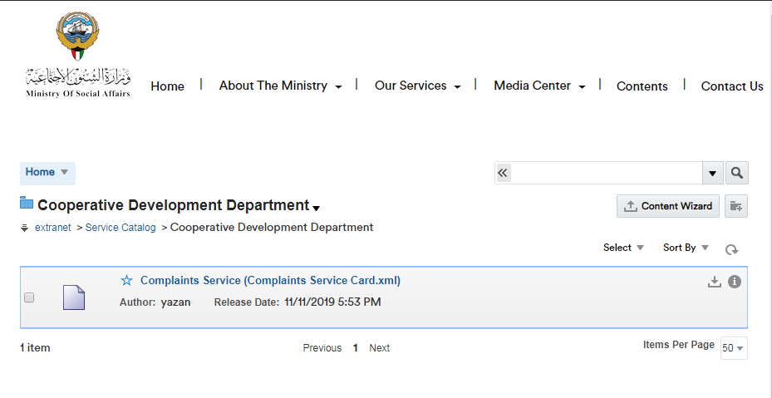

## Approve Service Card in Workflow

|  |  |
| --- | --- |
| Task name | Approve Service Cards |
| Task owner | MOSA Extranet Service Card Approver |
| Description | The approver will preview Service Card file and approve it. |
| Task preconditions | * The user logs on to the system. * The user is an Extranet Service Card approver. * The Service Cards item is in Service Cards workflow. |
| Input |  |
| Output |  |
| Task outcome | Approve, Cancel. |

|  |  |
| --- | --- |
| Task Main Flow | |
| # | **Actor action** | **System response** |
|  | Click on Service Card file name in “Content Management” page (Service Cards tab) | The system will open the selected file in content previewer page. |
|  | Click “Approve” from the “Summary” tab in content previewer page. | The system will prompt with the approve dialog. |
|  | Click “Approve” | The system will approve the Service Card item and exist the workflow. |

|  |  |
| --- | --- |
| Task exceptional Flow | |
| # | **Actor action** | **System response** |
|  | If the user select “cancel” in any stage in the main flow | The dialog close. |

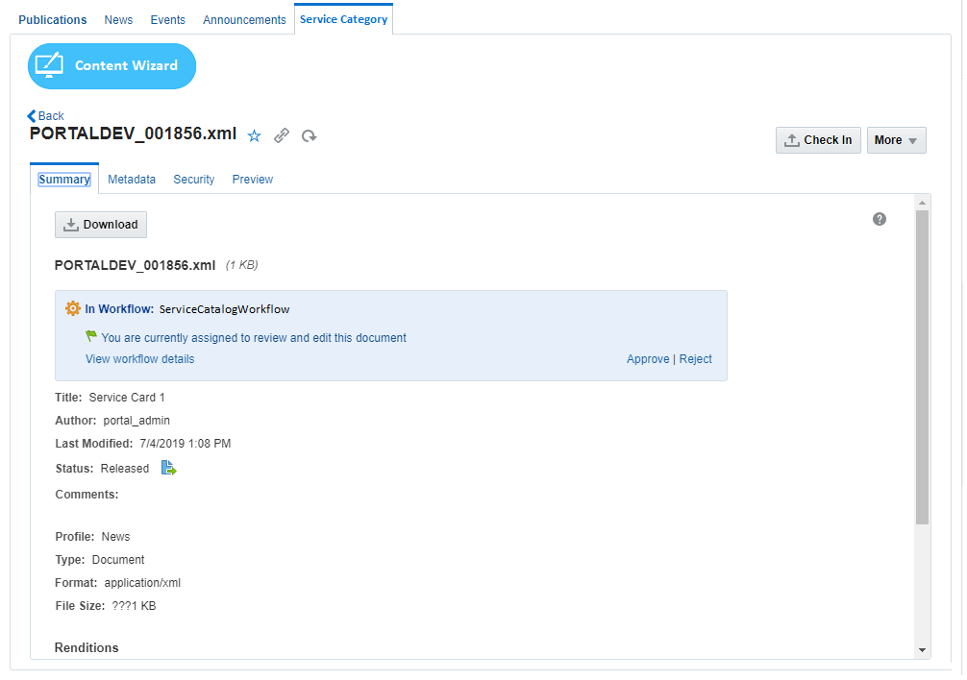

## Reject Service Card in Workflow

|  |  |
| --- | --- |
| Task name | Reject Service Card |
| Task owner | MOSA Extranet Service Card Approver |
| Description | The approver will preview Service Card file and reject it. |
| Task preconditions | * The user logs on to the system. * The user is an Extranet Service Card approver. * The Service Card item is in Service Cards workflow. |
| Input |  |
| Output |  |
| Task outcome | Reject, Cancel. |

|  |  |
| --- | --- |
| Task Main Flow | |
| # | **Actor action** | **System response** |
|  | Click on Service Card file name in “Content Management” page (Service Cards tab) | The system will open the selected file in content previewer page. |
|  | Click “Reject” from the “Summary” tab in content previewer page | The system will prompt with the reject dialog. |
|  | Optionally, the approver adds the rejection reason inside the box “Reason for rejection” in the reject dialog | The system hold the text in this box. |
|  | Click “Reject” | The system will reject the Service Card and notify the content contributor by mail and notify him about this rejection including the rejection reason in this mail and return back to ‘contribution’ workflow step.  *Note: this is initial step in any content workflow, to exist from this step, a new revision of the content item must be checked-in so the content fall in workflow again.* |

|  |  |
| --- | --- |
| Task exceptional Flow | |
| # | **Actor action** | **System response** |
|  | If the user select “cancel” in any stage in the main flow | The dialog close. |



## Update Service Card

|  |  |
| --- | --- |
| Task name | Update Service Card |
| Task owner | MOSA Extranet Service Card Contributor |
| Description | The contributor will select a Service Card item from the Service Cards list in order to update its metadata. |
| Task preconditions | * The user logs on to the system. * The user is an Extranet Service Card Contributor. * The file exist in Service Cards folder. |
| Input | The Service Card update form details and data. |
| Output | The Service Card update form. |
| Task outcome | Update, reset. |

|  |  |
| --- | --- |
| Task Main Flow | |
| # | **Actor action** | **System response** |
|  | Click on Service Card file name in “Content Management” page (Service Cards tab) | The system will open the selected file in “Content Previewer” page. |
|  | Click on “Edit” in “Content Previewer” page (Metadata tab) | The system will switch the form into edit mode. |
|  | Update the metadata as needed and click “Save” | The system stores the new updates. |

|  |  |
| --- | --- |
| Task exceptional Flow | |
| # | **Actor action** | **System response** |
|  | If the user select “cancel” in any stage during the update | The system will switch the form into read-only mode. |

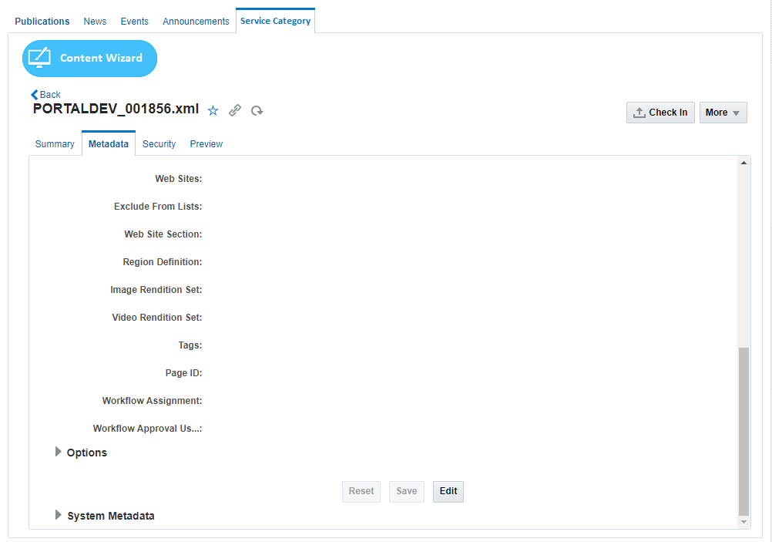

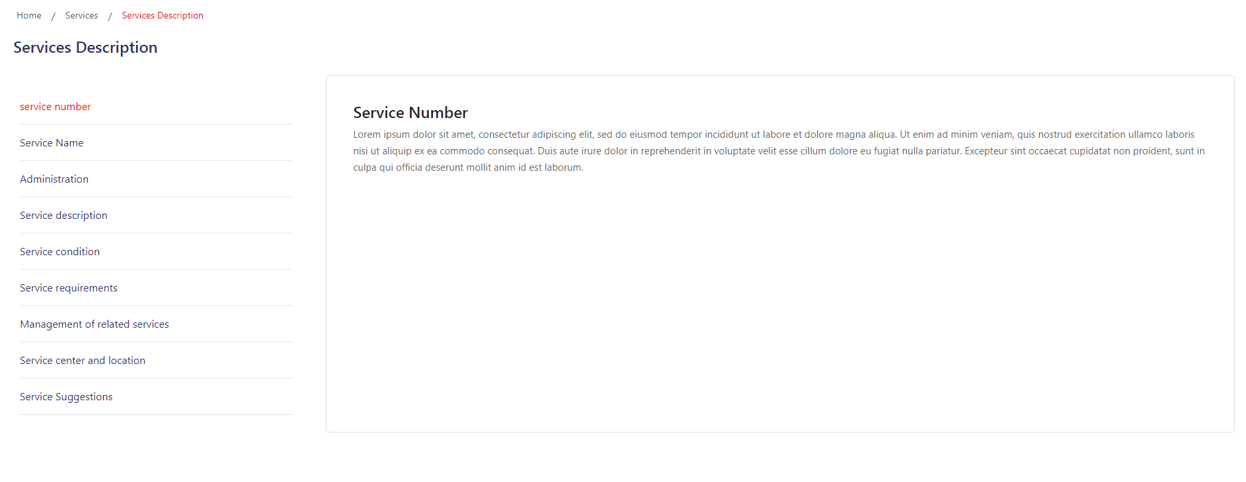

Workflow

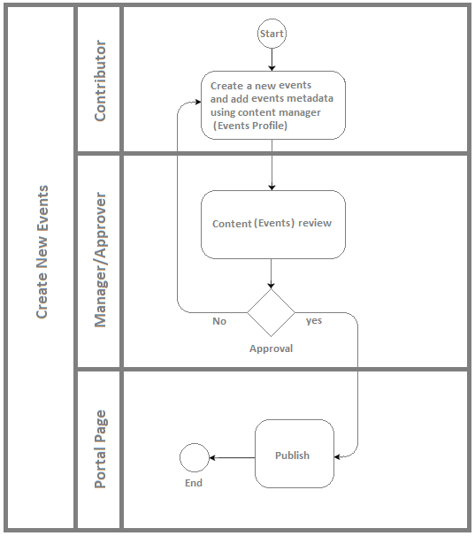

Developers & Contributors Tasks to Enable the Service

|  |  |  |
| --- | --- | --- |
| **Task** | **Application** | **Responsibility of** |
| Add Content Region Definition for Service Cards | Site Studio | Content Administrator |
| Add Content Elements as Service Card Metadata | Site Studio | Content Administrator |
| Add Content Information Fields for Service Cards | Webcenter Content | Content Administrator |
| Group Service Card Fields in Content Rule | Webcenter Content | Content Administrator |
| Create a Content Profile for Service Cards Including the Content Rule | Webcenter Content | Content Administrator |
| Create a Content Presenter for Service Cards | Webcenter Portal | Portal Administrator |
| Create a Page and Add the Content Presenter for Service Cards | Webcenter Portal | Content Contributor |
| Publish the Page for Users | Webcenter Portal | Content Contributor |

Updates Log