**functional requirements document**

|  |  |  |  |  |  |
| --- | --- | --- | --- | --- | --- |
| **Project Name** | : | MoSA Portal | **Date** | : | 27/Oct/2019 |
| **Requirement #** | : |  | **Created by** | : | Yazan Awad |

Requirement Title

Intranet – Content Structure

Detailed Description

The Content Structure is an Intranet Portal feature that classifies the contents of the system based on the department’s users of the Ministry.

* Each Department have public folder and private folder
* The Private folder is shared between the employees that shares the same department.
* The Created Sub-folders should inherit the same rule as in the parent folders.
* Sorting should appear by default alphabetically.
* Searching mechanism allows the user to enter a whole word or part of it.
* The upload process should have a validation in any content, which allows the user to upload any attachment that is less than 5 MB.
* When uploading an image, the allowed extensions are (JPEG, PNG and SVG), any other extension will display a validation message.
* When uploading a document, the allowed extension is the PDF, any other extension will display a validation message.
* Confirmation Messages should appear when clicking on approve, delete and reject the documents or images.

Content Structure based on the users

1. Employee

The Employee have access to the Contents Page that displays all the Departments folders (His Department, Other Departments)

* His Department

The System will display to the Employee Two folders (Public Folder and Private Folder) which allows the Employee to View, Search and Sort the Documents only

* Other Departments

The System will only present the Public folders for the other departments to the Employee which allows the Employee to View, Search and Sort the Documents only.

The Private folders for the other departments will be hidden for the Employee

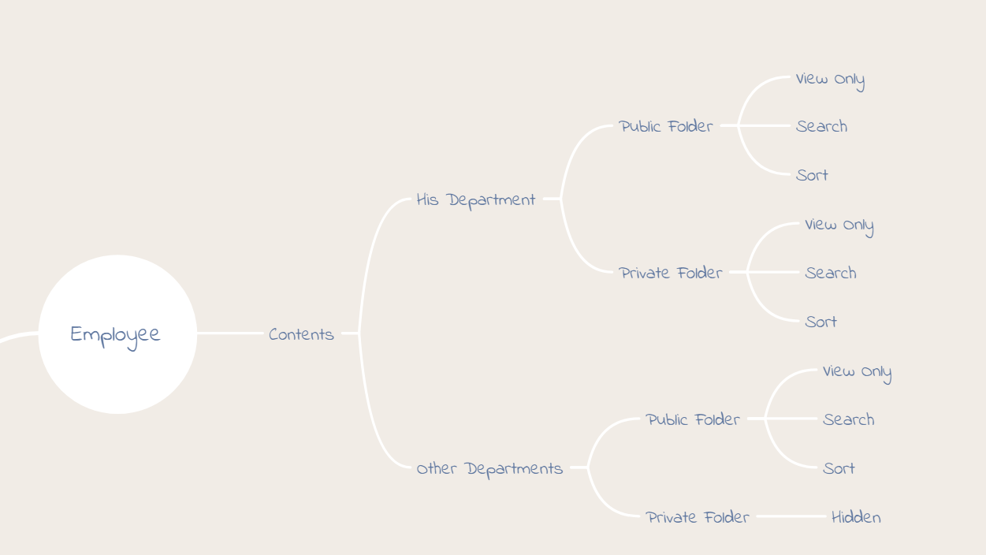

1. Department Contributor

The Department Contributor have access to the Contents Page that displays all the Departments folders (His Department, Other Departments)

* His Department

The System will display to the Department Contributor Two folders (Public Folder and Private Folder) which allows the Department Contributor to Upload, Search, Sort, Edit, Delete and Create Subfolders.

* Other Departments

The System will only present the Public folder for the Department Contributor which allows him/her to View, Search and Sort the Documents only.

The Private folders for the other departments will be hidden for the Department Contributor.

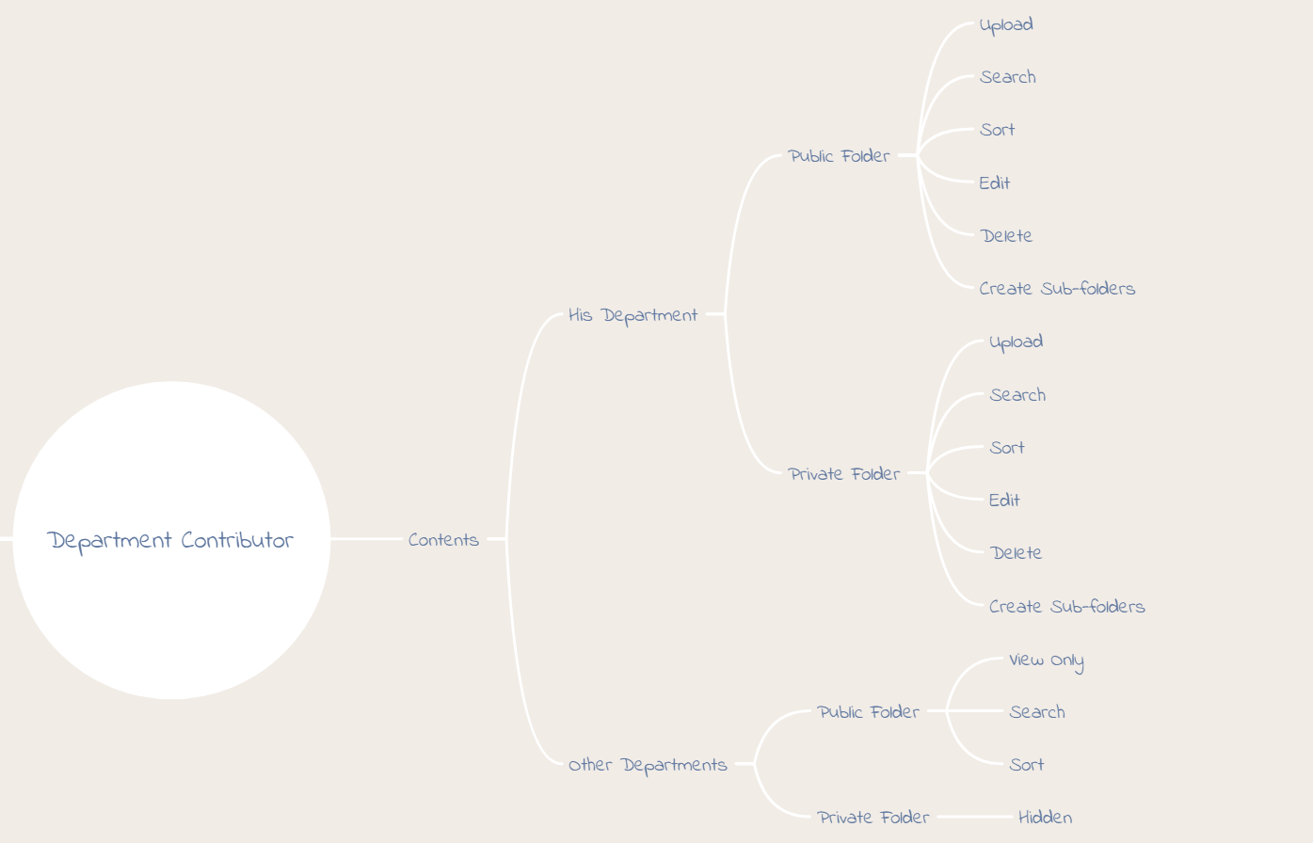

1. Portal Contributor

The Portal Contributor will have the access to the Contents page that displays all of the Departments folders in addition to the Content Management folders.

* His Department

The Portal Contributor will be treated as a normal employee in his department, the System will give him/her the permission to Search, Sort and View only both the Public and the Private folders.

* Other Departments

The Portal Contributor will be treated as a normal employee in the other departments, the System will give him/her the permission to Search, Sort and View only the Public Folders while keeping the Private Folders hidden.

* Create Folders

The Portal Contributor is the only user that have the privilege to Create Root folders in the Content Page

* Content Management

The Portal Contributor will be handling the portal content for the website by managing the Core contents such as (News, Announcements, Articles, etc.)

