**functional requirements document**

|  |  |  |  |  |  |
| --- | --- | --- | --- | --- | --- |
| **Project Name** | : | MoSA Portal | **Date** | : | 30/Jun/2019 |
| **Requirement #** | : |  | **Created by** | : | Shakboua Zaid |

Requirement Title

Intranet - Image Gallery

Detailed Description

Image gallery is considered as the images library of the ministry, extranet (public) users will be provided with the ability of previewing images of the ministry in this gallery (page).

The ministry images will be added and verified in the content server through the portal. This type of content will be available for users from the main menu navigation.

Requirements

Image Gallery is a custom service, it represents a content profile displayed in a content presenter at the portal.

**Image Gallery Profile Information Fields (Image Gallery Attributes)**:

|  |  |  |  |  |  |  |
| --- | --- | --- | --- | --- | --- | --- |
| **Field** | **Caption** | **Field Type** | **Required?** | **LOV?** | **Data Type** | **List** |
| dDocName | Content ID | Hidden |  |  | Text |  |
| dDocType | Type | Read Only |  |  | Text | * Application * Binary * **DigitalMedia** * Document * Article * System * ServiceCard * Slide * News * Announcement * Event * Publication * Resource |
| dDocTitle | Title | Edit |  |  | Text |  |
| dDocAuthor | Author | Hidden |  |  | Text | The list of all available users in the system.  Text entry is also applicable. |
| dSecurityGroup | Security Group | Edit |  |  | Text | * Public * Secure * PersonalSpaces * WebcenterSpaces * Extranet * **Intranet** |
| dRevLabel | Revision | Hidden |  |  | Number |  |
| primaryFile | Image Gallery File | Hidden |  |  | File |  |
| dInDate | Release Date | Hidden |  |  | Date |  |

Use Cases

## Create New Image Gallery

|  |  |
| --- | --- |
| Task name | Create New Image Gallery |
| Task owner | MOSA Intranet Image Gallery Contributor |
| Description | The contributor will fill out the Image Gallery creation form in order to add a new image gallery. |
| Task preconditions | * The user logs on to the system. * The user is an Intranet Image Gallery contributor. * The file does not exist in Image Gallery folder. |
| Input | The Image Gallery creation form details and data. |
| Output | The Image Gallery creation form. |
| Task outcome | Check-in, Cancel. |

|  |  |
| --- | --- |
| Task Main Flow | |
| # | **Actor action** | **System response** |
|  | Select “Image Gallery” from the dropdown control “Upload” in “Content Management” page (Image Gallery tab) | The system will prompt with the Document Upload dialog. |
|  | Drag the image gallery file from your drive into the dialog or click browse and select the image gallery file from your drive | The system will prepare the file for upload and enable the section for metadata entry for this image gallery item. |
|  | Fill out the metadata fields and select file to be uploaded | The system will check and verify the data. |
|  | Click “Upload” | The system will upload the document and the dialog close, the system will also notify the user by a message displays on top of the page that the document is successfully uploaded. |

|  |  |
| --- | --- |
| Task exceptional Flow | |
| # | **Actor action** | **System response** |
|  | If the user select “cancel” in any stage in the main flow | The dialog close. |

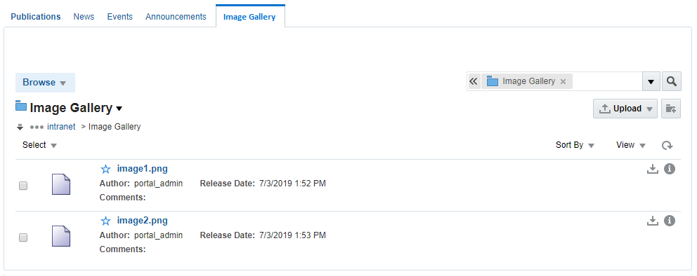

## Approve Image Gallery in Workflow

|  |  |
| --- | --- |
| Task name | Approve Image Gallery |
| Task owner | MOSA Intranet Image Gallery Approver |
| Description | The approver will preview image gallery file and approve it. |
| Task preconditions | * The user logs on to the system. * The user is an Intranet Image Gallery approver. * The Image Gallery item is in Image Gallery workflow. |
| Input |  |
| Output |  |
| Task outcome | Approve, Cancel. |

|  |  |
| --- | --- |
| Task Main Flow | |
| # | **Actor action** | **System response** |
|  | Click on Image Gallery file name in “Content Management” page (Image Gallery tab) | The system will open the selected file in content previewer page. |
|  | Click “Approve” from the “Summary” tab in content previewer page. | The system will prompt with the approve dialog. |
|  | Click “Approve” | The system will approve the image gallery item and exist the workflow. |

|  |  |
| --- | --- |
| Task exceptional Flow | |
| # | **Actor action** | **System response** |
|  | If the user select “cancel” in any stage in the main flow | The dialog close. |

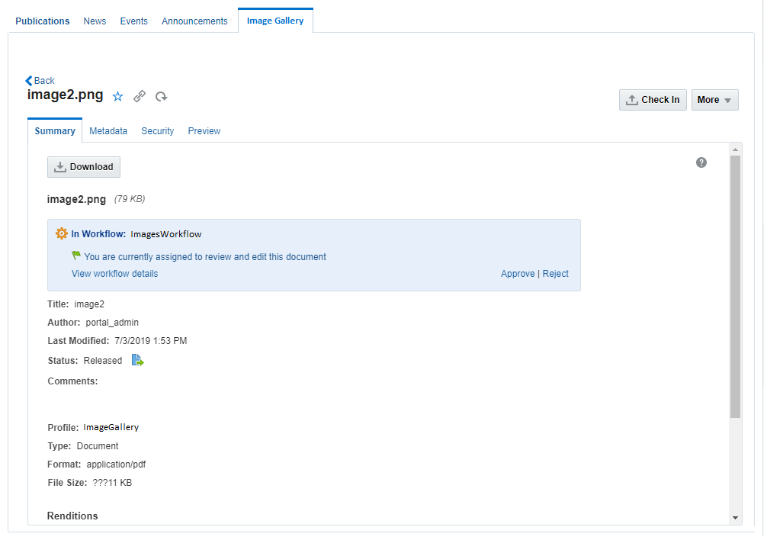

## Reject Image Gallery in Workflow

|  |  |
| --- | --- |
| Task name | Reject Image Gallery |
| Task owner | MOSA Intranet Image Gallery Approver |
| Description | The approver will preview image gallery file and reject it. |
| Task preconditions | * The user logs on to the system. * The user is an Intranet Image Gallery approver. * The Image Gallery item is in Image Gallery workflow. |
| Input |  |
| Output |  |
| Task outcome | Reject, Cancel. |

|  |  |
| --- | --- |
| Task Main Flow | |
| # | **Actor action** | **System response** |
|  | Click on Image Gallery file name in “Content Management” page (Image Gallery tab) | The system will open the selected file in content previewer page. |
|  | Click “Reject” from the “Summary” tab in content previewer page | The system will prompt with the reject dialog. |
|  | The approver adds the rejection reason inside the box “Reason for rejection” in the reject dialog | The system hold the text in this box. |
|  | Click “Reject” | The system will reject the image gallery and notify the content contributor by mail and notify him about this rejection including the rejection reason in this mail and return back to ‘contribution’ workflow step.  *Note: this is initial step in any content workflow, to exist from this step, a new revision of the content item must be checked-in so the content fall in workflow again.* |

|  |  |
| --- | --- |
| Task exceptional Flow | |
| # | **Actor action** | **System response** |
|  | If the user select “cancel” in any stage in the main flow | The dialog close. |



## Update Image Gallery

|  |  |
| --- | --- |
| Task name | Update Image Gallery |
| Task owner | MOSA Intranet Image Gallery Contributor |
| Description | The contributor will select a Image Gallery item from the Image Gallery list in order to update its metadata or upload new revision (new file). |
| Task preconditions | * The user logs on to the system. * The user is an Intranet Image Gallery contributor. * The file exist in Image Gallery folder. |
| Input | The Image Gallery update form details and data. |
| Output | The Image Gallery update form. |
| Task outcome | Update, reset. |

|  |  |
| --- | --- |
| Task Main Flow | |
| # | **Actor action** | **System response** |
|  | Click on Image Gallery file name in “Content Management” page (Image Gallery tab) | The system will open the selected file in “Content Previewer” page. |
|  | Click on “Edit” in “Content Previewer” page (Metadata tab) | The system will switch the form into edit mode. |
|  | Update the metadata as needed and click “Save” | The system stores the new updates. |

|  |  |
| --- | --- |
| Task exceptional Flow | |
| # | **Actor action** | **System response** |
|  | If the user select “cancel” in any stage during the update | The system will switch the form into read-only mode. |
|  | If the user select “cancel” in any stage during the update | The changes will be ignored and the data will be reverted back to its initial values. |

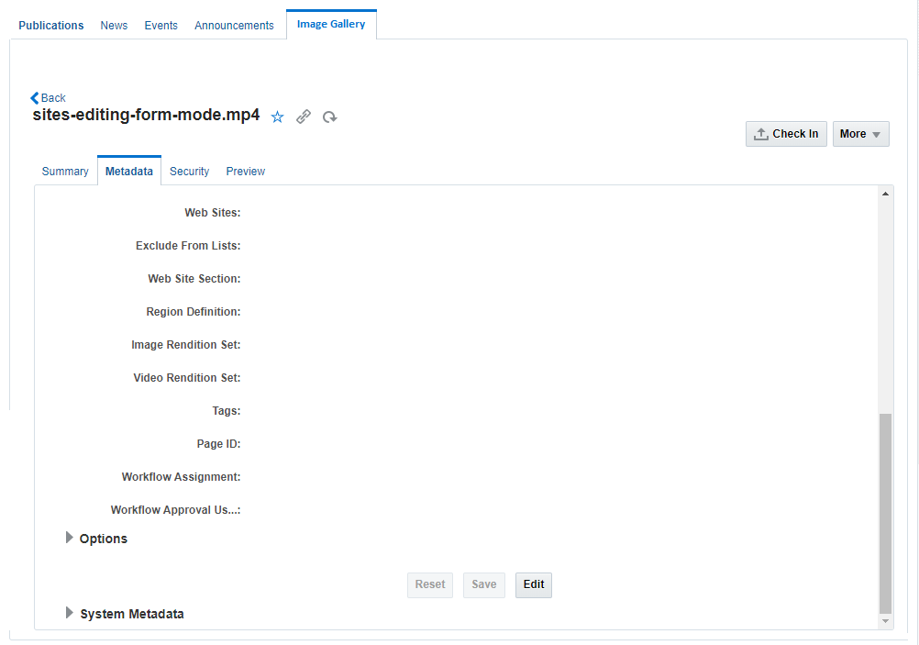

Workflow

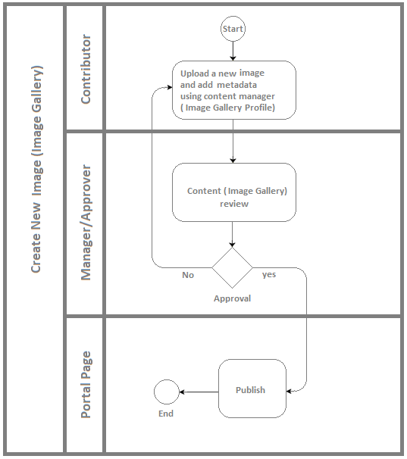

Developers & Contributors Tasks to Enable the Service

|  |  |  |
| --- | --- | --- |
| **Task** | **Application** | **Responsibility of** |
| Add Content Information Fields for Image Gallery | Webcenter Content | Content Administrator |
| Group Image Gallery Fields in Content Rule | Webcenter Content | Content Administrator |
| Create a Content Profile for Image Gallery Including the Content Rule | Webcenter Content | Content Administrator |
| Create a Content Presenter for Image Gallery | Webcenter Portal | Portal Administrator |
| Create a Page and Add the Content Presenter for Image Gallery | Webcenter Portal | Content Contributor |
| Publish the Page for Users | Webcenter Portal | Content Contributor |

Updates Log