**functional requirements document**

|  |  |  |  |  |  |
| --- | --- | --- | --- | --- | --- |
| **Project Name** | : | MoSA Portal | **Date** | : | 01/Jul/2019 |
| **Requirement #** | : |  | **Created by** | : | Shakboua Zaid |

Requirement Title

Extranet - Articles

Detailed Description

Articles is used to inform extranet (public) users about the ministry with the power to write about the topics and subjects that relates to the ministry business and services.

Article documents will be created and edited in a rich text editor which allow content editing in WYSIWYG or HTML modes, as it allow embedding existing resources (ex. images) inside the body of the article.

Requirements

Article is a custom service, it represents a site studio element based on a content profile displayed in a content presenter at the portal.

**Articles Profile Information Fields (Articles Attributes)**:

|  |  |  |  |  |  |  |
| --- | --- | --- | --- | --- | --- | --- |
| **Field** | **Caption** | **Field Type** | **Required?** | **LOV?** | **Data Type** | **List** |
| dDocName | Content ID | Hidden |  |  | Text |  |
| dDocType | Type | Read Only |  |  | Text | * Application * Binary * DigitalMedia * Document * **Article** * System * ServiceCard * Slide * News * Announcement * Event * Publication * Resource |
| dDocTitle | Title | Edit |  |  | Text |  |
| dDocAuthor | Author | Hidden |  |  | Text | The list of all available users in the system.  Text entry is also applicable. |
| dSecurityGroup | Security Group | Edit |  |  | Text | * Public * Secure * PersonalSpaces * WebcenterSpaces * Intranet * **Extranet** |
| dRevLabel | Revision | Hidden |  |  | Number |  |
| primaryFile | Article File | Edit |  |  | File |  |
| image | Article Image | Edit |  |  | Image Element Definition (Site Studio) |  |
| details | Article Details | Edit |  |  | WYSIWYG Element Definition (Site Studio) |  |
| dInDate | Release Date | Hidden |  |  | Date |  |

Use Cases

## Create New Articles

|  |  |
| --- | --- |
| Task name | Create New Articles |
| Task owner | MOSA Extranet Articles Contributor |
| Description | The contributor will follow the steps at content creation wizard in order to add a new articles. |
| Task preconditions | * The user logs on to the system. * The user is an Extranet article contributor. |
| Input | The content creation wizard details and metadata. |
| Output | The content view mode editor. |
| Task outcome | Save and Close, Cancel. |

|  |  |
| --- | --- |
| Task Main Flow | |
| # | **Actor action** | **System response** |
|  | From “Contents” page click on “Articles” folder in the content manager. | The system will open the articles content folder. |
|  | Click on “Content Wizard” button on the right top of the content manager. | The system will open the content creation wizard in a new browser tab. |
|  | The next step is to select if you want to create new or update existing item then click “Next” | The wizard will forward to the next step. |
|  | Modify the default metadata if needed, or move to the last step by clicking “Finish”  *Note: for better content management, make sure to name the created data file with something relevant like <data file title>.xml (ex. my first news.xml). If you did not, the file will be automatically named by the content Id <dDocName>.xml (ex. PORTALDEV_15428.xml).* | The wizard will create the article item and open it view edit mode. |
|  | At the view edit mode, insert the data in the specified areas (ex. insert summary text inside “Summary” area) then click “Save and Close” | The new Article item created and added to the repository and entered the workflow. |

|  |  |
| --- | --- |
| Task exceptional Flow | |
| # | **Actor action** | **System response** |
|  | If the user select “cancel” in any step before the last step (before clicking “Finish”) | The content creation wizard close without adding any new items. |
|  | If the user select “cancel” in any step after the last step (after clicking “Finish”) | The content creation wizard close and a new article item is initiated. |

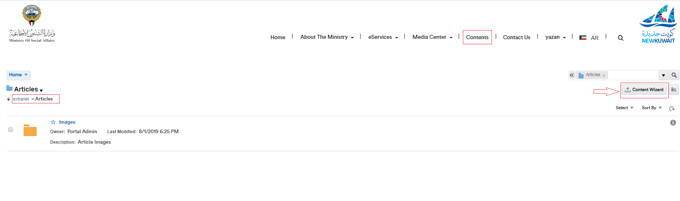

## Approve Articles in Workflow

|  |  |
| --- | --- |
| Task name | Approve Articles |
| Task owner | MOSA Extranet Articles Approver |
| Description | The approver will preview Article file and approve it. |
| Task preconditions | * The user logs on to the system. * The user is an Extranet Articles approver. * The Article item is in Article workflow. |
| Input |  |
| Output |  |
| Task outcome | Approve, Cancel. |

|  |  |
| --- | --- |
| Task Main Flow | |
| # | **Actor action** | **System response** |
|  | Click on article item name in at the article list in the content manager. | The system will open the selected item in content previewer page. |
|  | Click “Approve” from the “Summary” tab in content previewer page. | The system will prompt with the approve dialog. |
|  | Click “Approve” | The system will approve the Article item and exist the workflow. |

|  |  |
| --- | --- |
| Task exceptional Flow | |
| # | **Actor action** | **System response** |
|  | If the user select “Cancel” in any stage in the main flow | The dialog close. |

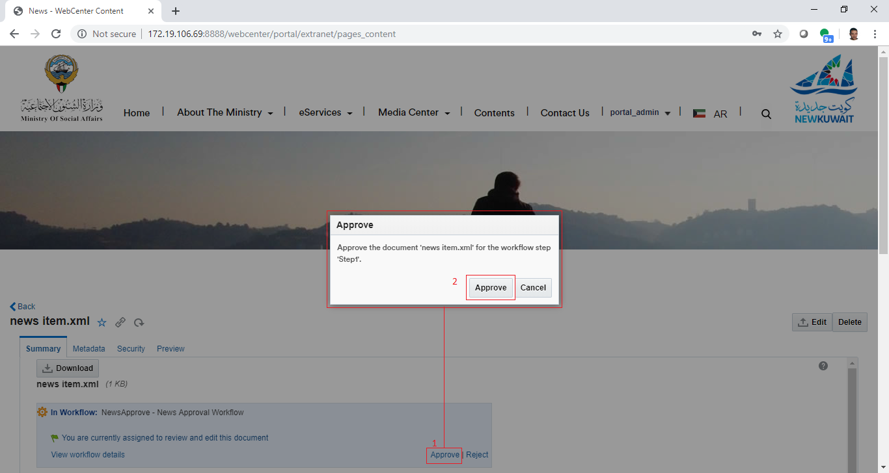

## Reject Articles in Workflow

|  |  |
| --- | --- |
| Task name | Reject Articles |
| Task owner | MOSA Extranet Articles Approver |
| Description | The approver will preview Articles file and reject it. |
| Task preconditions | * The user logs on to the system. * The user is an Extranet Articles approver. * The News item is in Articles workflow. |
| Input |  |
| Output |  |
| Task outcome | Reject, Cancel. |

|  |  |
| --- | --- |
| Task Main Flow | |
| # | **Actor action** | **System response** |
|  | Click on articles item name at the article list in the content manager. | The system will open the selected item in content previewer page. |
|  | Click “Reject” from the “Summary” tab in content previewer page | The system will prompt with the reject dialog. |
|  | The approver adds the rejection reason inside the box “Reason for rejection” in the reject dialog | The system hold the text in this box. |
|  | Click “Reject” | The system will reject the Article and notify the content contributor by mail and notify him about this rejection including the rejection reason in this mail and return back to ‘contribution’ workflow step.  *Note: this is initial step in any content workflow, to exist from this step, a new revision of the content item must be checked-in so the content fall in workflow again.* |

|  |  |
| --- | --- |
| Task exceptional Flow | |
| # | **Actor action** | **System response** |
|  | If the user select “cancel” in any stage in the main flow | The dialog close. |

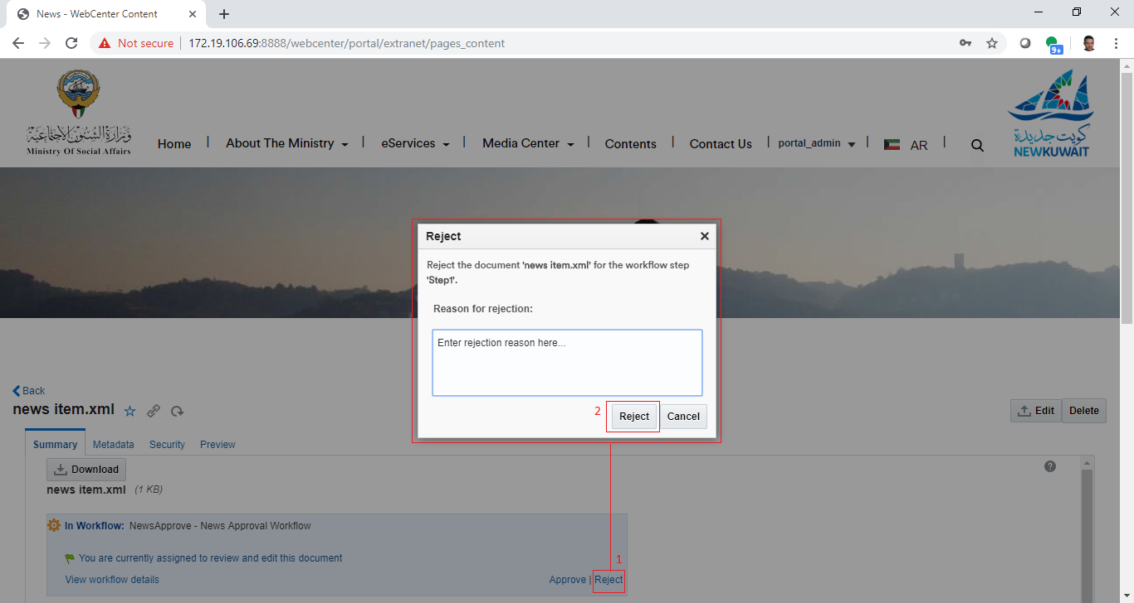

## Update Articles

|  |  |
| --- | --- |
| Task name | Update Articles |
| Task owner | MOSA Extranet Articles Contributor |
| Description | The contributor will select an article item from the article list in order to update its metadata and/or its content.  *Note: As the articles are web content items and created using the content wizard, updating article items will be also using the content wizard.* |
| Task preconditions | * The user logs on to the system. * The user is an Extranet Article contributor. * The file exist in Articles folder. |
| Input | The Article update form details and data. |
| Output | The Article update form. |
| Task outcome | Save and Close, Cancel, Reset. |

|  |  |
| --- | --- |
| Task Main Flow | |
| # | **Actor action** | **System response** |
|  | Select Article item checkbox from the Articles list in the content manager. | The article item checkbox is selected and the controls of the allowed actions (including item update) for the single selected item will be displayed. |
|  | Click on “Edit” icon control on the top of articles list in the content manager. | The system will open the selected article item in the content editor (the same content wizard). |
|  | **Or** click on the article item name at the articles list in the content manager. | The system will open the selected article item in the content previewer page. |
|  | Click on “Edit” icon control in the content previewer page. | The system will open the article item in the content editor (the same content wizard). |
|  | Modify the content areas (elements) in the content wizard “Elements tab” and click “Save and Close”. | The system stores the new modifications and the item re-enter the workflow. |
|  | Update the metadata “Metadata tab” as needed and click “Save and Close” | The system stores the new updates and the item re-enter the workflow. |

|  |  |
| --- | --- |
| Task exceptional Flow | |
| # | **Actor action** | **System response** |
|  | The user select more than one item.  *Note: it is allowed to select multiple items, but the user cannot update multiple items in one click.* | The controls of the allowed actions (including item update) for the single selected item will be hidden. |
|  | If the user removed the text or the image of a required area (element) or a required metadata field and did not add new values for it and tried to save the changes | The system will prompt with an error message telling that a required element or metadata field is empty which prevent saving the changes. |
|  | If the user select “Reset” in “Metadata tab” before he save the changes | All changes will be lost and fields will be reverted back into the previous values. |
|  | If the user select “Cancel” in any stage during the update | All changes will be ignored and the content editor (content wizard) will be closed. |

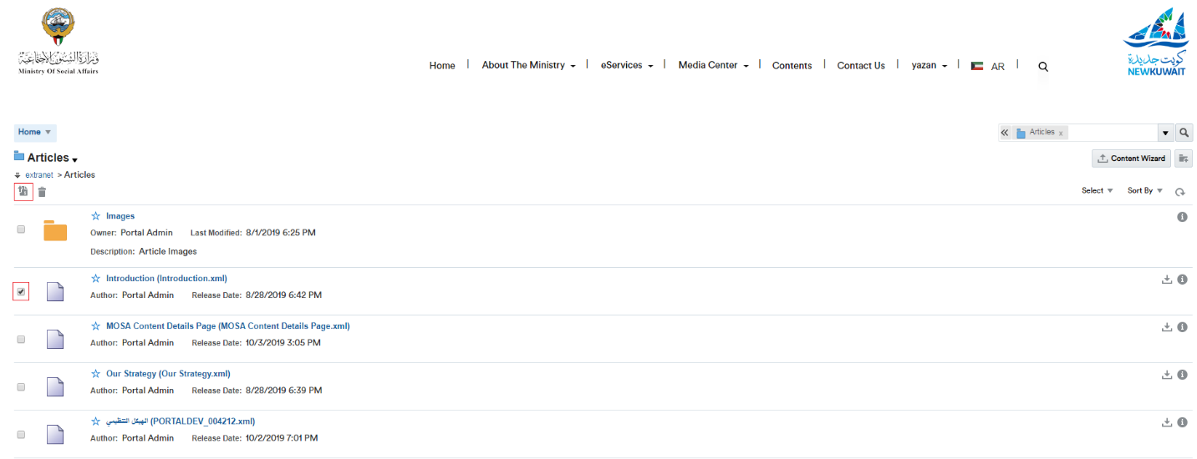

## Delete Articles

|  |  |
| --- | --- |
| Task name | Delete Articles |
| Task owner | MOSA Extranet Articles Contributor |
| Description | The contributor will select an Article item from the Articles list in order to delete it. |
| Task preconditions | * The user logs on to the system. * The user is an Extranet Articles contributor. * The file exist in Articles folder. * The article item is not in workflow. |
| Input | The Article to be deleted. |
| Output | The Article list updated and the article item removed. |
| Task outcome | Yes, No. |

|  |  |
| --- | --- |
| Task Main Flow | |
| # | **Actor action** | **System response** |
|  | Select article item checkbox from the articles list in the content manager. | The article item checkbox is selected and the controls of the allowed actions (including item delete) for the single selected item will be displayed. |
|  | Click on “delete” icon control on the top of articles list in the content manager. | The system will prompt with the delete confirmation dialog popup. |
|  | **Or** click on the article item name at the articles list in the content manager. | The system will open the selected article item in the content previewer page. |
|  | Select delete from the dropdown control “More” in the content previewer page. | The system will prompt with the delete confirmation dialog popup. |
|  | Click on “Yes” to delete the item. | The item deleted. |

|  |  |
| --- | --- |
| Task exceptional Flow | |
| # | **Actor action** | **System response** |
|  | If the user tried to delete an article item in the workflow | The system will prompt with an error message telling that the item in the workflow and it cannot be deleted. |
|  | If the user select “No” in delete confirmation dialog popup | The popup closed and the article item remain in the list. |

Alternative1: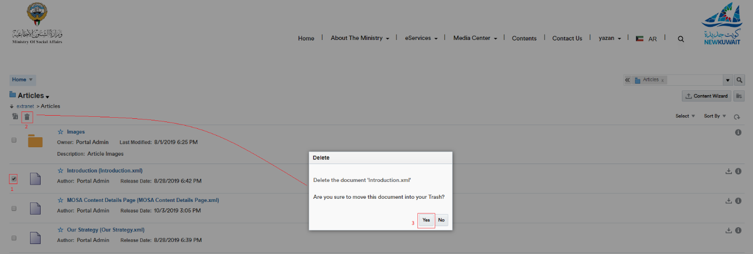

Alternative2:

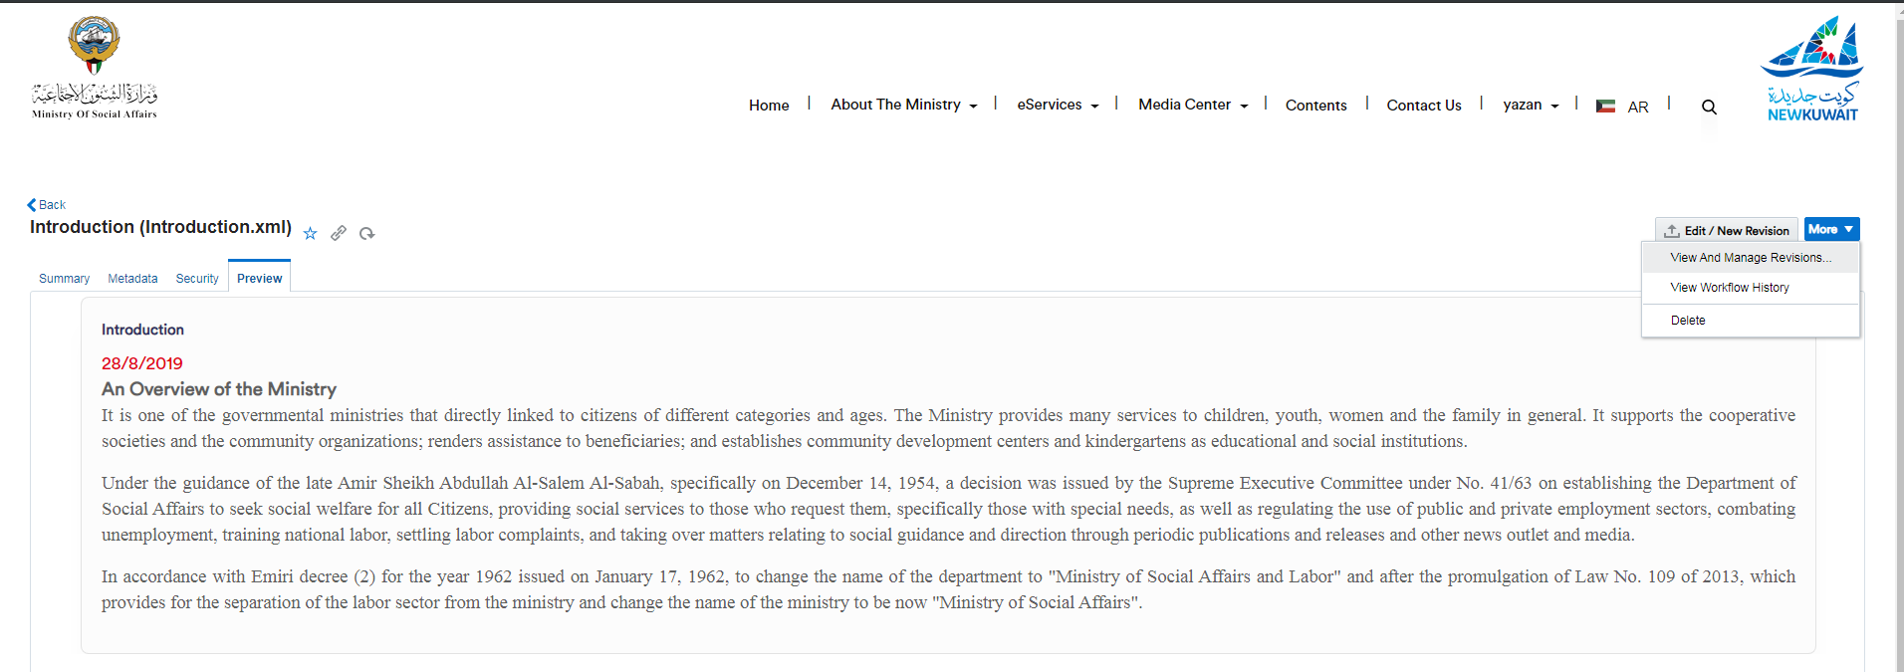

Workflow

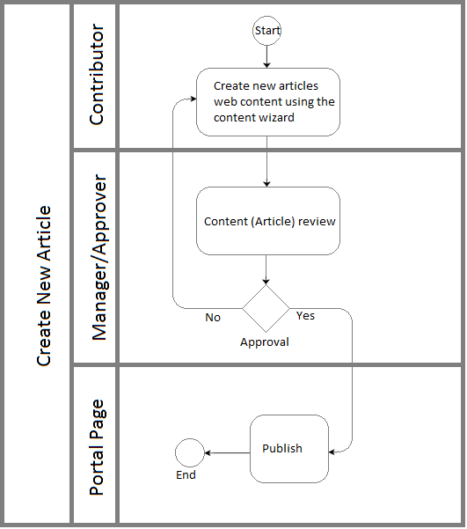

Developers & Contributors Tasks to Enable the Service

|  |  |  |
| --- | --- | --- |
| **Task** | **Application** | **Responsibility of** |
| Add Content Region Definition for Articles | Site Studio | Content Administrator |
| Add Content Elements as Article Metadata | Site Studio | Content Administrator |
| Add Content Information Fields for Articles | Webcenter Content | Content Administrator |
| Group Articles Fields in Content Rule | Webcenter Content | Content Administrator |
| Create a Content Profile for Articles Including the Content Rule | Webcenter Content | Content Administrator |
| Create a Content Presenter for Articles | Webcenter Portal | Portal Administrator |
| Create a Page and Add the Content Presenter for Articles | Webcenter Portal | Content Contributor |
| Publish the Page for Users | Webcenter Portal | Content Contributor |

Updates Log