Dispute Transactions
Use Case ID: UTL TRANS 002
Use Case Name: Talabat request on dispute module
Description |  | Allow PAM users to review all Talabat transactions through back-end “counter”.
Stakeholders
Service Channels |  | Backend users
Analyzed by |  | Abdelrhaman Almomani
SRS documented by |  | Abdelrhaman Almomani
Developed by
Pre-conditions
# | Description |  | Business Rules
1. | Check “General Requirements” above.
 | The user should attache the civil card in the system by using a special device. |  | The system should fetch the civil ID from the attached card.
Basic Scenario
# | Description |  | Business Rules
 | User should access the transactions info screen.
 | The user should enter the civil ID of labor. |  | we will use a card reader to get the labor civil id automatically
 | The user should click on “جلب الطلب” button to review the selected transaction.
 | The system should call this procedure when the user click on get oreder “جلب الطلب” :  sec_pkg.get_transactions_by_civil_id (  p_user_id VARCHAR2,  p_labor_civil_id varchar2,  is_success OUT NUMBER,  trans_id OUT NUMBER,  taskflow_id OUT VARCHAR,  RETURN_MESSAGE OUT VARCHAR  ); |  | p_user_id => login Username  In this case the system should pass the “trans_id” to the next screen.  Hint:  The procedure should returen the screen “taskflow_id” so the system should open screen according to the return value from this field.
Prototype
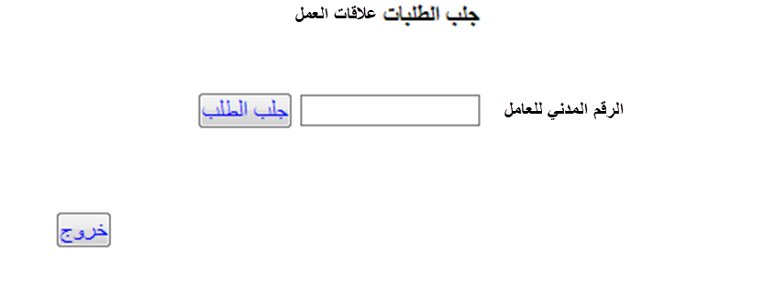

REQUIRED FUNCTIONS AND PROCEDURES TO BE CREATED
Package name | sec_pkg
Function/procedure | Procedure | name | get_dispute_transactions
In parameters | p_user_id VARCHAR2,  p_labor_civil_id varchar2
Description | يعمل على استرجاع الطلبات المحوله الى علاقات العمل بحيث يتم استرجاع الطلبات بالاعتماد على الرقم المدني للعامل  اذا كان رقم العامل p_labor_civil_id ليس من ضمن البيانات ادنها يجب اظهار الرسالة التالية :  لا يوجد طلب للعامل  SELECT  I.trans_id,  I.trans_parent_id,  I.service_id,  I.trans_stage,  I.labor_id,  (SELECT CIVIL_ID FROM MPM_LABOR_PROFILE_TRANS WHERE TRANS_PARENT_ID = I.trans_id) AS CIVIL_ID,  IV.TASKFLOW_ID  FROM  mpm_work_visa_trans I, UTL_SERVICE II , SEC_MENUS IV  WHERE I.trans_stage = 13 AND II.SERVICE_ID = I.SERVICE_ID AND II.MENU_ID = IV.MENU_ID and (SELECT CIVIL_ID FROM MPM_LABOR_PROFILE_TRANS WHERE TRANS_PARENT_ID = I.trans_id) =: p_civil_id  UNION ALL  SELECT  I.trans_id,  I.trans_parent_id,  I.service_id,  I.trans_stage,  I.labor_id,  (SELECT CIVIL_ID FROM MPM_LABOR_PROFILE_TRANS WHERE TRANS_PARENT_ID = I.trans_id) AS CIVIL_ID,  IV.TASKFLOW_ID  FROM  MPM_WORK_PERMIT_TRANS I, UTL_SERVICE II , SEC_MENUS IV  WHERE I.trans_stage = 13 AND II.SERVICE_ID = I.SERVICE_ID AND II.MENU_ID = IV.MENU_ID and (SELECT CIVIL_ID FROM MPM_LABOR_PROFILE_TRANS WHERE TRANS_PARENT_ID = I.trans_id) =: p_civil_id ;
Expected to return | is_success OUT NUMBER,  trans_id OUT NUMBER,  taskflow_id OUT VARCHAR,  RETURN_MESSAGE OUT VARCHAR

