**functional requirements document**

|  |  |  |  |  |  |
| --- | --- | --- | --- | --- | --- |
| **Project Name** | : | MoSA Portal | **Date** | : | 30/Jun/2019 |
| **Requirement #** | : |  | **Created by** | : | Shakboua Zaid |

Requirement Title

Common – Content Wizard

Detailed Description

A contributor editor that allow content creation at runtime (Web Content) from within the portal and store it at the content server.

Allowed content contributors will be able to access this editor via link in the portal “Content” page, create content files, add and/or select content elements, and finally preview the created files.

The Content Wizard application is shipped with 2 main sub-applications:

1. **Switch Content Wizard** which consist of 3 screens:
2. Choose Content File Screen
3. Check-In Content Screen
4. Confirmation Screen
5. **Content Editor**

Requirements

Content Wizard is a Webcenter Content OOTB component, it require some content server components to be enabled, a connection from the portal to the content server, and there should be already an OHS installed and configured.

According to the opened content profile; the region will be selected by default when clicking on the “Content Wizard” Action, the contributor will follow the steps to fill the metadata fields (profile fields) and add the elements (elements definitions) and save a new XML file, or select an existing file in the content server for updated.

Use Cases

## Access the Content Wizard Screens

|  |  |
| --- | --- |
| Task name | Access the Content Wizard Screens |
| Task owner | MOSA Content Contributor |
| Description | The contributor will access the Content Wizard screens in order to create a new data file, update metadata, or update the elements of an existing data file in the content server. |
| Task preconditions | * The user is a Content contributor. * The content manager folder of the contents (to be added or updated) must have the metadata option “**Prompt for metadata when documents are added to this folder**=**false**” (checkbox unchecked). |
| Input | The Content Wizard link. |
| Output | The Content Wizard “Switch Content Wizard” screens. |
| Task outcome | Finish, Next, Back, Cancel |

|  |  |
| --- | --- |
| Task Main Flow | |
| # | **Actor action** | **System response** |
|  | From the content tree in the “Content” page at the portal, open the folder where you want to create the new content.  Note: this folder must have the metadata option “**Prompt for metadata when documents are added to this folder**=**false**” (checkbox unchecked). | The system will open the folder in the content manager and the content wizard button appears at the right top of the content manager. |
|  | Click on the “Content Wizard” button from the right top of the content manager. | The system open the content wizard in a new tab forcing the login check (the system will check if the currently logged-in user has the permissions to create (check-in new files) and open the content wizard’s first screen “Choose Content File Screen”.  Note1: Unless if SSO is enabled and OHS is configured, the system will prompt for login even for logged-in users.  Note2: Users are supposed to select the region definition in this Content Wizard screen. But it has customized to pre-select the value of the region definition by passing the URL parameter “cpRegDef”, in this case, this screen will be skipped. |
|  | From “Choose Region Content” screen, select one from the dropdown options if the region definition is not yet select or “cpRegDef” parameters did not passed with the URL and click “Next”. | The system will continue to the next step “Choose Content File Screen” where you can choose to create new file or update an existing one. |
|  | From “Choose Content File” screen choose whether to create or update an existing file.   * Choose “New Contributor data file”. * Or choose “Existing file from server”.   Then click “Next”. | * If you choose “New Contributor data file”, the system will continue to the next step “Check-In Content Screen”. * If you choose “Existing file from server”, the system will open a content server page with a list of all of the existing related content items, you can choose an item from the list by clicking the button “select” in front of this item. |
|  | For new contributor data files, you need to enter the metadata field values, fill the check-in form and click “Next”. | The system will create the new data file (and entered the workflow if the selected content type require approval) and continue to the next step “Confirmation Screen”. |
|  | From “Confirmation” screen choose whether to edit the content item now or to exist without editing.   * Choose “Edit content item now”. * Or choose “Exit without editing”.   Then click “Finish”. | * If you choose “Edit content item now”, the system will open the newly created (or the selected) item in the content editor and close the Content Wizard Switcher. * If you choose “Exit without editing”, the system close the Content Wizard Switcher. |
|  | If the user click on “Back” in any of the steps in the Content Wizard Switcher. | The system will return back to the previous screen. |
|  | In the Content Editor, select or enter the data in the elements (images, plain text, or rich text) from “Elements” tab, change the metadata from “Metadata” tab.  You can preview the data file by clicking on Preview icon (http://172.19.106.69:16200/cs/resources/wcm/base/images/icon-preview.gif).  You can reset the value by clicking on Reset icon (http://172.19.106.69:16200/cs/resources/wcm/base/images/icon-reset.gif).  You can view the differences comparing with the previous release(s) by click on View Differences icon (http://172.19.106.69:16200/cs/resources/wcm/base/images/icon-compare.gif).  Then click “Save and Close”. | The system will store the modifications in an XML at the content server re-enter the workflow for the data files that are not already in the workflow if the selected content type require approval.  Note: after a successful data file editing, the system developed to return back to the opener page and close the current page.  If the opener was a portal page, the system should close the Content Editor and return back to the portal page. |

|  |  |
| --- | --- |
| Task exceptional Flow | |
| # | **Actor action** | **System response** |
|  | If the user click on “Cancel” in the any step in the Content Wizard Switcher before the step “Check-In Content”. | The system will return back to the first screen “Choose Content File” in the wizard and data file will not be created. |
|  | If the user click on “Cancel” in the any step in the Content Wizard Switcher after the step “Check-In Content”. | The system will return back to the first screen “Choose Content File” in the wizard but an empty data file will be created and entered the workflow if the selected content type require approval. |
|  | If the user click on “Cancel” in the any step in the Content Editor. | The system will close the Content Editor and elements changes and modifications will be ignored. |

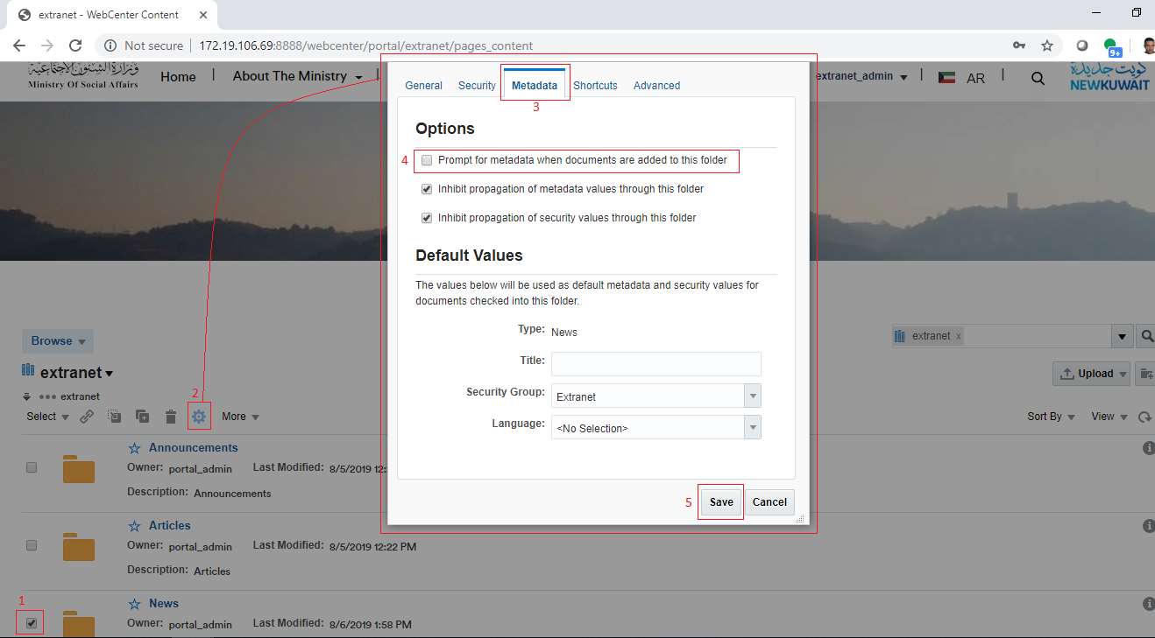

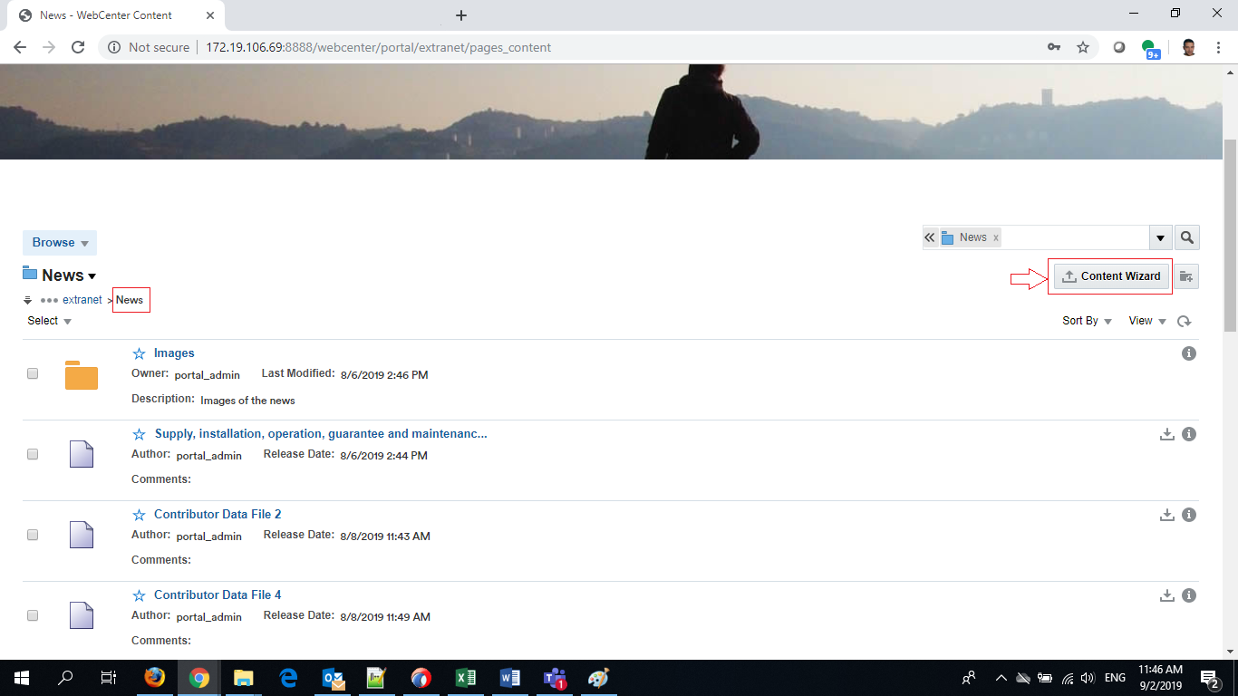

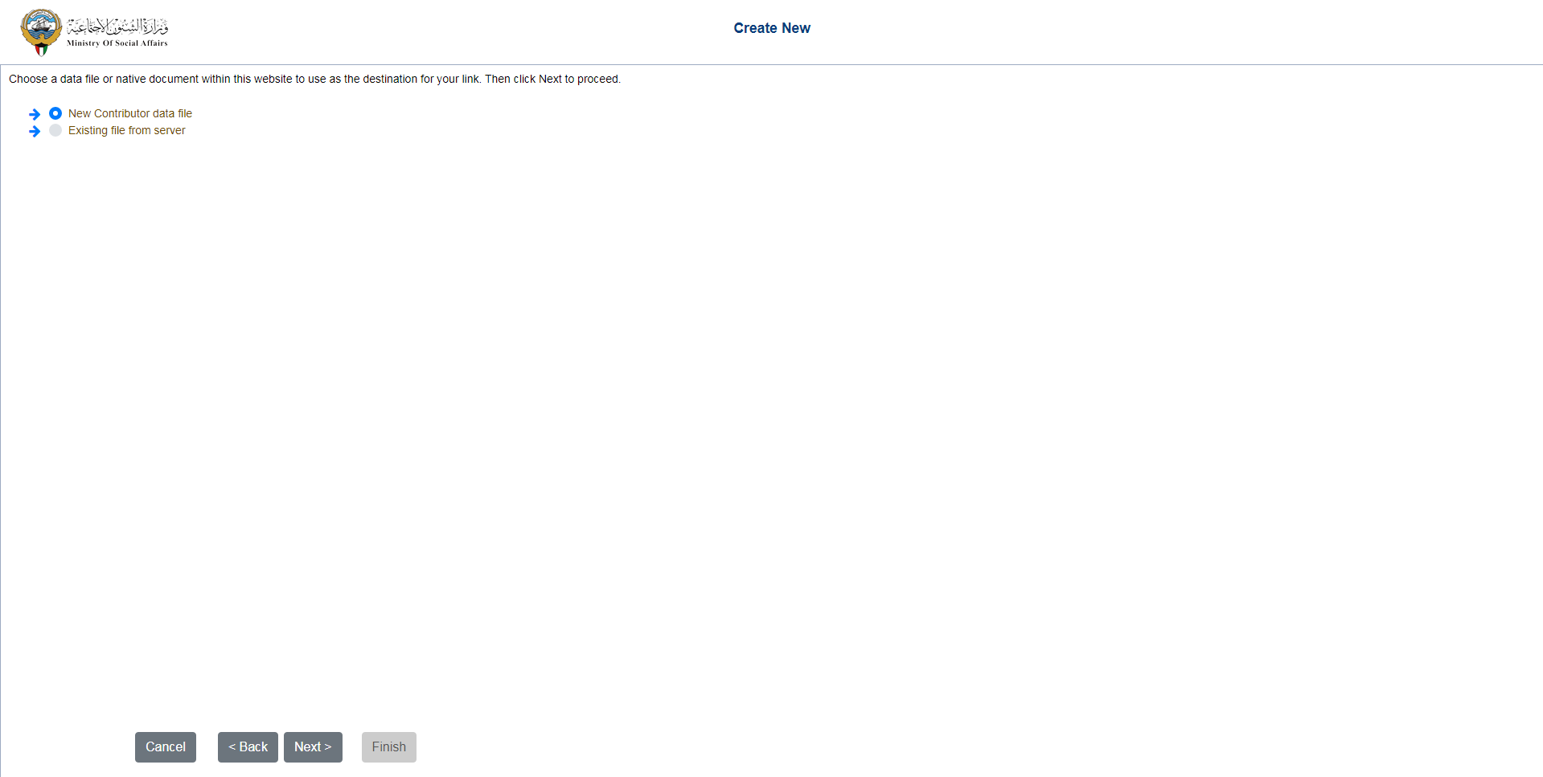

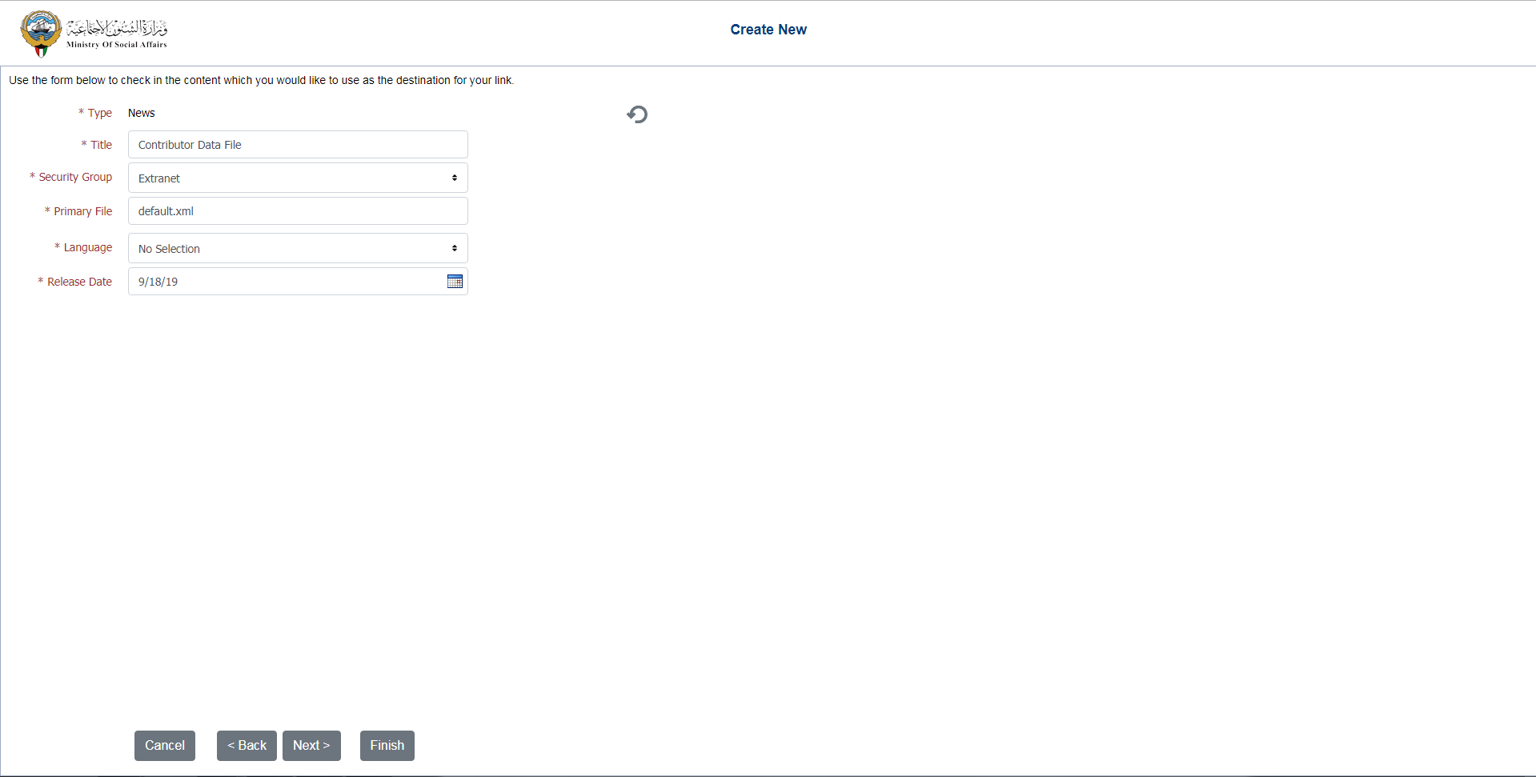

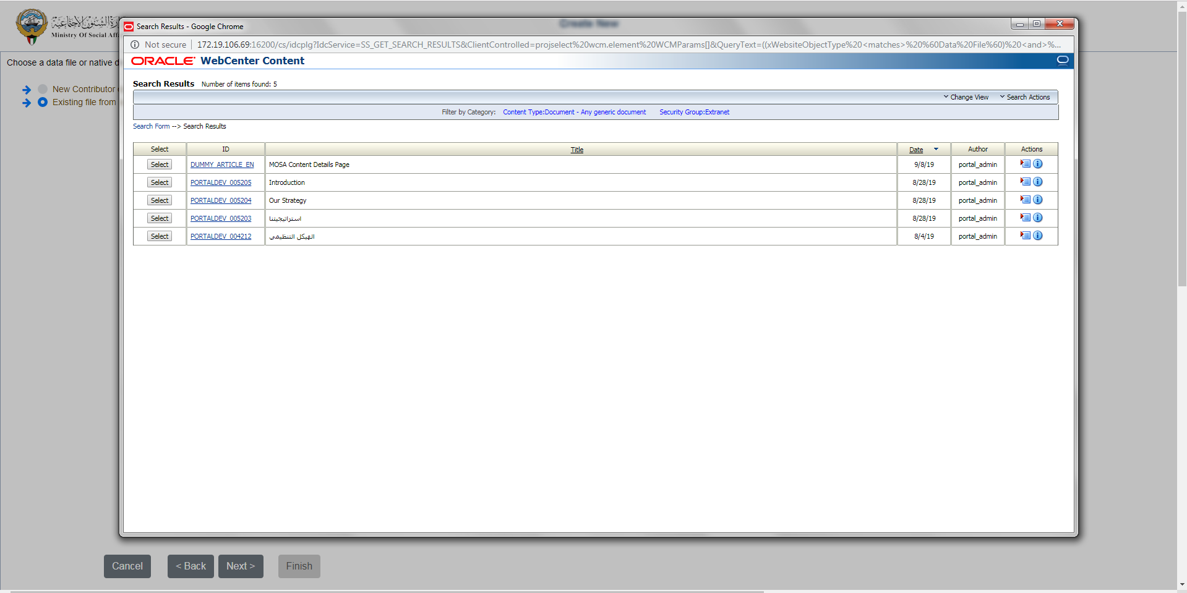

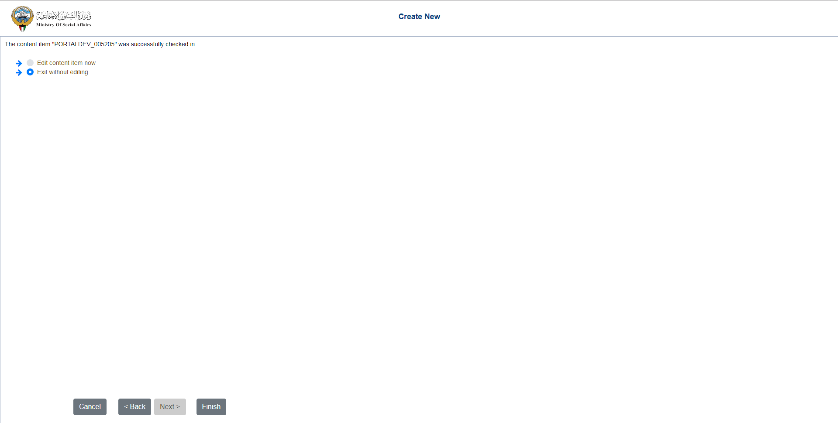

## Create New Data File (ex. News)

|  |  |
| --- | --- |
| Task name | Create New Data File (ex. News) |
| Task owner | MOSA Content Contributor |
| Description | The contributor will access the Content Wizard screens in order to create a new news data file and store it in the content server. |
| Task preconditions | * The user is a Content contributor. * The content manager news folder must have the metadata option “**Prompt for metadata when documents are added to this folder**=**false**” (checkbox unchecked). |
| Input | News Content Wizard link. |
| Output | News Content Wizard “Switch Content Wizard” screens. |
| Task outcome | Finish, Next, Back, Cancel |

|  |  |
| --- | --- |
| Task Main Flow | |
| # | **Actor action** | **System response** |
|  | From the content tree in the “Content” page at the portal, open the folder News.  Note: News folder must have the metadata option “**Prompt for metadata when documents are added to this folder**=**false**” (checkbox unchecked). | The system will open the News folder in the content manager and the content wizard button appears at the right top of the content manager. |
|  | Click on the “Content Wizard” button from the right top of the content manager. | The system open the content wizard in a new tab forcing the login check (the system will check if the currently logged-in user has the permissions to create (check-in new files). |
|  | From “Choose Content File” screen choose “New Contributor data file” and click “Next”. | The system will continue to the next step “Check-In Content Screen”. |
|  | At “Check-In Content” screen enter the metadata field values, fill the check-in form and click “Next”. | The system will create the news data file and enter the news workflow and continue to the next step “Confirmation Screen”. |
|  | From “Confirmation” screen choose “Edit content item now” then click “Finish”. | The system will open the newly created news item in the content editor and close the Content Wizard Switcher. |
|  | In the Content Editor, select or enter the data in the elements (images, plain text, or rich text) from “Elements” tab, change the metadata from “Metadata” tab then click “Save and Close”. | The system will store the modifications in an XML at the content server.  Note: after a successful data file editing, the system developed to return back to the opener page and close the current page.  If the opener was a portal page, the system should close the Content Editor and return back to the portal page. |

|  |  |
| --- | --- |
| Task exceptional Flow | |
| # | **Actor action** | **System response** |
|  | If the user click on “Cancel” in the any step in the Content Wizard Switcher before the step “Check-In Content”. | The system will return back to the first screen “Choose Content File” in the wizard and data file will not be created. |
|  | If the user click on “Cancel” in the any step in the Content Wizard Switcher after the step “Check-In Content”. | The system will return back to the first screen “Choose Content File” in the wizard but an empty data file will be created and entered the workflow. |
|  | If the user click on “Cancel” in the any step in the Content Editor. | The system will close the Content Editor and elements changes and modifications will be ignored. |





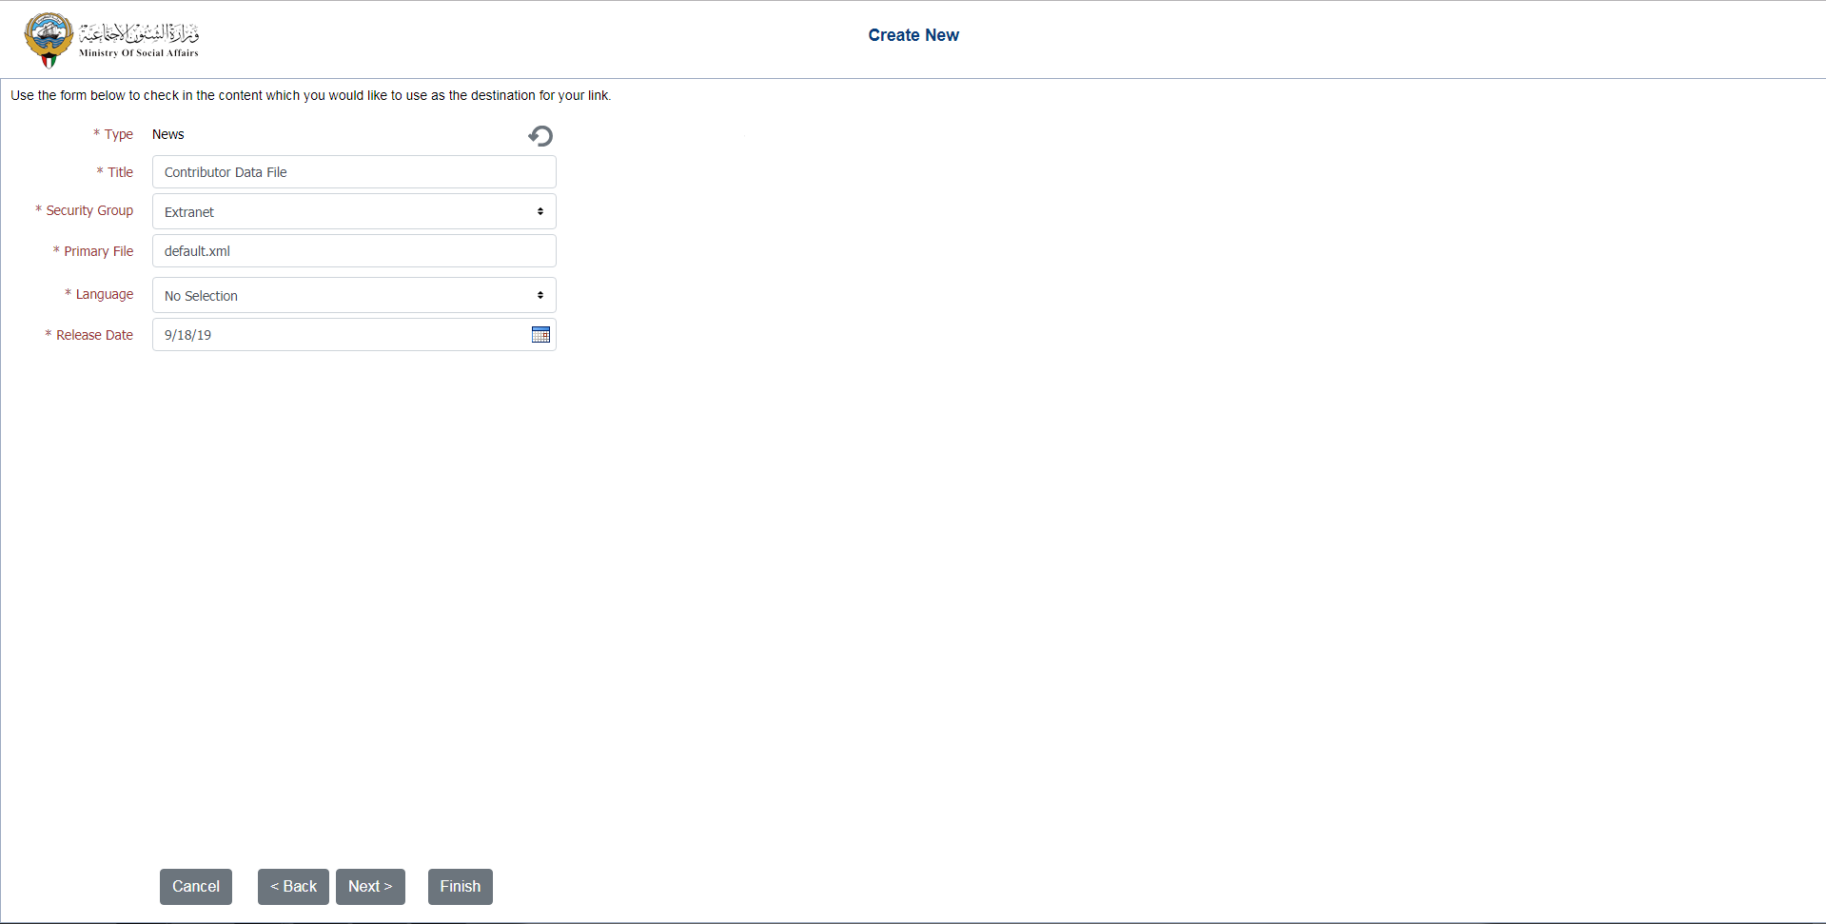

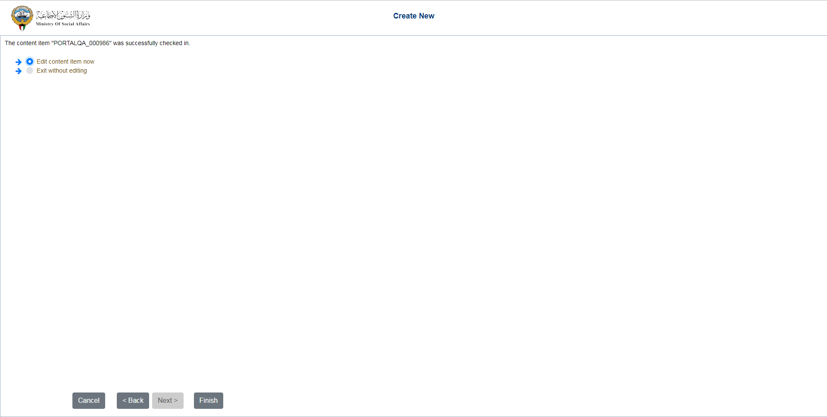

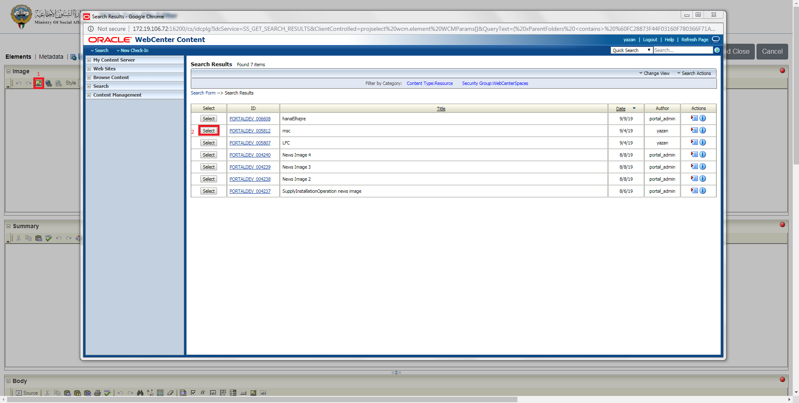

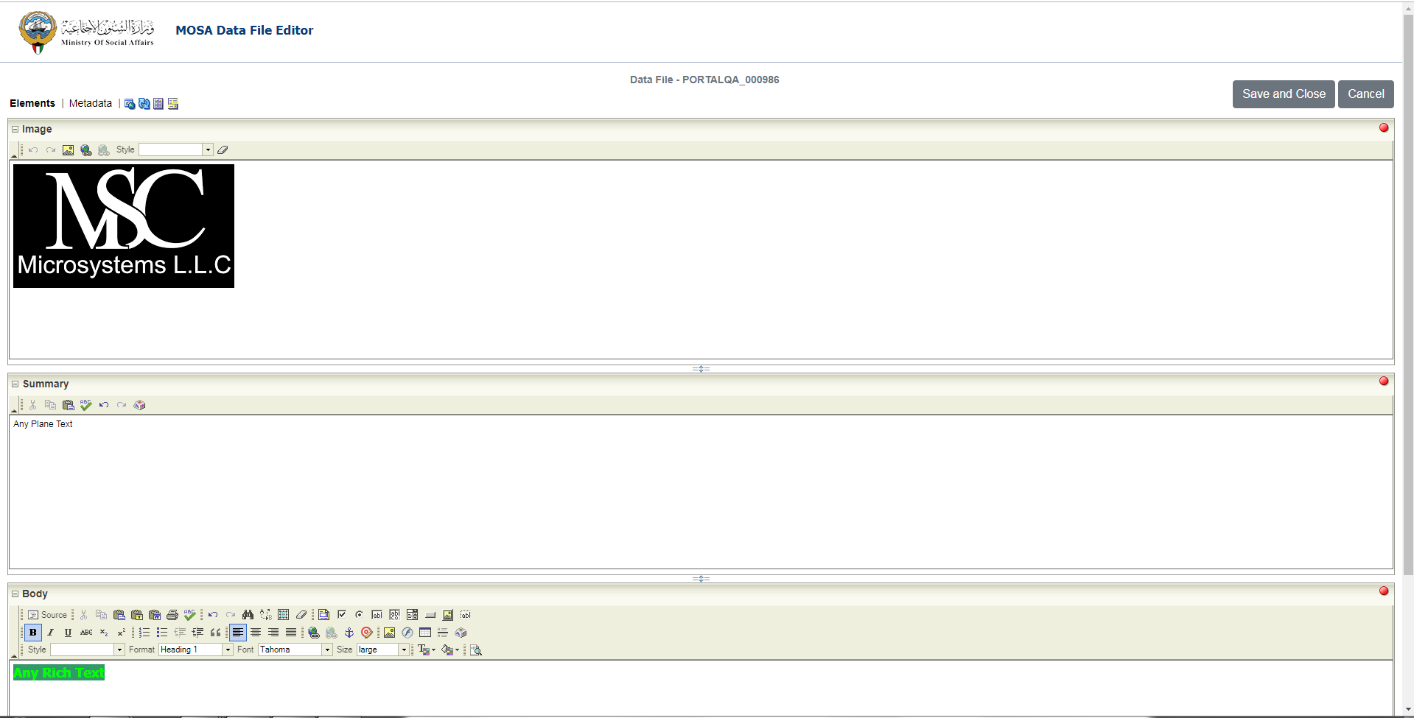

## Edit Data File (ex. News)

|  |  |
| --- | --- |
| Task name | Edit Data File (ex. News) |
| Task owner | MOSA Content Contributor |
| Description | The contributor will access the Content Wizard screens in order to update the metadata and/or update the elements of an existing news data file in the content server. |
| Task preconditions | * The user is a Content contributor. * The content manager news folder must have the metadata option “**Prompt for metadata when documents are added to this folder**=**false**” (checkbox unchecked). * The news data file is exist in the content server. |
| Input | The Content Wizard link. |
| Output | The Content Wizard “Content Editor” screens. |
| Task outcome | Save and Close, Cancel |

|  |  |
| --- | --- |
| Task Main Flow | |
| # | **Actor action** | **System response** |
|  | From the content tree in the “Content” page at the portal, open the folder News.  Note: News folder must have the metadata option “**Prompt for metadata when documents are added to this folder**=**false**” (checkbox unchecked). | The system will open the folder in the content manager and the content wizard button appears at the right top of the content manager. |
|  | Select News item checkbox from the news list in the content manager. | The news item checkbox is selected and the controls of the allowed actions (including item edit) for the single selected item will be displayed. |
|  | Click on “Edit” icon control on the top of news list in the content manager. | The system will open the selected news item in the Content Editor. |
|  | In the Content Editor, select or enter the data in the elements (images, plain text, or rich text) from “Elements” tab, change the metadata from “Metadata” tab then click “Save and Close”. | The system will store the modifications in an XML at the content server re-enter the workflow.  Note: Unless if you unchecked the box “Revision Finished Editing” the content will re-enter the workflow. |

|  |  |
| --- | --- |
| Task exceptional Flow | |
| # | **Actor action** | **System response** |
|  | If the user click on “Cancel” in the any step in the Content Editor. | The system will close the Content Editor and elements changes and modifications will be ignored. |

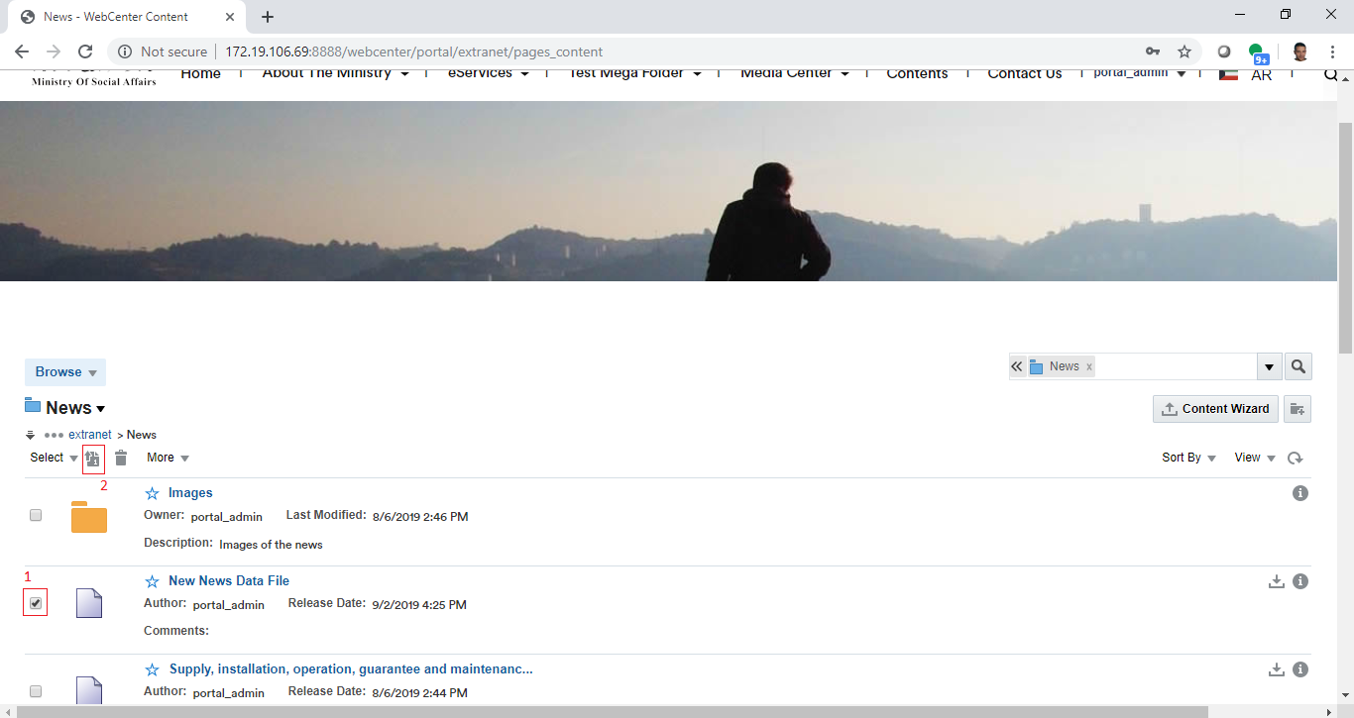



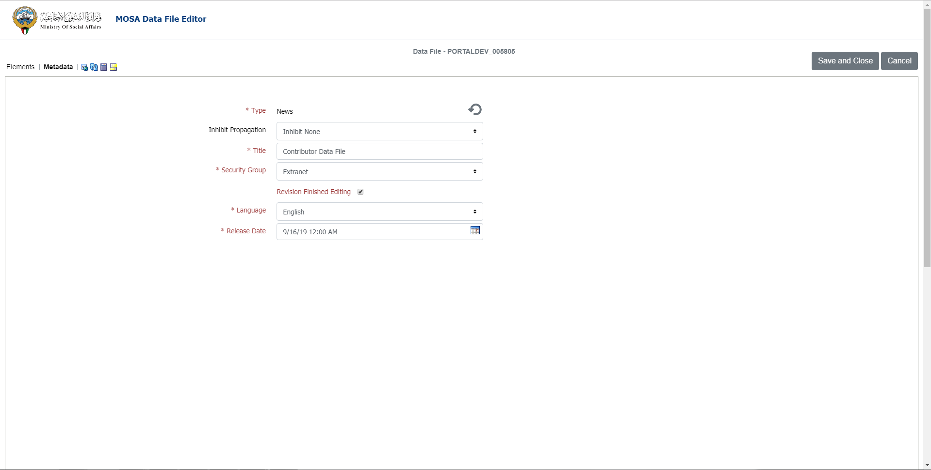

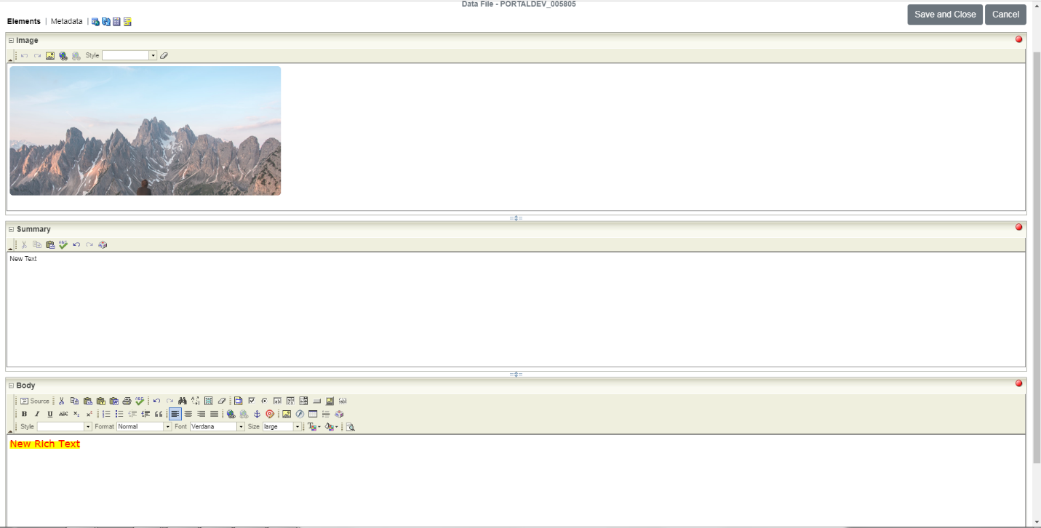

Developers & Contributors Tasks to Enable the Service

|  |  |  |
| --- | --- | --- |
| **Task** | **Application** | **Responsibility of** |
| Add Content Region Definitions | Site Studio | Content Administrator |
| Add Content Elements Definitions | Site Studio | Content Administrator |
| Add Content Information Fields | Webcenter Content | Content Administrator |
| Group the Information Fields in a Content Rule | Webcenter Content | Content Administrator |
| Create a Content Profile Including the Content Rules | Webcenter Content | Content Administrator |
| Create/Update Data Files Using the Content Wizard | Site Studio | Content Contributor |

Updates Log