**functional requirements document**

|  |  |  |  |  |  |
| --- | --- | --- | --- | --- | --- |
| **Project Name** | : | MoSA Portal | **Date** | : | 01/Jul/2019 |
| **Requirement #** | : |  | **Created by** | : | Shakboua Zaid |

Requirement Title

Extranet - News

Detailed Description

News is used to inform extranet (public) users about the new updates, activities and news of the ministry.

All news about the ministry will be added and verified in the content server through the portal. This type of content will be available for users from the main menu navigation in “News” page and from the “Home” page via a news carousal.

“News” page provides the users with the ability to find MOSA news, it will be displayed as mini-view news item which consist of a thumbnail image, a summary about the news, and the date of the news. The users will be also able to sort the news by date and name, as they will be able to search for news from this page.

“News Detail” page display full information about the news (all metadata).

Requirements

News is a custom service, it represents a site studio element based on a content profile displayed in a content presenter at the portal.

**News Profile Information Fields (News Attributes)**:

|  |  |  |  |  |  |  |
| --- | --- | --- | --- | --- | --- | --- |
| **Field** | **Caption** | **Field Type** | **Required?** | **LOV?** | **Data Type** | **List** |
| dDocName | Content ID | Hidden |  |  | Text |  |
| dDocType | Type | Read Only |  |  | Text | * Application * Binary * DigitalMedia * Document * System * ServiceCard * Slide * **News** * Announcement * Event * Publication * Resource |
| dDocTitle | Title | Edit |  |  | Text |  |
| dDocAuthor | Author | Hidden |  |  | Text | The list of all available users in the system.  Text entry is also applicable. |
| dSecurityGroup | Security Group | Edit |  |  | Text | * Public * Secure * PersonalSpaces * WebcenterSpaces * Intranet * **Extranet** |
| dRevLabel | Revision | Hidden |  |  | Number |  |
| primaryFile | News File | Edit |  |  | File |  |
| summary | News Summary | Edit |  |  | Plain Text Element Definition (Site Studio) |  |
| image | News Image | Edit |  |  | Image Element Definition (Site Studio) |  |
| details | News Details | Edit |  |  | WYSIWYG Element Definition (Site Studio) |  |
| dInDate | Release Date | Edit |  |  | Date |  |

Use Cases

## Create New News

|  |  |
| --- | --- |
| Task name | Create New News |
| Task owner | MOSA Extranet News Contributor |
| Description | The contributor will follow the steps at content creation wizard in order to add a new news. |
| Task preconditions | * The user logs on to the system. * The user is an Extranet News contributor. |
| Input | The content creation wizard details and metadata. |
| Output | The content view mode editor. |
| Task outcome | Save and Close, Cancel. |

|  |  |
| --- | --- |
| Task Main Flow | |
| # | **Actor action** | **System response** |
|  | From “Contents” page click on “News” folder in the content manager. | The system will open the news content folder. |
|  | Click on “Content Wizard” button on the right top of the content manager. | The system will open the content creation wizard in a new browser tab. |
|  | At the content creation wizard, the first step is to select the content type. Select “News” from region definition drop down control and click “Next”. | The wizard will forward to the next step. |
|  | The next step is to select if you want to create new or update existing item then click “Next” | The wizard will forward to the next step. |
|  | Modify the default metadata if needed, or move to the last step by clicking “Finish”  *Note: for better content management, make sure to name the created data file with something relevant like <data file title>.xml (ex. my first news.xml). If you did not, the file will be automatically named by the content Id <dDocName>.xml (ex. PORTALDEV_15428.xml).* | The wizard will create the News item and open it view edit mode. |
|  | At the view edit mode, insert the data in the specified areas (ex. insert summary text inside “Summary” area) then click “Save and Close” | The new News item created and added to the repository and entered the workflow. |

|  |  |
| --- | --- |
| Task exceptional Flow | |
| # | **Actor action** | **System response** |
|  | If the user select “cancel” in any step before the last step (before clicking “Finish”) | The content creation wizard close without adding any new items. |
|  | If the user select “cancel” in any step after the last step (after clicking “Finish”) | The content creation wizard close and a new news item is initiated. |

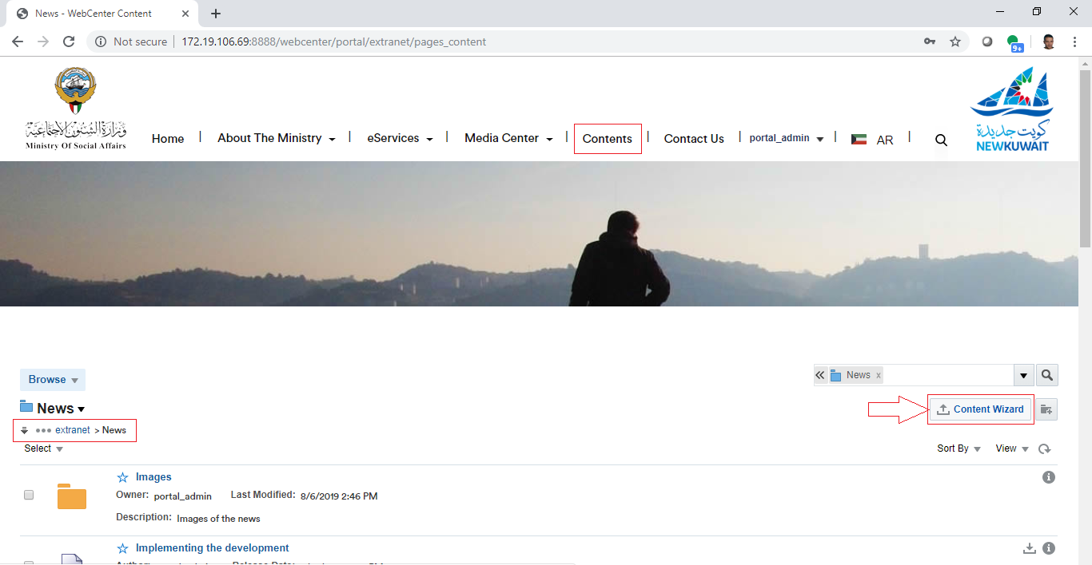

## Approve News in Workflow

|  |  |
| --- | --- |
| Task name | Approve News |
| Task owner | MOSA Extranet News Approver |
| Description | The approver will preview News file and approve it. |
| Task preconditions | * The user logs on to the system. * The user is an Extranet News approver. * The News item is in News workflow. |
| Input |  |
| Output |  |
| Task outcome | Approve, Cancel. |

|  |  |
| --- | --- |
| Task Main Flow | |
| # | **Actor action** | **System response** |
|  | Click on news item name in at the news list in the content manager. | The system will open the selected item in content previewer page. |
|  | Click “Approve” from the “Summary” tab in content previewer page. | The system will prompt with the approve dialog. |
|  | Click “Approve” | The system will approve the News item and exist the workflow. |

|  |  |
| --- | --- |
| Task exceptional Flow | |
| # | **Actor action** | **System response** |
|  | If the user select “Cancel” in any stage in the main flow | The dialog close. |

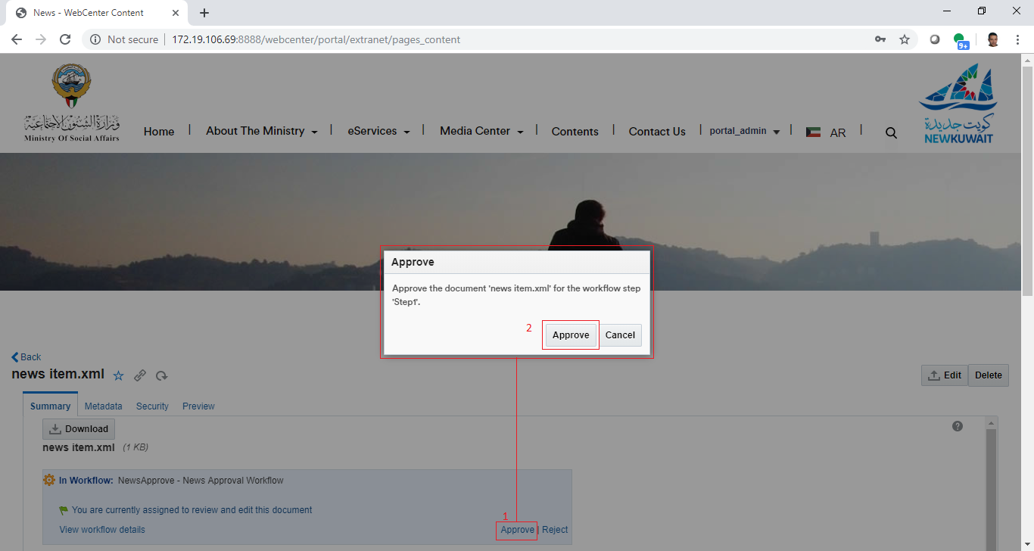

## Reject News in Workflow

|  |  |
| --- | --- |
| Task name | Reject News |
| Task owner | MOSA Extranet News Approver |
| Description | The approver will preview News file and reject it. |
| Task preconditions | * The user logs on to the system. * The user is an Extranet News approver. * The News item is in News workflow. |
| Input |  |
| Output |  |
| Task outcome | Reject, Cancel. |

|  |  |
| --- | --- |
| Task Main Flow | |
| # | **Actor action** | **System response** |
|  | Click on news item name at the news list in the content manager. | The system will open the selected item in content previewer page. |
|  | Click “Reject” from the “Summary” tab in content previewer page | The system will prompt with the reject dialog. |
|  | Optionally, the approver adds the rejection reason inside the box “Reason for rejection” in the reject dialog | The system hold the text in this box. |
|  | Click “Reject” | The system will reject the News and notify the content contributor by mail and notify him about this rejection including the rejection reason in this mail and return back to ‘contribution’ workflow step.  *Note: this is initial step in any content workflow, to exist from this step, a new revision of the content item must be checked-in so the content fall in workflow again.* |

|  |  |
| --- | --- |
| Task exceptional Flow | |
| # | **Actor action** | **System response** |
|  | If the user select “cancel” in any stage in the main flow | The dialog close. |

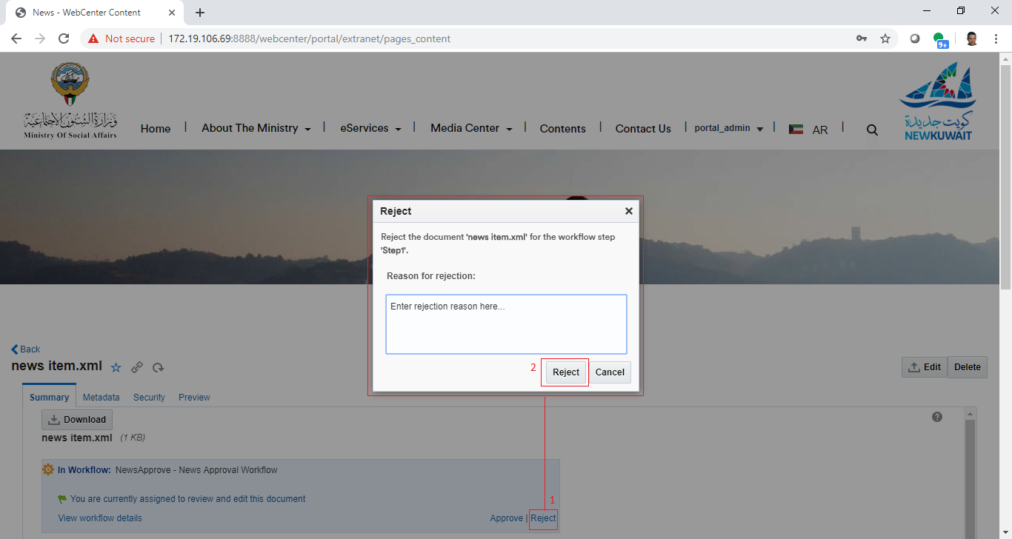

## Update News

|  |  |
| --- | --- |
| Task name | Update News |
| Task owner | MOSA Extranet News Contributor |
| Description | The contributor will select a News item from the News list in order to update its metadata and/or its content.  *Note: As the news are web content items and created using the content wizard, updating news items will be also using the content wizard.* |
| Task preconditions | * The user logs on to the system. * The user is an Extranet News contributor. * The file exist in News folder. |
| Input | The News update form details and data. |
| Output | The News update form. |
| Task outcome | Save and Close, Cancel, Reset. |

|  |  |
| --- | --- |
| Task Main Flow | |
| # | **Actor action** | **System response** |
|  | Select News item checkbox from the news list in the content manager. | The news item checkbox is selected and the controls of the allowed actions (including item update) for the single selected item will be displayed. |
|  | Click on “Edit” icon control on the top of news list in the content manager. | The system will open the selected news item in the content editor (the same content wizard). |
|  | **Or** click on the news item name at the news list in the content manager. | The system will open the selected news item in the content previewer page. |
|  | Click on “Edit” icon control in the content previewer page. | The system will open the news item in the content editor (the same content wizard). |
|  | Modify the content areas (elements) in the content wizard “Elements tab” and click “Save and Close”. | The system stores the new modifications and the item re-enter the workflow. |
|  | Update the metadata “Metadata tab” as needed and click “Save and Close” | The system stores the new updates and the item re-enter the workflow. |

|  |  |
| --- | --- |
| Task exceptional Flow | |
| # | **Actor action** | **System response** |
|  | The user select more than one item.  *Note: it is allowed to select multiple items, but the user cannot update multiple items in one click.* | The controls of the allowed actions (including item update) for the single selected item will be hidden. |
|  | If the user removed the text or the image of a required area (element) or a required metadata field and did not add new values for it and tried to save the changes | The system will prompt with an error message telling that a required element or metadata field is empty which prevent saving the changes. |
|  | If the user select “Reset” in “Metadata tab” before he save the changes | All changes will be lost and fields will be reverted back into the previous values. |
|  | If the user select “Cancel” in any stage during the update | All changes will be ignored and the content editor (content wizard) will be closed. |

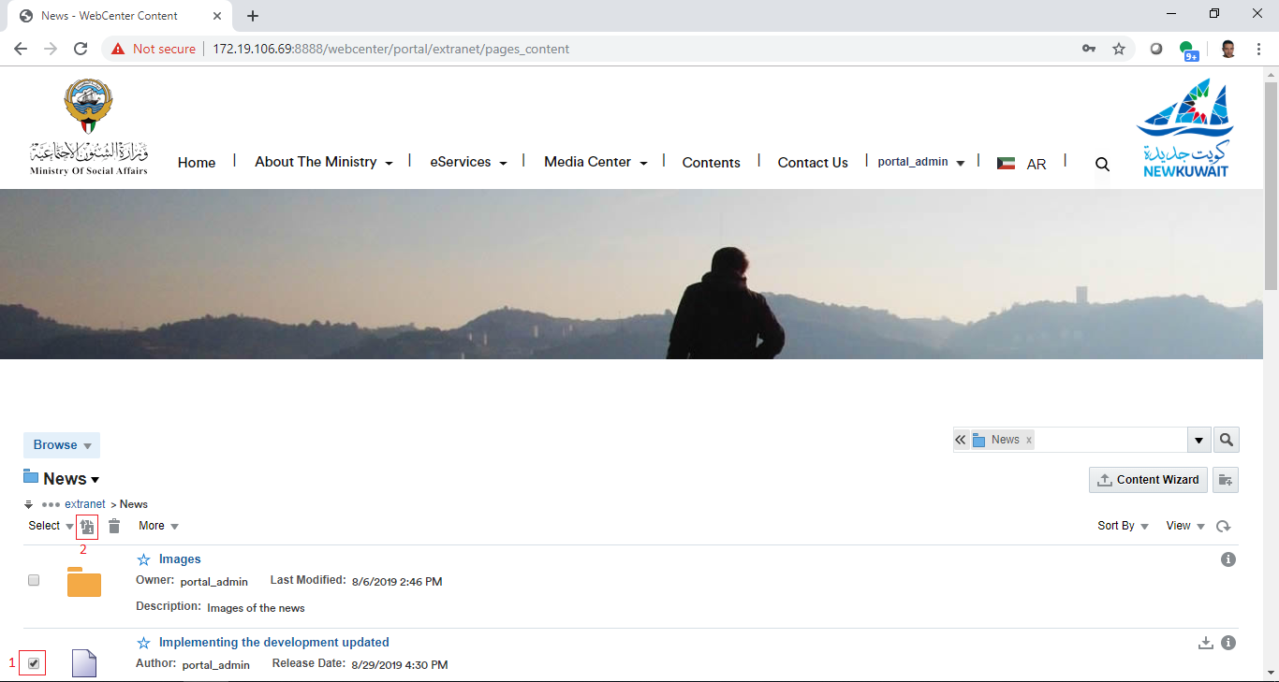

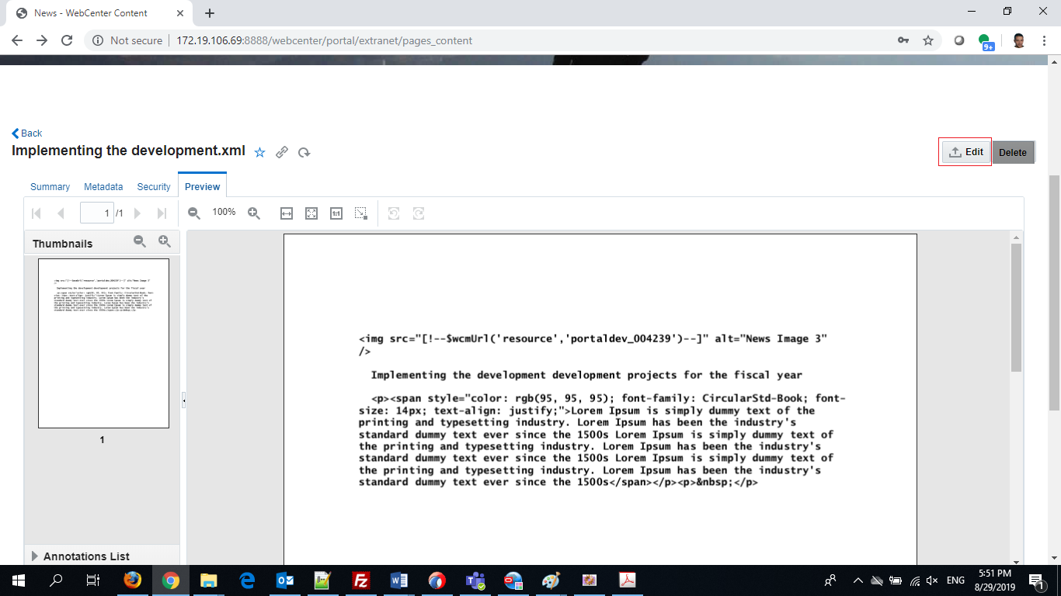

## Delete News

|  |  |
| --- | --- |
| Task name | Delete News |
| Task owner | MOSA Extranet News Contributor |
| Description | The contributor will select a News item from the News list in order to delete it. |
| Task preconditions | * The user logs on to the system. * The user is an Extranet News contributor. * The file exist in News folder. * The news item is not in workflow. |
| Input | The News to be deleted. |
| Output | The News list updated and the news item removed. |
| Task outcome | Yes, No. |

|  |  |
| --- | --- |
| Task Main Flow | |
| # | **Actor action** | **System response** |
|  | Select News item checkbox from the news list in the content manager. | The news item checkbox is selected and the controls of the allowed actions (including item delete) for the single selected item will be displayed. |
|  | Click on “delete” icon control on the top of news list in the content manager. | The system will prompt with the delete confirmation dialog popup. |
|  | **Or** click on the news item name at the news list in the content manager. | The system will open the selected news item in the content previewer page. |
|  | Select delete from the dropdown control “More” in the content previewer page. | The system will prompt with the delete confirmation dialog popup. |
|  | Click on “Yes” to delete the item. | The item deleted. |

|  |  |
| --- | --- |
| Task exceptional Flow | |
| # | **Actor action** | **System response** |
|  | If the user tried to delete a news item in the workflow | The system will prompt with an error message telling that the item in the workflow and it cannot be deleted. |
|  | If the user select “No” in delete confirmation dialog popup | The popup closed and the news item remain in the list. |

Alternative1: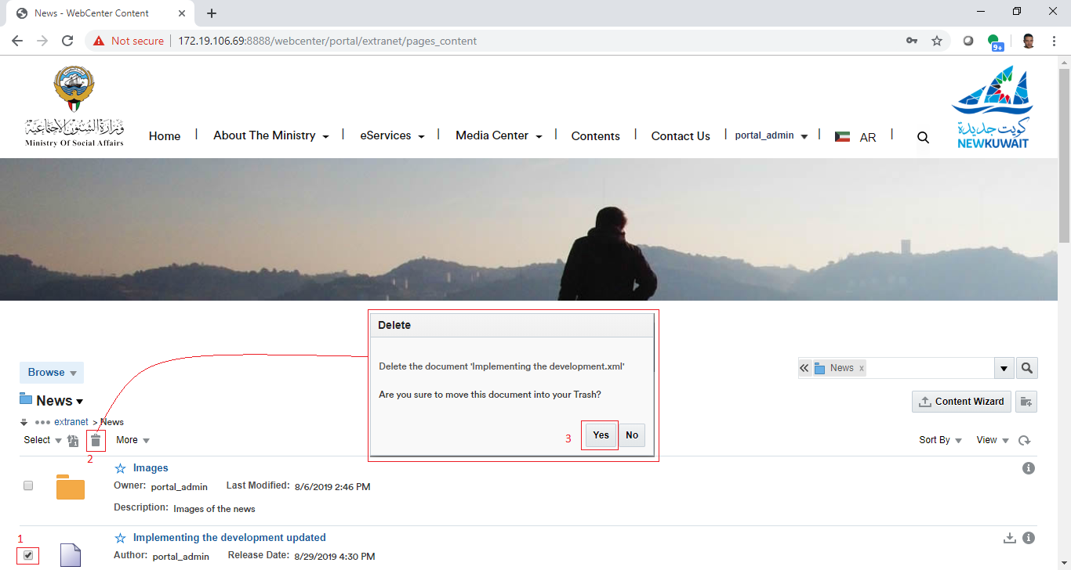

Alternative2: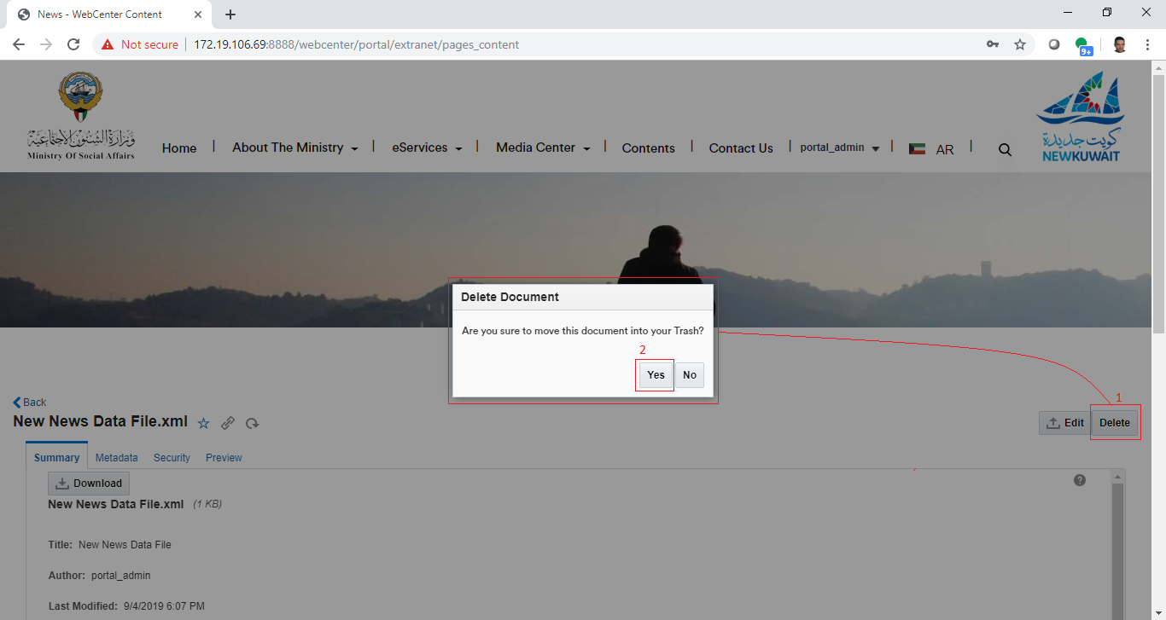

## Sort & Filter News

|  |  |
| --- | --- |
| Task name | Sort & Filter News |
| Task owner | MOSA Extranet User |
| Description | The user can sort News by News date or News name. |
| Task preconditions |  |
| Input | News list. |
| Output | Sorted News list. |
| Task outcome | Sort by name, Sort by date. |

|  |  |
| --- | --- |
| Task Main Flow | |
| # | **Actor action** | **System response** |
|  | Click on “Sort by date” from the top right of the News list in “News” page. | The system will reorder the items in the News list by News date descending or ascending. |
|  | Click on “Sort by name” from the top right of the News list in “News” page. | The system will reorder the items in the News list by News name alphabetically. |
|  | Click on “Reset” action from the top right of the News list in “News” page. | The system will restore the default ordering and clear the searched value. |

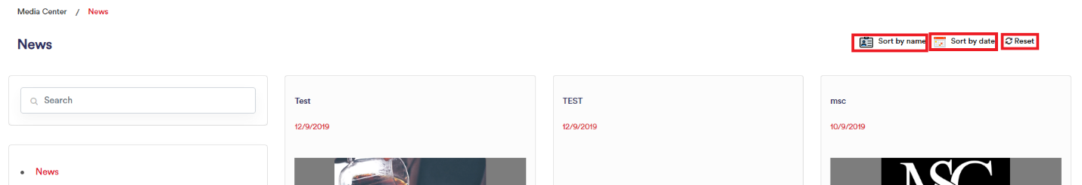

## Search News

|  |  |
| --- | --- |
| Task name | Search News |
| Task owner | MOSA Extranet User |
| Description | The user can search News by keyword. |
| Task preconditions |  |
| Input | News list. |
| Output | Keyword matched/contained items News list. |
| Task outcome | Search Icon. |

|  |  |
| --- | --- |
| Task Main Flow | |
| # | **Actor action** | **System response** |
|  | Enter a keyword in the search box on top of the sidebar list and click on search icon in the same box.  *Note: for partial matching use the asterisk (*) at the beginning of the keyword so it will return all items that contains at least an area (ex. title, summary, or body) with one word ends with this keyword, OR use it at the end of the keyword so it will return all items that contains at least an area with one word starts with this keyword.* | The system will filter the news list by this keyword and keep only the news items with one or more areas that contains this keyword. |

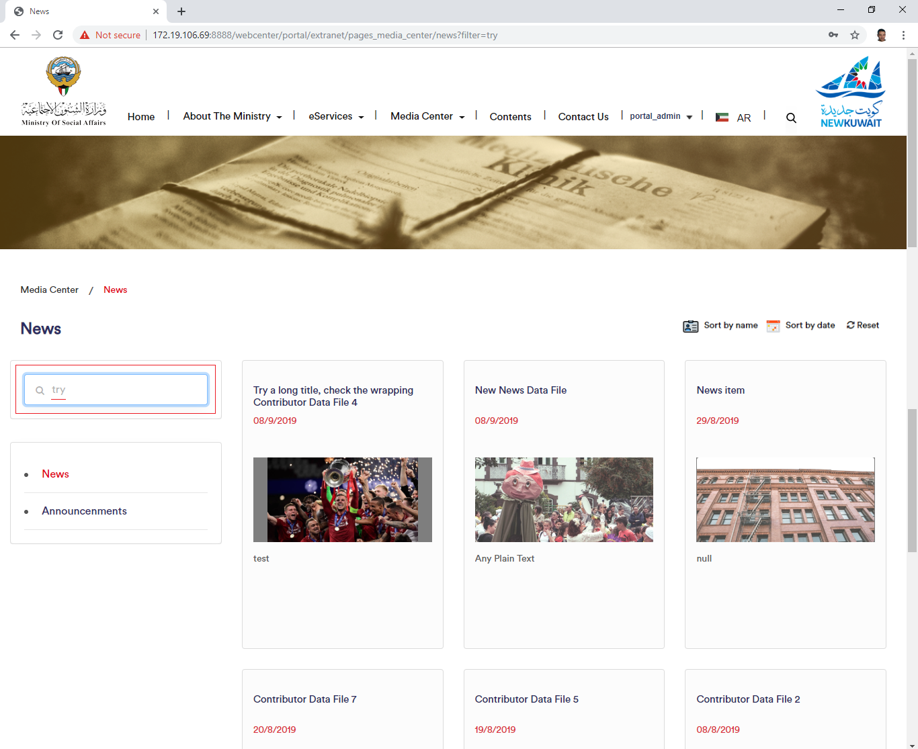

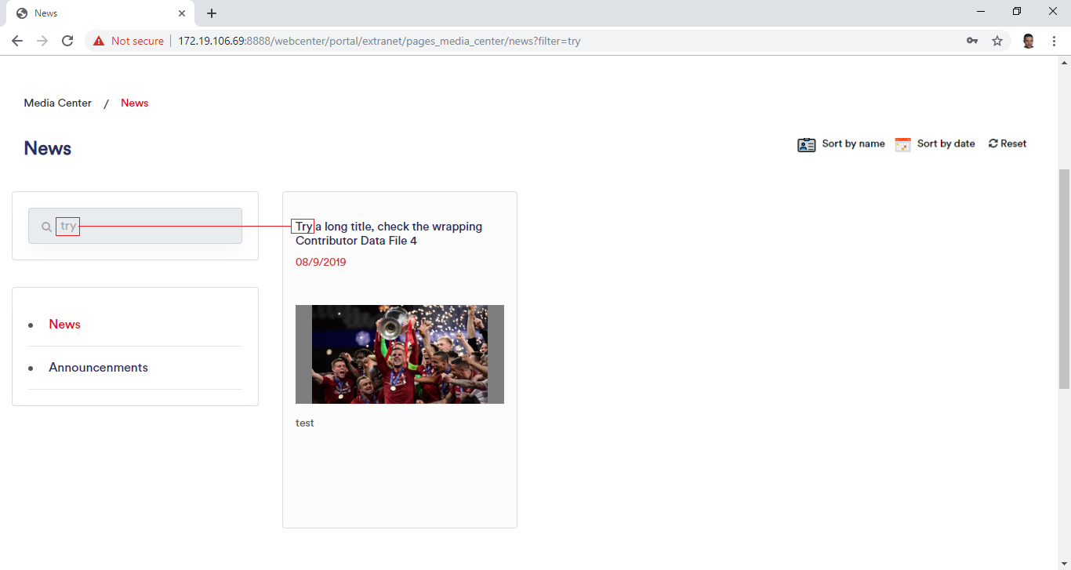

Workflow

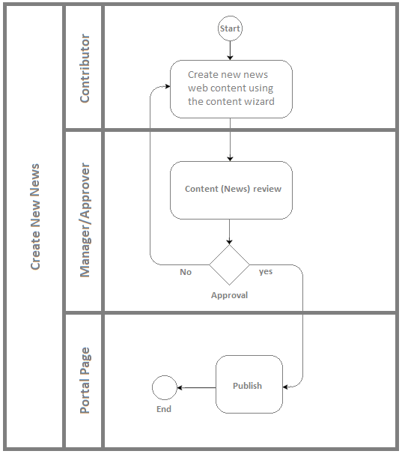

Developers & Contributors Tasks to Enable the Service

|  |  |  |
| --- | --- | --- |
| **Task** | **Application** | **Responsibility of** |
| Add Content Region Definition for News | Site Studio | Content Administrator |
| Add Content Elements as News Metadata | Site Studio | Content Administrator |
| Add Content Information Fields for News | Webcenter Content | Content Administrator |
| Group News Fields in Content Rule | Webcenter Content | Content Administrator |
| Create a Content Profile for News Including the Content Rule | Webcenter Content | Content Administrator |
| Create a Content Presenter for News | Webcenter Portal | Portal Administrator |
| Create a Page and Add the Content Presenter for News | Webcenter Portal | Content Contributor |
| Publish the Page for Users | Webcenter Portal | Content Contributor |

Updates Log