**functional requirements document**

|  |  |  |  |  |  |
| --- | --- | --- | --- | --- | --- |
| **Project Name** | : | MoSA Portal | **Date** | : | 30/Jun/2019 |
| **Requirement #** | : |  | **Created by** | : | Shakboua Zaid |

Requirement Title

Extranet - Slides

Detailed Description

Slides are useful PDF files for the extranet (public) users of the ministry. Users can find official information about the ministry in these files.

The users can preview the content of these files or download it from “Slides” screen, the users can also search for slides, sort it by name or date, and filter it by slide’s category all in the same screen.

The content contributors can create or update these files via a one-step approval workflow from the slide’s content management screen. The content contributors can also delete these files from the same screen.

Requirements

Slides is a custom service, it represents a content profile displayed in a content presenter at the portal.

**Slide Profile Information Fields (Slide Attributes)**:

|  |  |  |  |  |  |
| --- | --- | --- | --- | --- | --- |
| **Field** | **Caption** | **Required?** | **LOV?** | **Data Type** | **List** |
| dDocName | Content ID |  |  | Text |  |
| dDocType | Type |  |  | Text | * Application * Binary * DigitalMedia * Document * System * ServiceCard * **Slide** * News * Announcement * Event * Publication * Resource |
| dDocTitle | Title |  |  | Text |  |
| dDocAuthor | Author |  |  | Text | The list of all available users in the system.  Text entry is also applicable. |
| dSecurityGroup | Security Group |  |  | Text | * Public * Secure * PersonalSpaces * WebcenterSpaces * Intranet * **Extranet** |
| dRevLabel | Revision |  |  | Number |  |
| dInDate | Release Date |  |  | Date |  |
| primaryFile | Slide File |  |  | File |  |
| xSlideText | Slide Text |  |  | Text |  |

Use Cases

## Create New Slide

|  |  |
| --- | --- |
| Task name | Create New Slide |
| Task owner | MOSA Extranet Slide Contributor |
| Description | The contributor will fill out the Slide creation form in order to add a new slide. |
| Task preconditions | * The user logs on to the system. * The user is an Extranet Slide contributor. * The file does not exist in Slides folder. |
| Input | The Slide creation form details and data. |
| Output | The Slide creation form. |
| Task outcome | Check-in, Cancel. |

|  |  |
| --- | --- |
| Task Main Flow | |
| # | **Actor action** | **System response** |
|  | From “Contents” page click on “Slides” folder in the content manager. | The system will open the slides content folder. |
|  | Inside the slides folder click on the control “Upload” at the right top of the content manager.  Note: When you try to upload document using the content manager you will be provided with the option to choose the content profile, keep the selected profile for slides “Slides (Images)”. | The system will open the content uploader. |
|  | Drag the slide file from your drive into the dialog or click browse and select the slide file from your drive. | The system will prepare the file for upload and enable the section for metadata entry for this slide item. |
|  | Fill out the metadata fields and select file to be uploaded | The system will check and verify the data. |
|  | Click “Upload” | The system will upload the document and the dialog close, the system will also notify the user by a message displays on top of the page that the document is successfully uploaded. |

|  |  |
| --- | --- |
| Task exceptional Flow | |
| # | **Actor action** | **System response** |
|  | If the user select “cancel” in any stage in the main flow | The dialog close. |

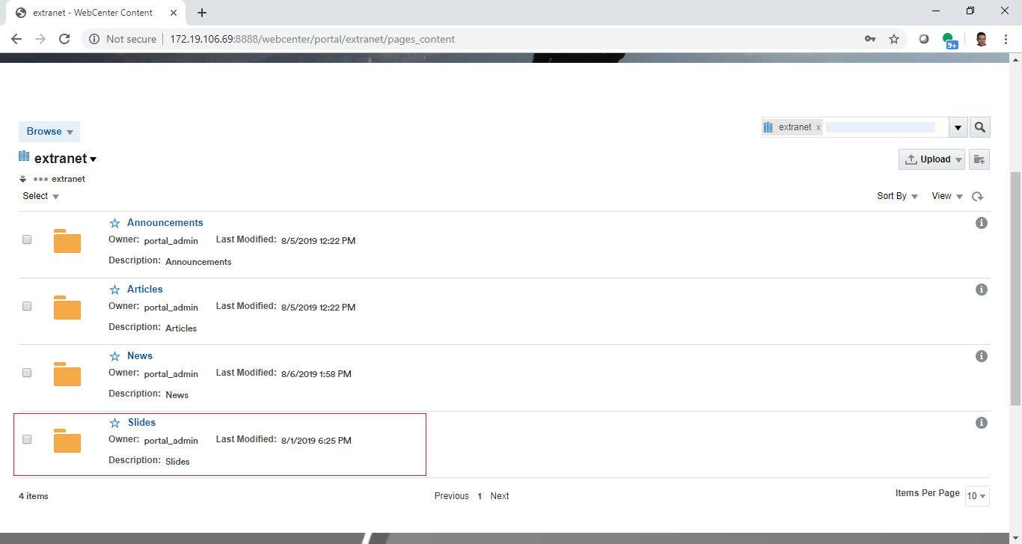

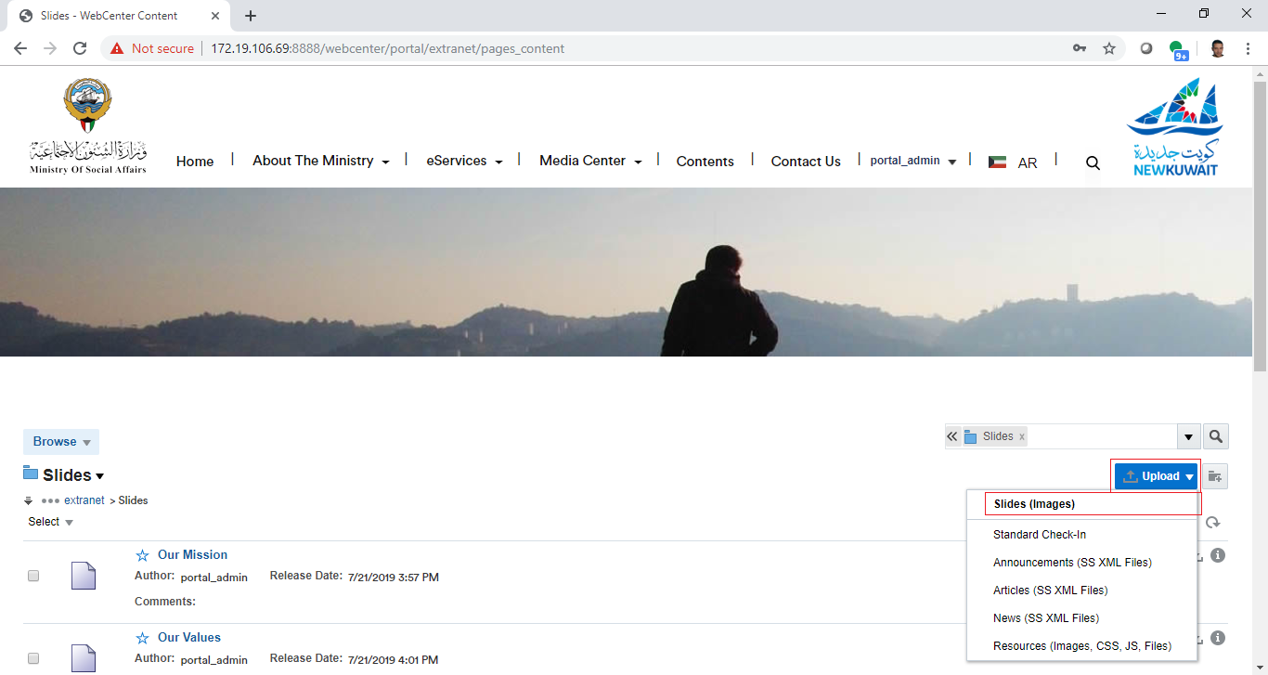

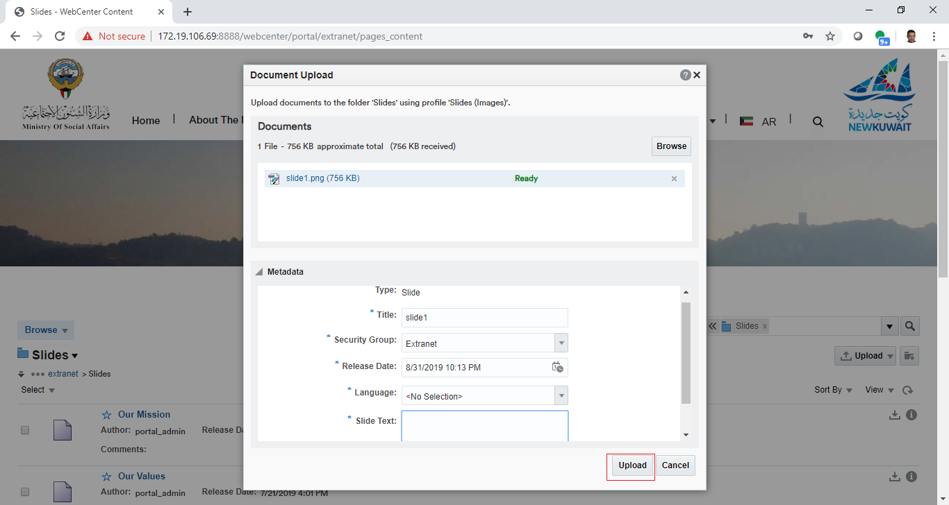

## Approve Slide in Workflow

|  |  |
| --- | --- |
| Task name | Approve Slide |
| Task owner | MOSA Extranet Slide Approver |
| Description | The approver will preview slide file and approve it. |
| Task preconditions | * The user logs on to the system. * The user is an Extranet Slide approver. * The Slide item is in Slide workflow. |
| Input |  |
| Output |  |
| Task outcome | Approve, Cancel. |

|  |  |
| --- | --- |
| Task Main Flow | |
| # | **Actor action** | **System response** |
|  | Click on Slide file name in “Content Management” page (Slide tab) | The system will open the selected file in content previewer page. |
|  | Select “Approve” from the dropdown control “More” in the content previewer page | The system will prompt with the approve dialog. |
|  | Click “Approve” | The system will approve the slide item and exist the workflow. |
|  | **Or** click “Approve” from the “Summary” tab in content previewer page. | The system will prompt with the approve dialog. |
|  | Click “Approve” | The system will approve the slide item and exist the workflow. |

|  |  |
| --- | --- |
| Task exceptional Flow | |
| # | **Actor action** | **System response** |
|  | If the user select “cancel” in any stage in the main flow | The dialog close. |

Alternative 1:

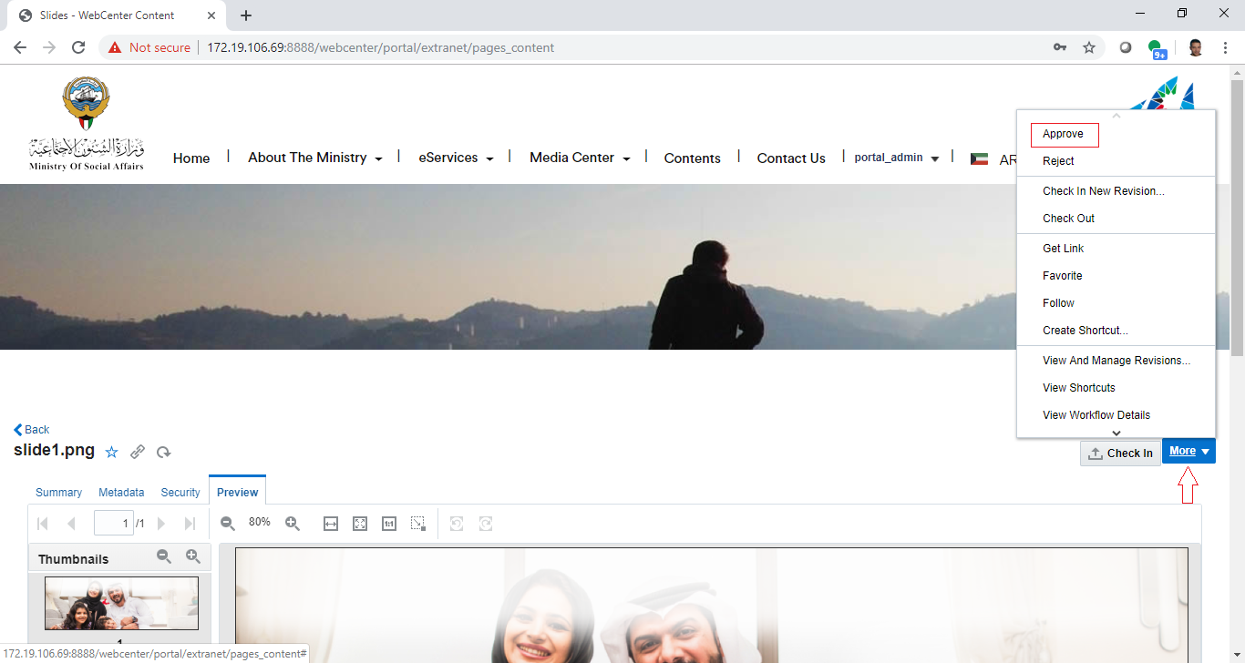

Alternative2:

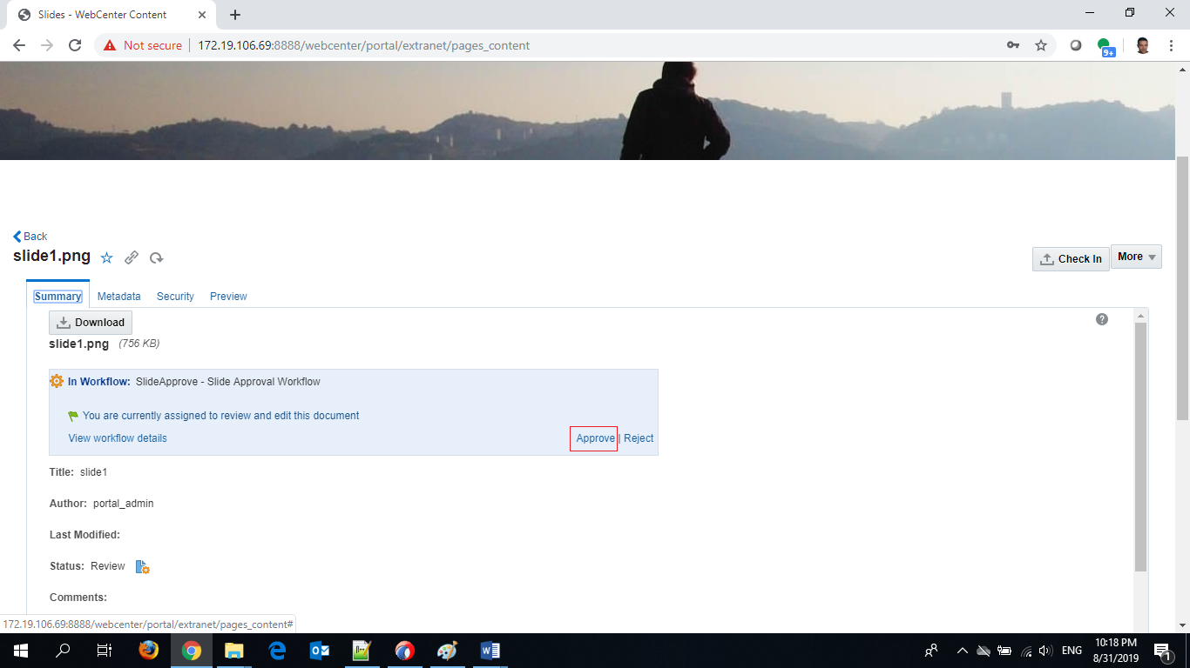

## Reject Slide in Workflow

|  |  |
| --- | --- |
| Task name | Reject Slide |
| Task owner | MOSA Extranet Slide Approver |
| Description | The approver will preview slide file and reject it. |
| Task preconditions | * The user logs on to the system. * The user is an Extranet Slide approver. * The Slide item is in Slide workflow. |
| Input |  |
| Output |  |
| Task outcome | Reject, Cancel. |

|  |  |
| --- | --- |
| Task Main Flow | |
| # | **Actor action** | **System response** |
|  | Click on Slide file name in “Content Management” from Slides folder | The system will open the selected file in content previewer page. |
|  | Select “Reject” from the dropdown control “More” in the content previewer page | The system will prompt with the reject dialog. |
|  | Optionally, the approver adds the rejection reason inside the box “Reason for rejection” in the reject dialog | The system hold the text in this box. |
|  | Click “Reject” | The system will reject the slide and notify the content contributor by mail and notify him about this rejection including the rejection reason in this mail and return back to ‘contribution’ workflow step.  *Note: this is initial step in any content workflow, to exist from this step, a new revision of the content item must be checked-in so the content fall in workflow again.* |
|  | **Or** click “Reject” from the “Summary” tab in content previewer page | The system will prompt with the reject dialog. |
|  | Optionally, the approver adds the rejection reason inside the box “Reason for rejection” in the reject dialog | The system hold the text in this box. |
|  | Click “Reject” | The system will reject the slide and notify the content contributor by mail and notify him about this rejection including the rejection reason in this mail and return back to ‘contribution’ workflow step.  *Note: this is initial step in any content workflow, to exist from this step, a new revision of the content item must be checked-in so the content fall in workflow again.* |

|  |  |
| --- | --- |
| Task exceptional Flow | |
| # | **Actor action** | **System response** |
|  | If the user select “cancel” in any stage in the main flow | The dialog close. |

Alternative:1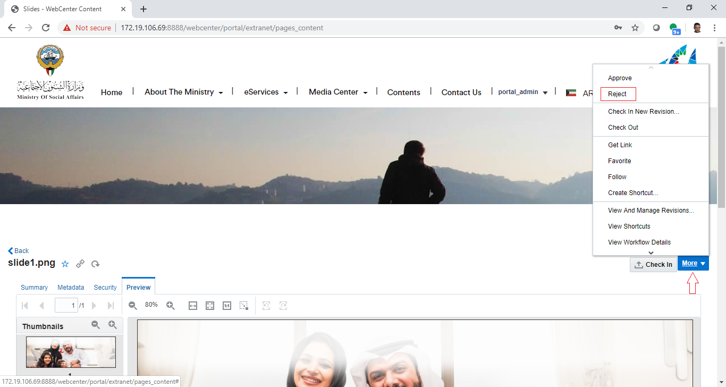

Alternative2:

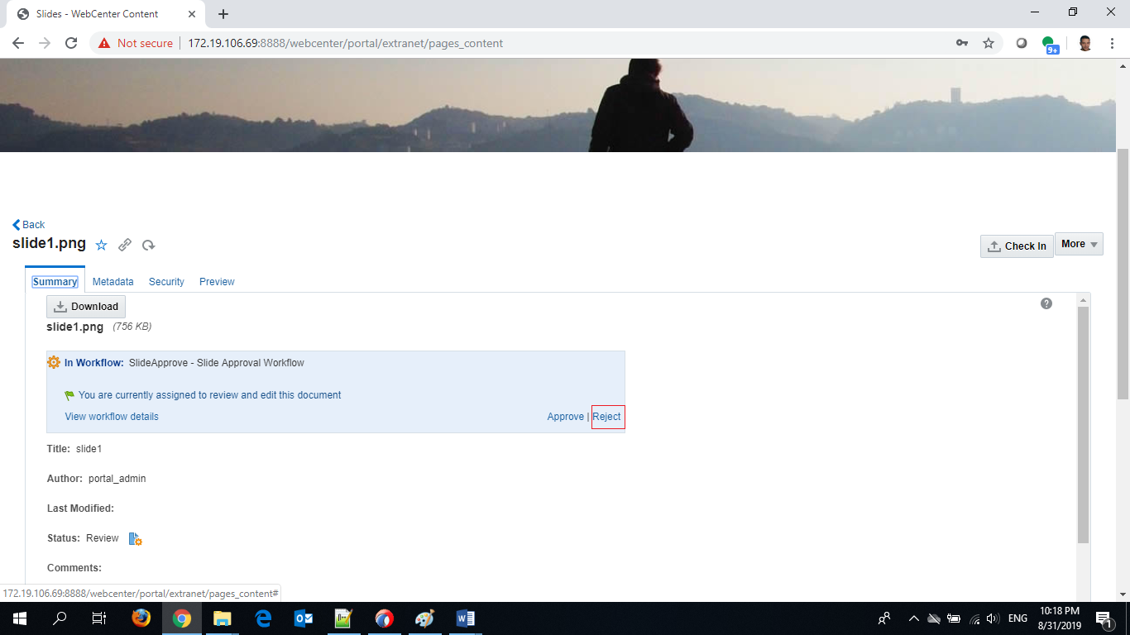

## Update Slides

|  |  |
| --- | --- |
| Task name | Update Slide |
| Task owner | MOSA Extranet Slide Contributor |
| Description | The contributor will select a Slide item from the Slides list in order to update its content and metadata. |
| Task preconditions | * The user logs on to the system. * The user is an Extranet Slide contributor. * The file exist in Slides folder. * The user must select only one item. |
| Input | The Slide content uploader form details and data. |
| Output | The Slide content uploader form. |
| Task outcome | Upload, Cancel. |

|  |  |
| --- | --- |
| Task Main Flow | |
| # | **Actor action** | **System response** |
|  | Select Slide item checkbox from the news list in the content manager. | The news item checkbox is selected and the controls of the allowed actions (including item update) for the single selected item will be displayed. |
|  | Click on “Check-in New Revision” icon control on the top of slides list in the content manager. | The system will open the content uploader. |
|  | Drag the slide file from your drive into the dialog or click browse and select the slide file from your drive. | The system will prepare the file for upload and enable the section for metadata entry for this slide item. |
|  | Update the metadata fields as needed and click “Upload”. | The system stores the new modifications and create a new release of this slide and re-enter the workflow. |

|  |  |
| --- | --- |
| Task exceptional Flow | |
| # | **Actor action** | **System response** |
|  | If the user select “cancel” in any stage during the update | The system will switch the form into read-only mode and will be ignored and reverted back to its initial values. |
|  | If the user check multiple boxes. | The system will hide the allowed actions (including “Check In New Revision”) for the single selected |

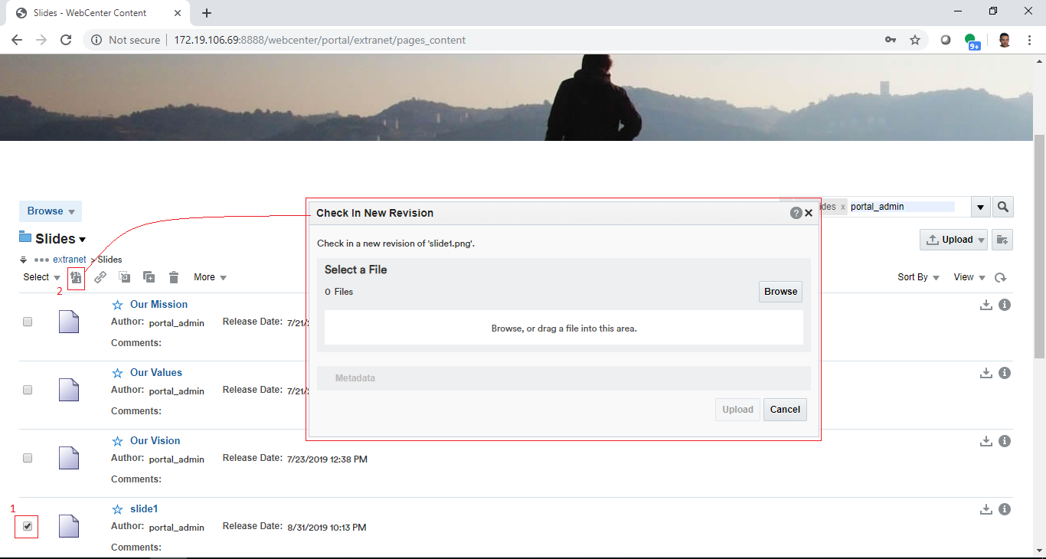

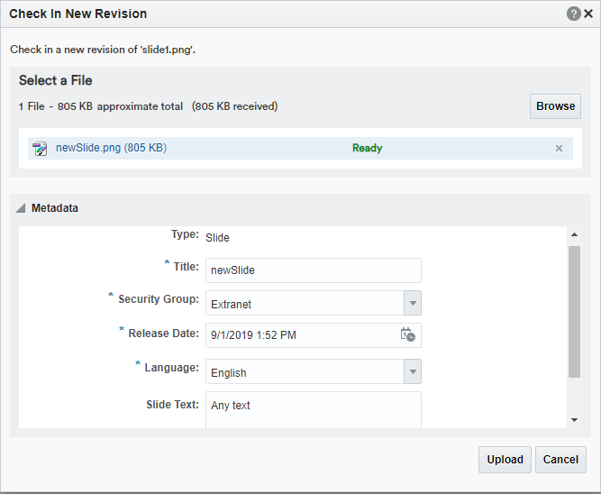

## Update Slides Metadata Only

|  |  |
| --- | --- |
| Task name | Update Slide |
| Task owner | MOSA Extranet Slide Contributor |
| Description | The contributor will select a Slide item from the Slides list in order to update its metadata. |
| Task preconditions | * The user logs on to the system. * The user is an Extranet Slide contributor. * The file exist in Slides folder. |
| Input | The Slide update form details and data. |
| Output | The Slide update form. |
| Task outcome | Update, Reset, Save. |

|  |  |
| --- | --- |
| Task Main Flow | |
| # | **Actor action** | **System response** |
|  | Click on Slide file name in “Content Management” from Slides folder. | The system will open the selected file in “Content Previewer” page. |
|  | Click on “Edit” in “Content Previewer” page (Metadata tab) | The system will switch the form into edit mode. |
|  | Update the metadata as needed and click “Save” | The system stores the new updates. |

|  |  |
| --- | --- |
| Task exceptional Flow | |
| # | **Actor action** | **System response** |
|  | If the user select “cancel” in any stage during the update | The system will switch the form into read-only mode and will be ignored and reverted back to its initial values. |
|  | If the user select “Reset” in any stage during the update | The changes will be ignored and reverted back to its initial values. |

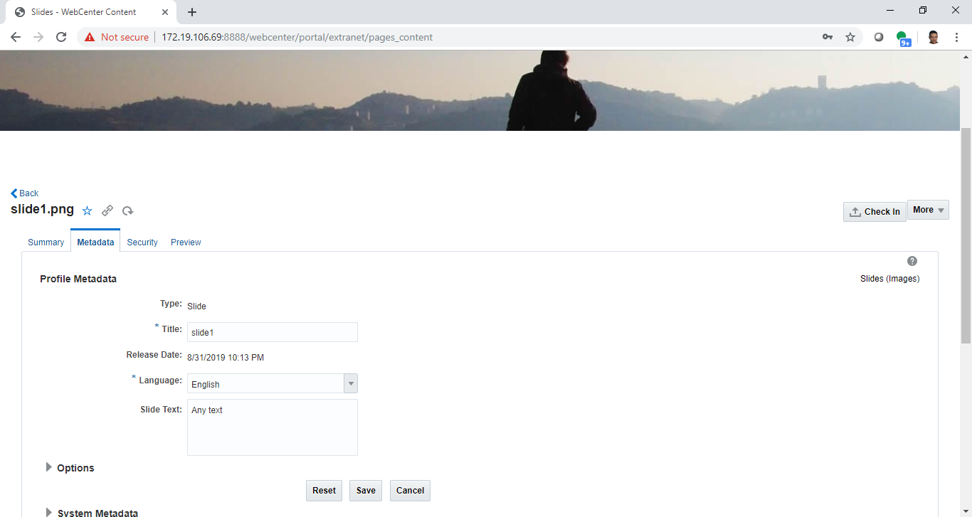

## Delete Slides

|  |  |
| --- | --- |
| Task name | Update Slide |
| Task owner | MOSA Extranet Slide Contributor |
| Description | The contributor will select a Slide item from the Slides list in order to delete it. |
| Task preconditions | * The user logs on to the system. * The user is an Extranet Slide contributor. * The file exist in Slides folder. * The file is not in a workflow. |
| Input | The Slide to be deleted. |
| Output | The Slide removed. |
| Task outcome | Delete, Cancel. |

|  |  |
| --- | --- |
| Task Main Flow | |
| # | **Actor action** | **System response** |
|  | Select Slide item checkbox from the slides list in the content manager. | The slide item checkbox is selected and the controls of the allowed actions (including item delete) for the single selected item will be displayed. |
|  | Click on “delete” icon control on the top of slides list in the content manager. | The system will prompt with the delete confirmation dialog popup. |
|  | **Or** click on the slide item name at the slides list in the content manager. | The system will open the selected slide item in the content previewer page. |
|  | Select delete from the dropdown control “More” in the content previewer page. | The system will prompt with the delete confirmation dialog popup. |
|  | Click on “Yes” to delete the item. | The item deleted. |

|  |  |
| --- | --- |
| Task exceptional Flow | |
| # | **Actor action** | **System response** |
|  | If the user tried to delete a slide item in the workflow | The system will prompt with an error message telling that the item in the workflow and it cannot be deleted. |
|  | If the user select “No” in delete confirmation dialog popup | The popup closed and the slide item remain in the list. |

Alternative1:

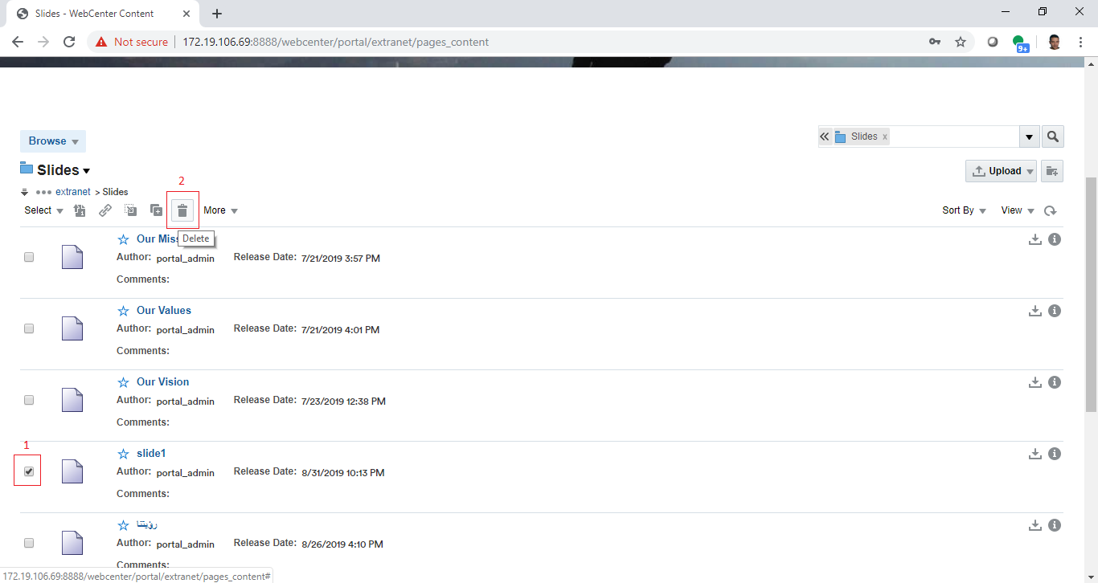

Alternative2: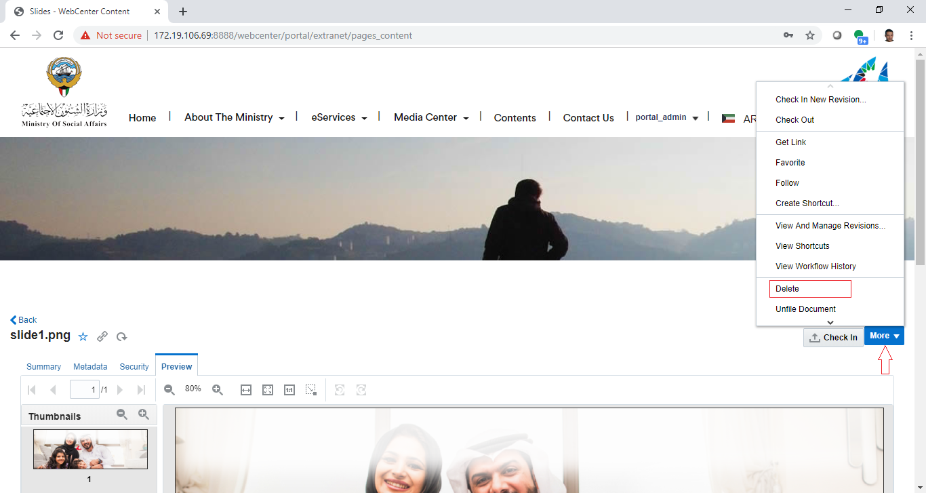

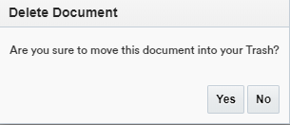

Workflow

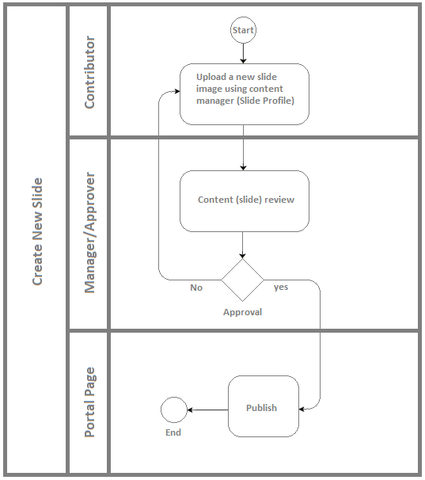

Developers & Contributors Tasks to Enable the Service

|  |  |  |
| --- | --- | --- |
| **Task** | **Application** | **Responsibility of** |
| Add Content Information Fields for Slides | Webcenter Content | Content Administrator |
| Group Slide Fields in Content Rule | Webcenter Content | Content Administrator |
| Create a Content Profile for Slide Including the Content Rule | Webcenter Content | Content Administrator |
| Create a Content Presenter for Slide | Webcenter Portal | Portal Administrator |
| Create a Page and Add the Content Presenter for Slide | Webcenter Portal | Content Contributor |
| Publish the Page for Users | Webcenter Portal | Content Contributor |

Updates Log