**functional requirements document**

|  |  |  |  |  |  |
| --- | --- | --- | --- | --- | --- |
| **Project Name** | : | MoSA Portal | **Date** | : | 30/Jun/2019 |
| **Requirement #** | : |  | **Created by** | : | Shakboua Zaid |

Requirement Title

Extranet – Menu Navigation

Detailed Description

A rich full-width multileveled navigation area that reflects the pages navigation model in Webcenter portal. It is a large panel of content which is displayed below first-level menu item when the user clicks over.

Mega Menus can contain sub menu items, images, or maybe widgets.

When any of the first level menu items that have sub-menus clicked, a full-width sub-menu container will be collapsed. All related sub-menus (all levels) will be displayed.

Requirements

Menu navigation is a Webcenter Portal native service (OOTB service), it is a set of links for portals, pages, external links, content item(s), or folders stored as data rows in Webcenter schema table and customization in MDS.

Use Cases

## Access Navigation Menu Administration

|  |  |
| --- | --- |
| Task name | Access Navigation Menu Administration |
| Task owner | MOSA Extranet Page Contributor |
| Description | The contributor will access the navigation menu administration in order to create a new, update, or delete an item (page or folder) in the navigation menu. |
| Task preconditions | * The user logs on to the system. * The user is an Extranet Page contributor. |
| Input | The Administration Link. |
| Output | The Navigation Menu Administration screen (Editor). |
| Task outcome | -- |

|  |  |
| --- | --- |
| Task Main Flow | |
| # | **Actor action** | **System response** |
|  | From the username submenu click “Administration”. | The system will open the portal general setting page in the administration. |
|  | From the sidebar navigation in general settings page in the administration (or any page in the administration) select “Edit Portal” icon. | The system will switch to the Portal Editor and open the root item (ex. extranet home page) in edit mode with the list of navigation items collapsed. |
|  | Click on the same icon (the tooltip of this icon ‘Edit Portal’ will be changed into ‘pages’) to expand the navigation items list. | The system will keep the selected page opened in edit mode and show the list of all navigation items. |
|  | Select the needed navigation item. | The system will switch to the selected page and open it in edit mode and close the previously selected item. |
|  | To switch to page information mode click on the page and expand the page menu and select “page Information”.  Note 1: In Edit Mode, you can add/remove content to the page from the resource catalog, in Information Mode, you can update page information like title, target frame, page icon if needed, the security for this page if it require additional security specification, and the code source of the page.  Note 2: if the selected item is not a page (ex. link, folder, or content item), the system will open the item information automatically as these items are editable using the page editor. | The system will switch to page information mode. |

|  |  |
| --- | --- |
| Task exceptional Flow | |
| # | **Actor action** | **System response** |
|  | If the user leaved the administration by clicking “View Portal” or by clicking the icon for “Portals List” | Navigate away from the portal administration. |

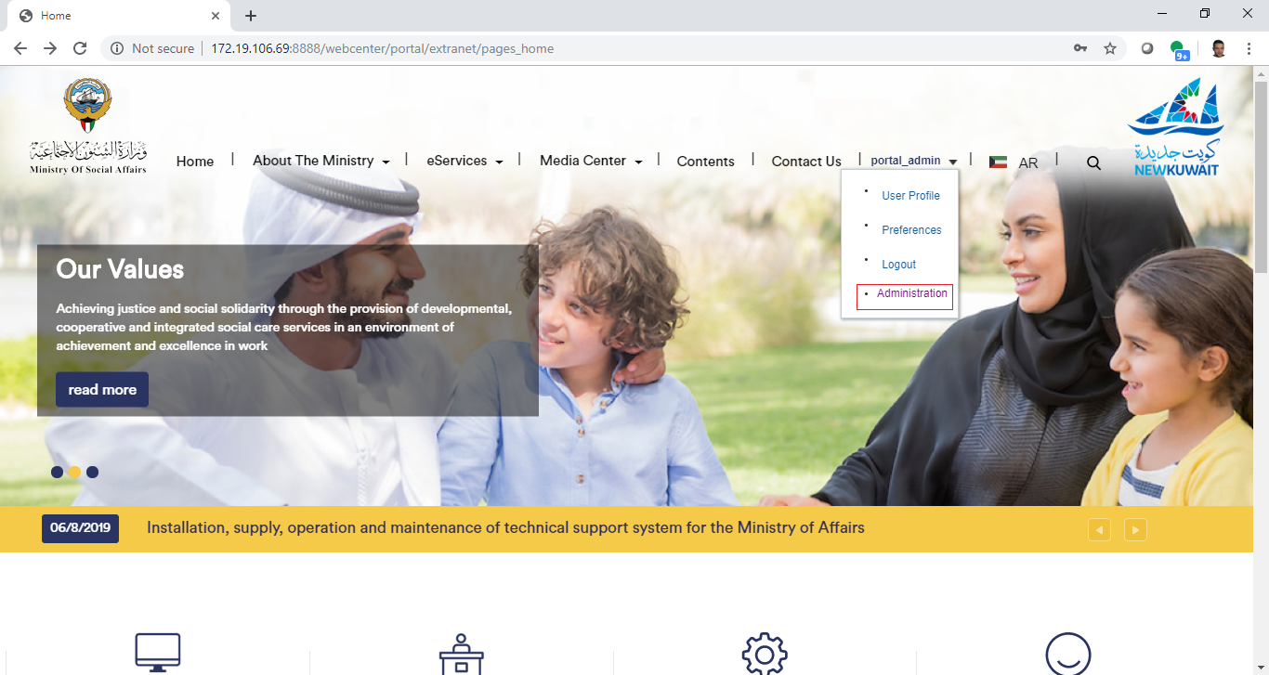

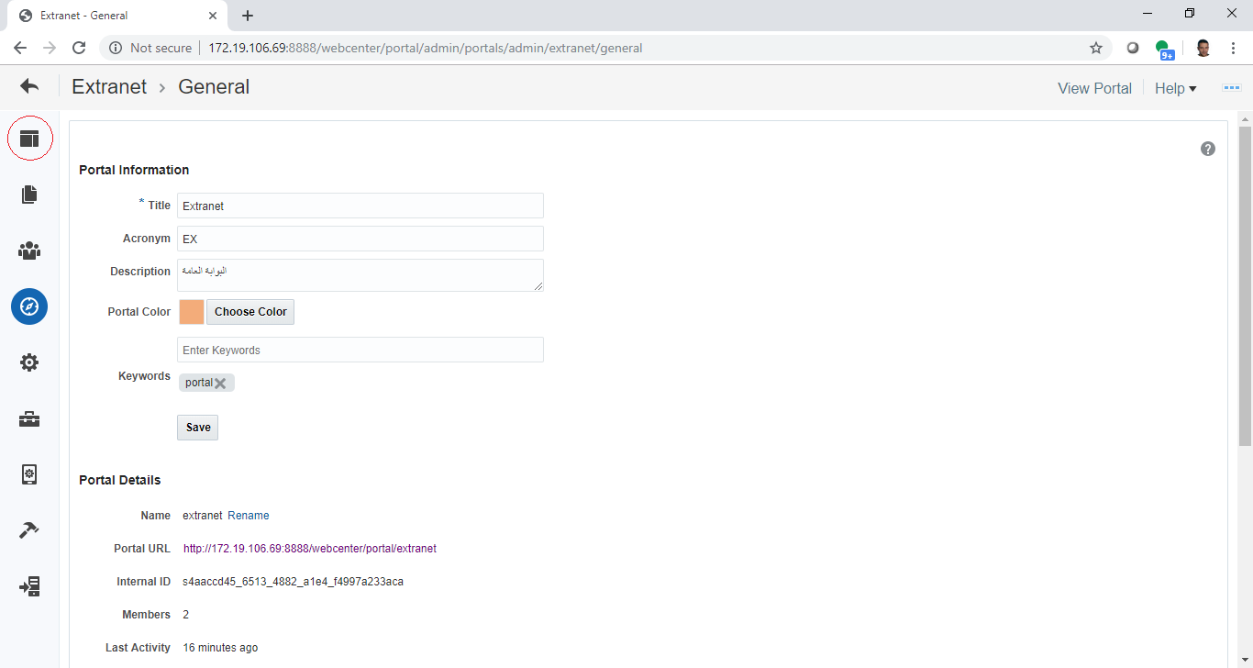

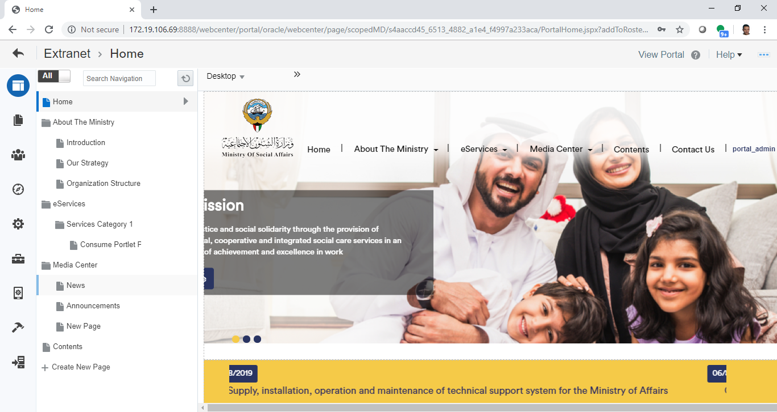

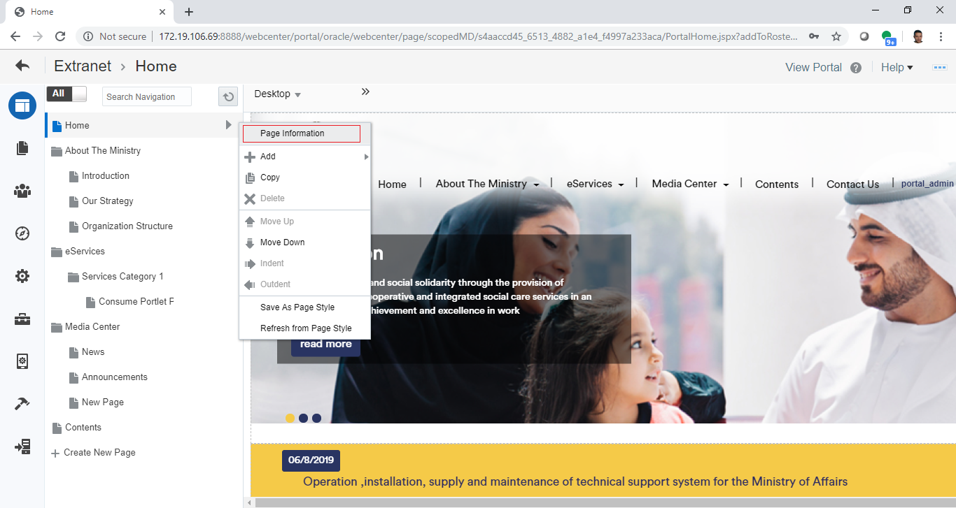

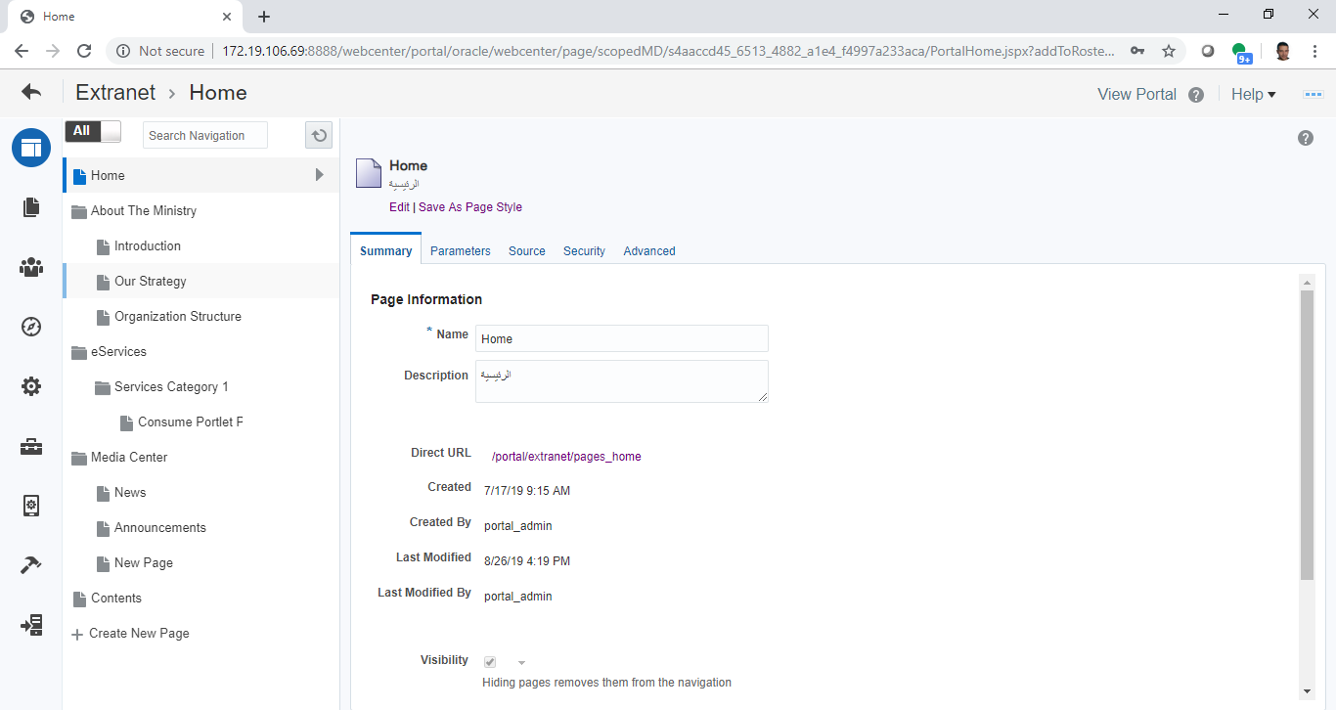

## Create New Menu (New Page)

|  |  |
| --- | --- |
| Task name | Create New Menu (New Page) |
| Task owner | MOSA Extranet Page Contributor |
| Description | The contributor will create a new page in the navigation menu. |
| Task preconditions | * The user logs on to the system. * The user is an Extranet Page contributor. |
| Input | The “Create new page” wizard. |
| Output | The page. |
| Task outcome | Create Page, Cancel. |

|  |  |
| --- | --- |
| Task Main Flow | |
| # | **Actor action** | **System response** |
|  | From the menu editor click “Create New Page”, or select “Add” from the actions menu of a page then select “New Page” | The system will prompt with the New Page editor. |
|  | Choose one of the available page styles where:   * Extranet Home Page style is consist of a slider and announcements strip at the top of the page, an area for content in the middle, and a footer underneath. * Article Page style consist of a banner at the top, an area for breadcrumbs showing the current location of the page in the navigation, an area for content in the middle, and a footer underneath. * Blank Page style consist of an area for content at the top, an area for breadcrumbs showing the current location of the page in the navigation, an area for content in the middle, and a footer underneath. * List Page style consist of a banner at the top, an area for breadcrumbs showing the current location of the page in the navigation, an area for content in the middle divided into 2 columns one for related pages list and content search and the other for content list, and a footer underneath. * Blog for blogs * Wiki for Wikis | -- |
|  | enter the page name (for English page title), enter page description (for Arabic page title), change the page name in the URL as needed, optionally enter keywords (helpful for search), and select to show or hide the link (visible) | -- |
|  | Select “Set Permissions” to set the security settings for the newly created page | The system will prompt with the Page Permissions editor. |
|  | Click on “Back to Create Page” to go back and complete page creation then click “Create Page” | The new page created and placed at the top level. |
|  |  |  |

|  |  |
| --- | --- |
| Task exceptional Flow | |
| # | **Actor action** | **System response** |
|  | If the user select “Cancel” in any stage in the main flow | Current changes will be ignored and the page will not be created. |

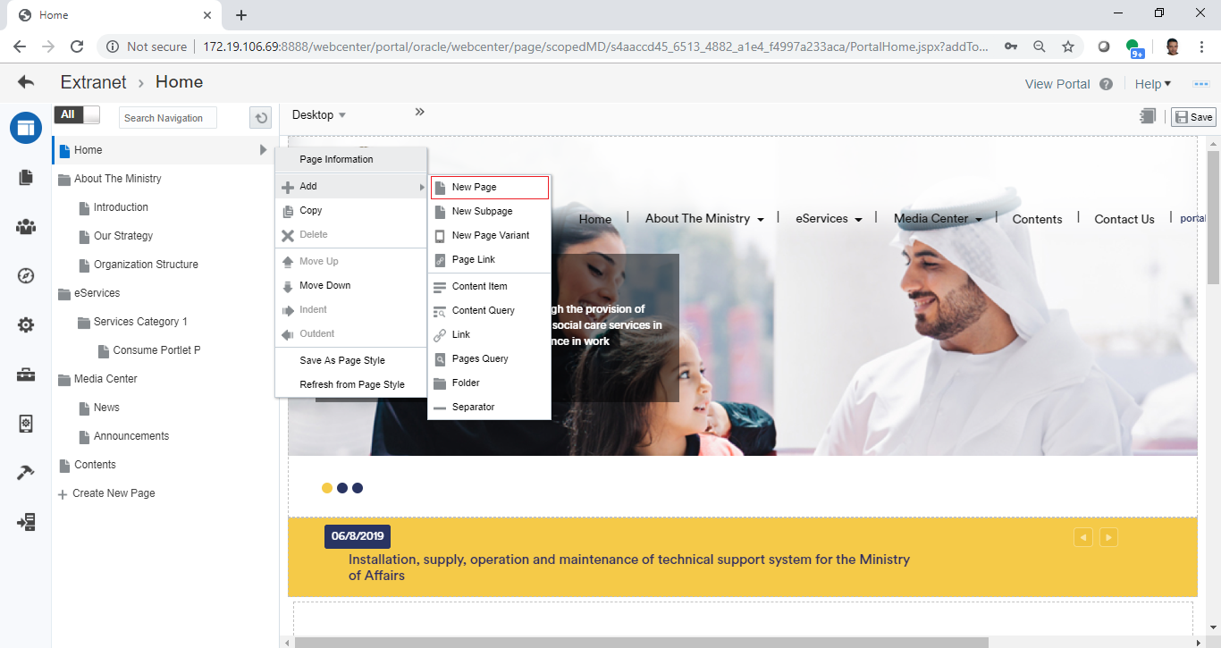

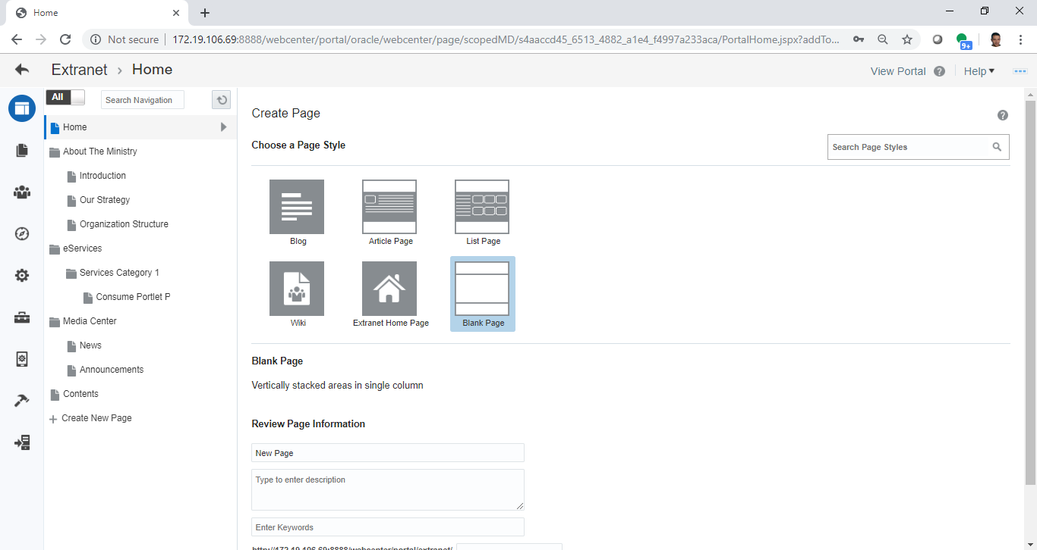

## Create New Menu (New Link)

|  |  |
| --- | --- |
| Task name | Create New Menu (New Link) |
| Task owner | MOSA Extranet Page Contributor |
| Description | The contributor will create a new link in the navigation menu. |
| Task preconditions | * The user logs on to the system. * The user is an Extranet Page contributor. |
| Input | The “Create Navigation Item – HTTP Link” popup. |
| Output | The navigation item – link created. |
| Task outcome | Ok, Cancel. |

|  |  |
| --- | --- |
| Task Main Flow | |
| # | **Actor action** | **System response** |
|  | Select “Add” from the actions menu of a page then select “Link” | The system will prompt with the Create Navigation Item – HTTP Link popup |
|  | At the Create Navigation Item – HTTP Link popup (Target tab) enter the link ID, the link name (for English link title), enter link description (for Arabic link title), select to show or hide the link (visible), and the destination URL | -- |
|  | At the Create Navigation Item – HTTP Link popup (Options tab) set the option for this link | -- |
|  | At the Create Navigation Item – HTTP Link popup (parameters tab) set the parameters (if any) for this link | -- |
|  | Click “Ok” | The new link created and placed at the selected level. |

|  |  |
| --- | --- |
| Task exceptional Flow | |
| # | **Actor action** | **System response** |
|  | If the user select “Cancel” in any stage in the main flow | Current changes will be ignored and the link will not be created. |

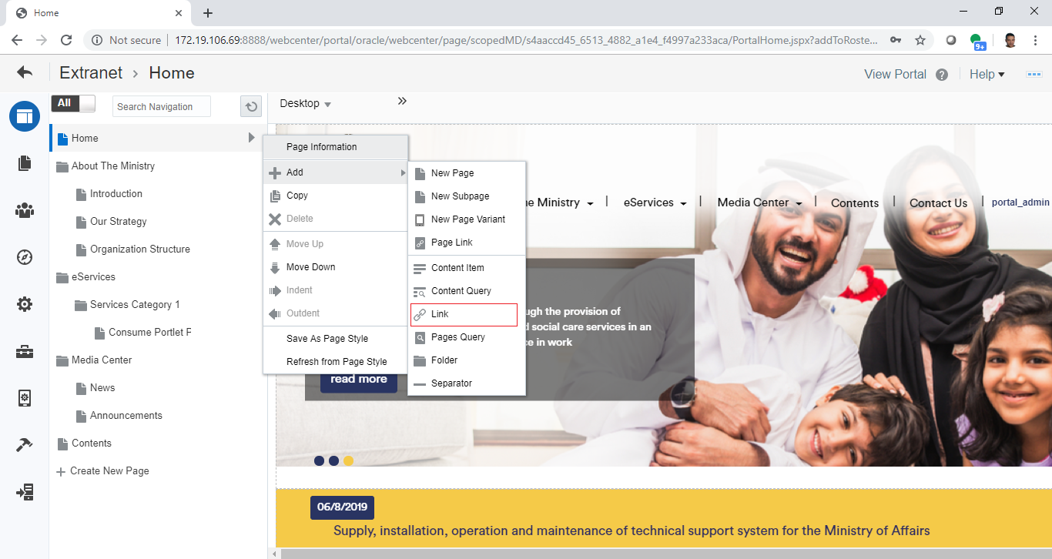

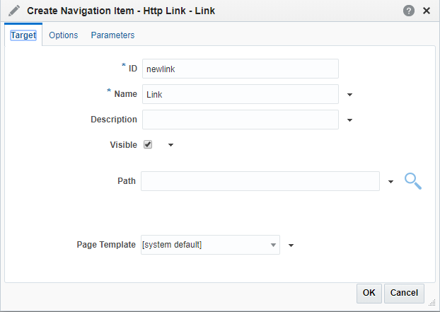

## Create New Menu (New Content Item)

|  |  |
| --- | --- |
| Task name | Create New Menu (New Content Item ) |
| Task owner | MOSA Extranet Page Contributor |
| Description | The contributor will create a new content item in the navigation menu. |
| Task preconditions | * The user logs on to the system. * The user is an Extranet Page contributor. * A connection to the content repository is enabled for this portal. |
| Input | The “Create Navigation Item – Content item” popup. |
| Output | The navigation item – content item created. |
| Task outcome | Ok, Cancel. |

|  |  |
| --- | --- |
| Task Main Flow | |
| # | **Actor action** | **System response** |
|  | Select “Add” from the actions menu of a page then select “Content item” | The system will prompt with the Create Navigation Item – Content Item popup |
|  | At the Create Navigation Item – Content Item popup (Target tab) enter the link ID, the content item name (for English content item title), enter link description (for Arabic content item title), select to show or hide the content item (visible), find & select the content item from the content repository, and optionally select the content presenter template to display this content item | -- |
|  | At the Create Navigation Item – Content Item popup (Options tab) set the option for this content item | -- |
|  | At the Create Navigation Item – Content Item popup (parameters tab) set the parameters (if any) for this content item | -- |
|  | Click “Ok” | The new content item created and placed at the selected level. |

|  |  |
| --- | --- |
| Task exceptional Flow | |
| # | **Actor action** | **System response** |
|  | If the user select “Cancel” in any stage in the main flow | Current changes will be ignored and the content item will not be created. |

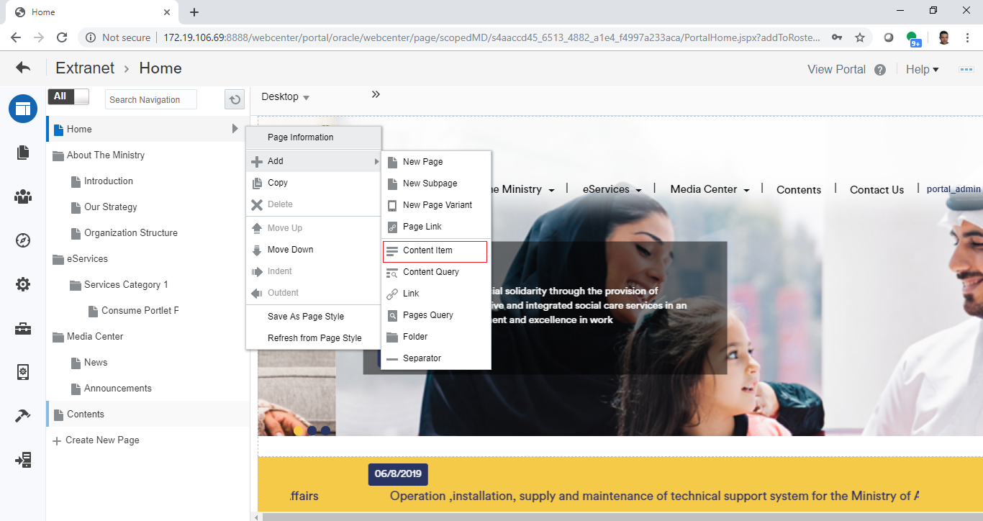

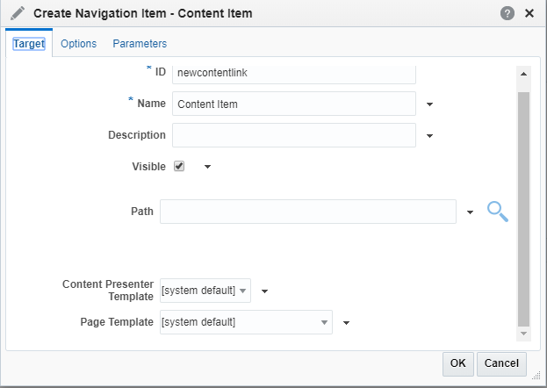

## Create New Folder (Group of Menu Items)

|  |  |
| --- | --- |
| Task name | Create New Menu (New Content Item ) |
| Task owner | MOSA Extranet Page Contributor |
| Description | The contributor will create a new folder in the navigation menu. |
| Task preconditions | * The user logs on to the system. * The user is an Extranet Page contributor. |
| Input | The “Create Navigation Item – Folder” popup. |
| Output | The navigation item – folder created. |
| Task outcome | Ok, Cancel. |

|  |  |
| --- | --- |
| Task Main Flow | |
| # | **Actor action** | **System response** |
|  | Select “Add” from the actions menu of a page then select “Folder” | The system will prompt with the Create Navigation Item – Folder popup |
|  | At the Create Navigation Item – Folder popup (Target tab) enter the folder ID, the content item name (for English content item title), enter link description (for Arabic content item title), and select to show or hide the folder (visible). | -- |
|  | At the Create Navigation Item – Folder popup (Options tab) set the option for this Folder. | -- |
|  | At the Create Navigation Item – Folder popup (Parameters tab) set the parameters (if any) for this Folder. | -- |
|  | Click “Ok” | The new content item created and placed at the selected level. |

|  |  |
| --- | --- |
| Task exceptional Flow | |
| # | **Actor action** | **System response** |
|  | If the user select “Cancel” in any stage in the main flow | Current changes will be ignored and the folder will not be created. |

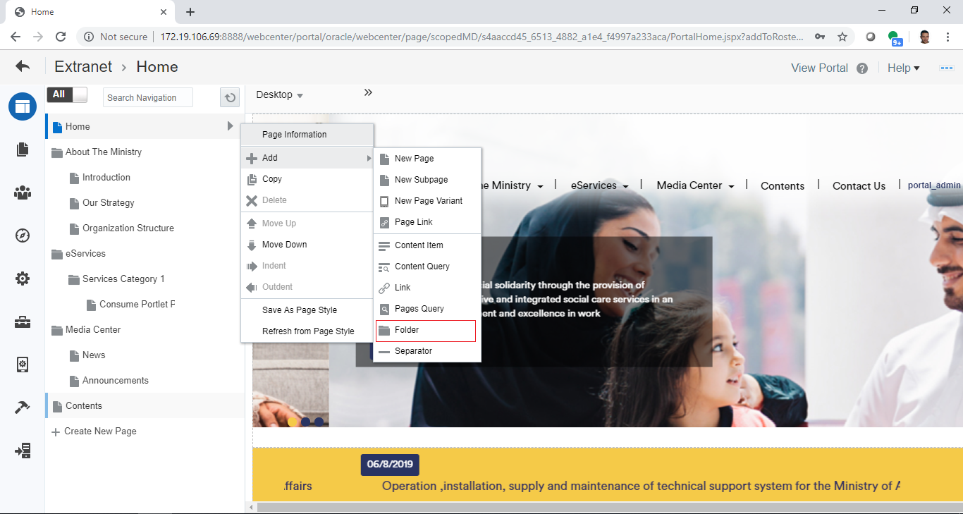

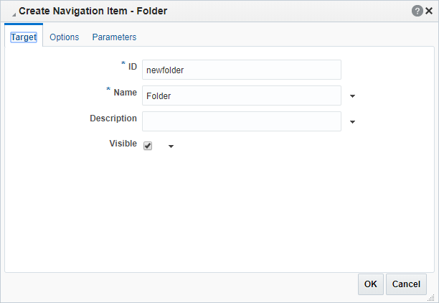

## Create New Mega-Menu Folder (Service Category and Services Items)

|  |  |
| --- | --- |
| Task name | Create New Menu (New Content Item ) |
| Task owner | MOSA Extranet Page Contributor |
| Description | The contributor will create a new folder in the navigation menu. |
| Task preconditions | * The user logs on to the system. * The user is an Extranet Page contributor. |
| Input | The “Create Navigation Item – Folder” popup. |
| Output | The navigation item – folder created. |
| Task outcome | Ok, Cancel. |

|  |  |
| --- | --- |
| Task Main Flow | |
| # | **Actor action** | **System response** |
|  | Select “Add” from the actions menu of a page then select “Folder” | The system will prompt with the Create Navigation Item – Folder popup |
|  | At the Create Navigation Item – Folder popup (Target tab) enter the folder ID, the content item name (for English content item title), enter link description (for Arabic content item title), and select to show or hide the folder (visible). | -- |
|  | At the Create Navigation Item – Folder popup (Options tab) set the option for this Folder.  *Note 1: for mega-menu folders, it is a must to add the attribute “****menu-style****” with the value “****mega-menu****” at the root folder (ex. eServices) of this menu.*  *Note 2: for submenu items in a mega-menu folder (ex. Service Category), each sub-folder can have a specific number of columns by adding the attribute “****reserved-cols****” with the value “[****2, 4, 6, …, or 12****]” that will be considered as the width of this category when rendered where a row in the mega-menu will be divided by the specified value, else, the row will be divided by 4 automatically.* | -- |
|  | At the Create Navigation Item – Folder popup (Parameters tab) set the parameters (if any) for this Folder. | -- |
|  | Click “Ok” | The new content item created and placed at the selected level. |

|  |  |
| --- | --- |
| Task exceptional Flow | |
| # | **Actor action** | **System response** |
|  | If the user select “Cancel” in any stage in the main flow | Current changes will be ignored and the folder will not be created. |





**Hint: Here you’ve finished creating the mega-menu with the categories inside, you can start adding the services as regular pages and add the services portlets inside these regular pages.**

## Delete Navigation Item from the Menu

|  |  |
| --- | --- |
| Task name | Delete Navigation Item from the Menu |
| Task owner | MOSA Extranet Page Contributor |
| Description | The contributor will place the navigation item in the navigation menu. |
| Task preconditions | * The user logs on to the system. * The user is an Extranet Page contributor. * The navigation item is exist and not the only one in the navigation menu. * The navigation item is not the root node ( home page) |
| Input | The navigation item. |
| Output | The navigation item removed. |
| Task outcome | Delete, Cancel. |

|  |  |
| --- | --- |
| Task Main Flow | |
| # | **Actor action** | **System response** |
|  | Select the navigation item in the menu navigation | The navigation item is selected and the system open the navigation item in edit mode (information mode for non-displayable items like links and content items). |
|  | Click on the page and expand the page menu and select “Delete”. | The system will prompt with the delete confirmation dialog. |
|  | **Or**, switch to Information Mode and select “Delete” from the options under the page title. | The system will prompt with the delete confirmation dialog. |
|  | Click on “Delete” in the delete confirmation dialog. | The page will be deleted. |

|  |  |
| --- | --- |
| Task exceptional Flow | |
| # | **Actor action** | **System response** |
|  | If the user select “Cancel” in the delete confirmation dialog | The page remains and the dialog close. |

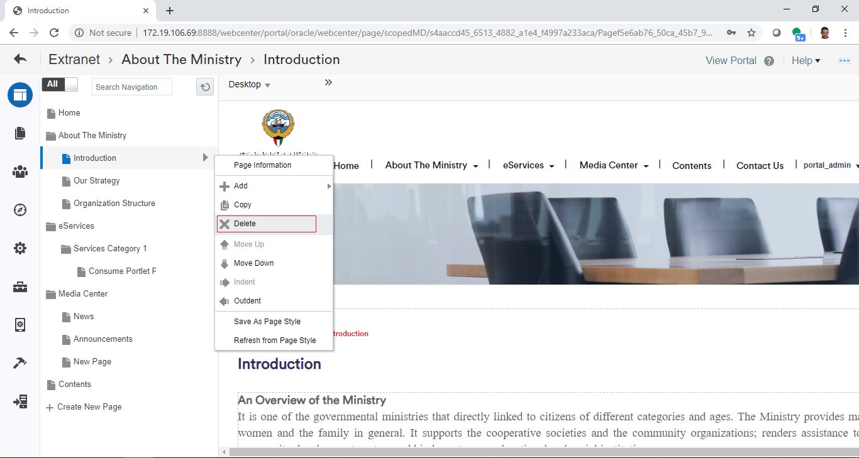

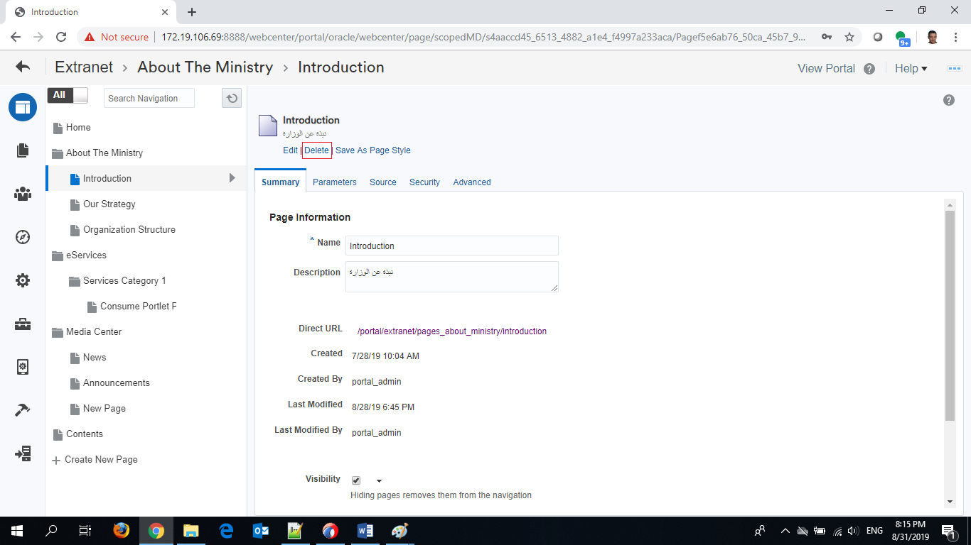

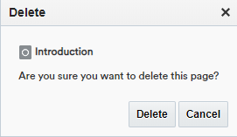

## Place Navigation Item in the Menu

|  |  |
| --- | --- |
| Task name | Place Navigation Item in the Menu |
| Task owner | MOSA Extranet Page Contributor |
| Description | The contributor will place the navigation item in the navigation menu. |
| Task preconditions | * The user logs on to the system. * The user is an Extranet Page contributor. * The navigation item is exist and not the only one in the navigation menu. |
| Input | The navigation item. |
| Output | The navigation item placed. |
| Task outcome | Move Up, Move down, Indent, Outdent. |

|  |  |
| --- | --- |
| Task Main Flow | |
| # | **Actor action** | **System response** |
|  | Select the navigation item in the menu navigation | The navigation item is selected and the system open the navigation item in edit mode (information edit mode for non-displayable items like links and content items). |
|  | Select “Move Up” from the actions menu of a navigation item to move the page up | The navigation item will be moved up inside the menu. |
|  | Select “Move Down” from the actions menu of a navigation item to move the navigation item down | The navigation item will be moved down inside the menu. |
|  | Select “Indent” from the actions menu of a navigation item to move the navigation item level down | The navigation item will be moved a level down inside the menu. |
|  | Select “Outdent” from the actions menu of a navigation item to move the navigation item level up | The navigation item will be moved a level up inside the menu. |

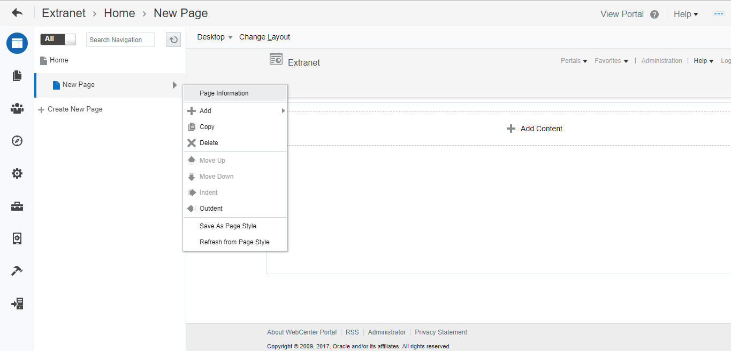

Developers & Contributors Tasks to Enable the Service

|  |  |  |
| --- | --- | --- |
| **Task** | **Application** | **Responsibility of** |
| Create a Page or Folder | Webcenter Portal | Page Contributor |
| Place the pages and folders in the menu | Webcenter Portal | Page Contributor |
| Publish the Page for Users | Webcenter Portal | Page Contributor |

Updates Log