**functional requirements document**

|  |  |  |  |  |  |
| --- | --- | --- | --- | --- | --- |
| **Project Name** | : | MoSA Portal | **Date** | : | 01/Jul/2019 |
| **Requirement #** | : |  | **Created by** | : | Shakboua Zaid |

Requirement Title

Intranet - Wikis

Detailed Description

Wikis provide the ministry with the power to write about the topics and subjects that relates to the ministry business and services.

Intranet (employee) users will be able to read this type of content without any special privileges as it is public content.

Requirements

Wikis functionality in WebCenter Portal requires that Content Server is the content repository. However, it is important to be aware that wikis are managed by WebCenter Portal, not by Content Server. Thus, folder settings in Content Server have no effect. For example, specifying a default profile on a Content Server folder in which wikis are stored has no effect on the creation of new wiki documents in that folder.

Use Cases

## Create New Wiki

|  |  |
| --- | --- |
| Task name | Create New wiki |
| Task owner | MOSA Intranet Content Contributor |
| Description | The contributor will create a new portal page using the page style “Wiki”. |
| Task preconditions | * The user logs on to the system. * The user is an Intranet contributor. |
| Input | New page with page style “Wiki”. |
| Output | Wiki page. |
| Task outcome | Create Page, Cancel. |

|  |  |
| --- | --- |
| Task Main Flow | |
| # | **Actor action** | **System response** |
|  | Select “Create Page” from the portal editing dropdown control at the top right of the portal | The system will prompt with the page style selection page. |
|  | Select the page style “Wiki” and click “Use This” | The system open the new page wizard. |
|  | At the page information (first step), enter the page name (for English page title), enter page description (for Arabic page title) and click “Next” | The wizard will forward to the next step. |
|  | Set the desired layout for this wiki (page) then click “Next” | The wizard will forward to the final step. |
|  | Set the security settings for the wiki (page) then click “Create” | The new Wiki page is created, a folder containing all the posts in this wiki is also created at the content repository |

|  |  |
| --- | --- |
| Task exceptional Flow | |
| # | **Actor action** | **System response** |
|  | If the user select “Cancel” in any step | The new page wizard closed. |

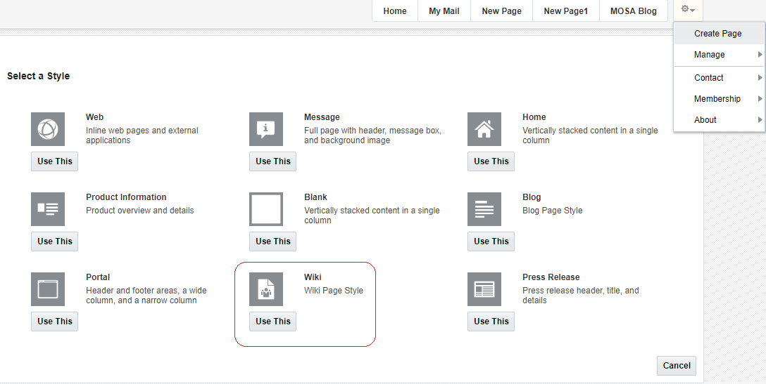

## Edit Wiki

|  |  |
| --- | --- |
| Task name | Create Wiki |
| Task owner | MOSA Intranet Content Contributor |
| Description | The contributor will edit the wiki. |
| Task preconditions | * The user logs on to the system. * The user is an Intranet contributor. |
| Input | The wiki. |
| Output | The wiki updated. |
| Task outcome | Edit, Save, Cancel. |

|  |  |
| --- | --- |
| Task Main Flow | |
| # | **Actor action** | **System response** |
|  | Select “Edit” from the wiki page header | The system will open the wiki in the editor (Rich Text Editor). |
|  | Edit the content of this wiki (WYSIWYG mode or HTML mode) then click “Save” | The system update the wiki. |

|  |  |
| --- | --- |
| Task exceptional Flow | |
| # | **Actor action** | **System response** |
|  | If the user select “Cancel” in any step | The wiki did not changed and the editor closed. |

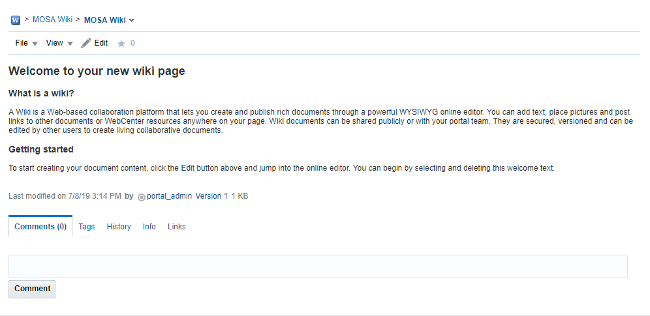

Developers & Contributors Tasks to Enable the Service

|  |  |  |
| --- | --- | --- |
| **Task** | **Application** | **Responsibility of** |
| Create a Page Using “Wikis” Page Style | Webcenter Portal | Content Contributor |
| Publish the Page for Users | Webcenter Portal | Content Contributor |

Updates Log