**functional requirements document**

|  |  |  |  |  |  |
| --- | --- | --- | --- | --- | --- |
| **Project Name** | : | MoSA Portal | **Date** | : | 30/Jun/2019 |
| **Requirement #** | : |  | **Created by** | : | Shakboua Zaid |

Requirement Title

Extranet – Message Board & Publisher

Detailed Description

Message Board & publisher is considered as the timeline of the intranet (employee) users. They will be provided with the ability to post a message, attach links and files.

Users can share, like/unlike, or comment on messages in the message board, message board show all the messages by user’s connections.

Requirements

Message Board & Publisher is a Webcenter Portal native service (OOTB service), it is a set of messages stored as data rows in Webcenter schema table and customization in MDS.

Use Cases

## Post a New Message

|  |  |
| --- | --- |
| Task name | Post a New Message |
| Task owner | MOSA Intranet User (employee) |
| Description | The user will post a message. |
| Task preconditions | * The user logs on to the system. * The user is an Intranet user. |
| Input | The message text. |
| Output | Message posted. |
| Task outcome | Publish. |

|  |  |
| --- | --- |
| Task Main Flow | |
| # | **Actor action** | **System response** |
|  | Enter the text in the message box | -- |
|  | Choose from the dropdown control to publish this message for “Everyone” or “Portals” (for a specific portal users) | The option is selected and the dropdown control text changed to the selected value. |
|  | Click “Publish” to post this message | The system publish this message then the message appeared in the user’s connections activity streams (timelines). |

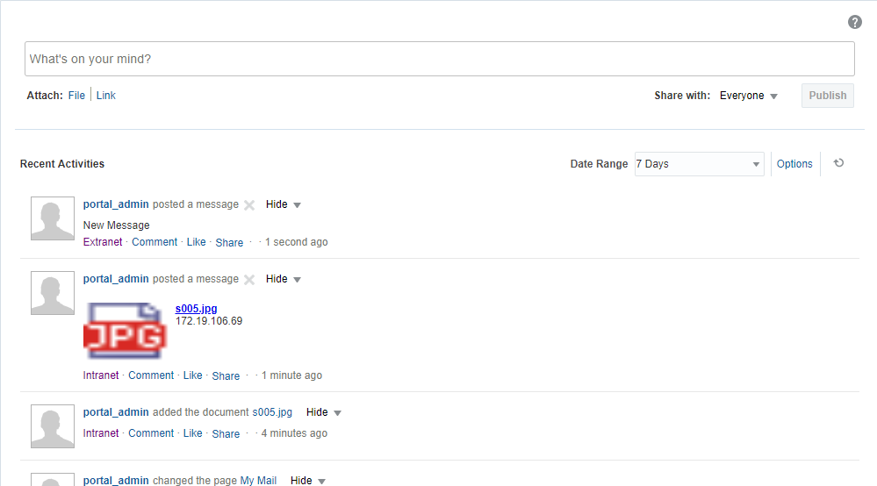

## Attach Files

|  |  |
| --- | --- |
| Task name | Attach Files |
| Task owner | MOSA Intranet User (employee) |
| Description | The user will attach file(s). |
| Task preconditions | * The user logs on to the system. * The user is an Intranet user. |
| Input | The file(s). |
| Output | The file(s) uploaded and published. |
| Task outcome | File, Cancel (icon). |

|  |  |
| --- | --- |
| Task Main Flow | |
| # | **Actor action** | **System response** |
|  | Click on “File” to attach a file | The system switch the publisher into content Uploader. |
|  | Drop file(s) inside the area or [select file](http://172.19.106.69:8888/webcenter/portal/intranet/pages_mymail?Adf-Window-Id=zivn0jw3f&Adf-Page-Id=44)(s) from your desktop and click “Upload” | The files will be uploaded to the user’s personal drive. |
|  | Click “Publish” to publish the attached file | The system publish this file then the file appeared in the user’s connections activity streams (timelines). |

|  |  |
| --- | --- |
| Task exceptional Flow | |
| # | **Actor action** | **System response** |
|  | If the user select “Cancel (icon)” in any stage in the main flow | The content Uploader switch back into publisher. |

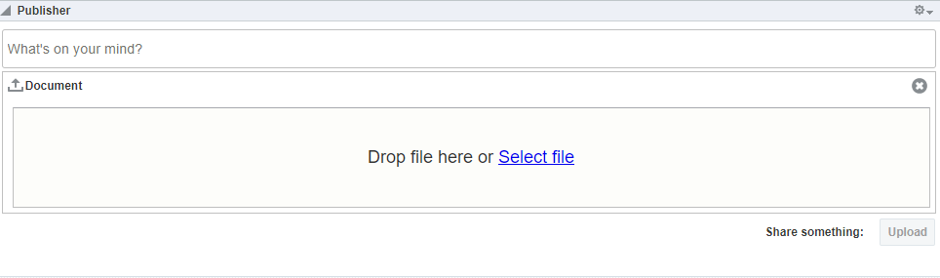

## Attach Links

|  |  |
| --- | --- |
| Task name | Attach Links |
| Task owner | MOSA Intranet User (employee) |
| Description | The user will attach link. |
| Task preconditions | * The user logs on to the system. * The user is an Intranet user. |
| Input | The link URL text. |
| Output | The link attached and published. |
| Task outcome | Link, Cancel (icon). |

|  |  |
| --- | --- |
| Task Main Flow | |
| # | **Actor action** | **System response** |
|  | Click on “Link” to attach a link | The system display text box for link URL on top of the publisher. |
|  | Enter the URL in the text box and click “Attach” | The system prepare the link (evaluate if the URL is qualified and add ‘http://’ if missing). |
|  | Click “Publish” to publish the attached link | The system publish this link then the link appeared in the user’s connections activity streams (timelines). |

|  |  |
| --- | --- |
| Task exceptional Flow | |
| # | **Actor action** | **System response** |
|  | If the user select “Cancel (icon)” in any stage in the main flow | The text box for link switch back into publisher. |

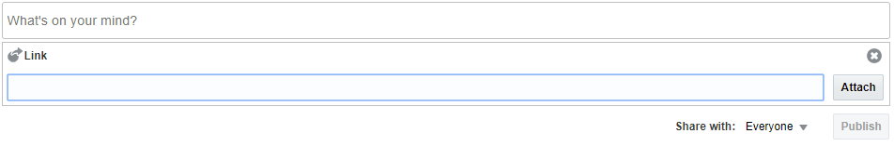

## Comment on a Post

|  |  |
| --- | --- |
| Task name | Comment on a Post |
| Task owner | MOSA Intranet User (employee) |
| Description | The user will comment on a post. |
| Task preconditions | * The user logs on to the system. * The user is an Intranet user. |
| Input | The comment text. |
| Output | The comment added and published. |
| Task outcome | Comment, Cancel (icon). |

|  |  |
| --- | --- |
| Task Main Flow | |
| # | **Actor action** | **System response** |
|  | Click on “Comment” under a post | The system display text box for comment. |
|  | Enter the comment in the text box and click “Comment” | The system publish the comment then the comment appeared in the user’s connections activity streams (timelines). |

|  |  |
| --- | --- |
| Task exceptional Flow | |
| # | **Actor action** | **System response** |
|  | If the user select “Cancel (icon)” in any stage in the main flow | The text box for comment closed. |

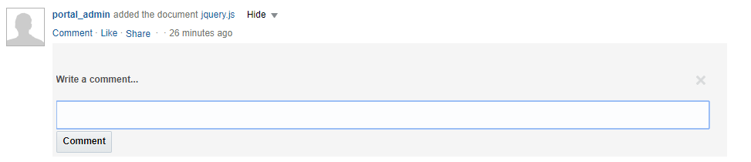

## Share a Post

|  |  |
| --- | --- |
| Task name | Share a Post |
| Task owner | MOSA Intranet User (employee) |
| Description | The user will share a post. |
| Task preconditions | * The user logs on to the system. * The user is an Intranet user. |
| Input | The post to share. |
| Output | The post shared and published. |
| Task outcome | Share. |

|  |  |
| --- | --- |
| Task Main Flow | |
| # | **Actor action** | **System response** |
|  | Click on “Share” under a post | The system display a mini popup to sharing option. |
|  | Select “This Activity” to share the post into the user’s activity streams (timelines), or “Send Mail” to share the post by mail. | The option selected and the system will prompt with the selected tool popup. |
|  | If you select “This Activity” | The system will use the Share popup |
|  | If you select “Send Mail” | The system will prompt with the default mail tool |
|  | Enter the message for the new post (shared) and click “Share” | The system will publish the new post including the shared post. |

|  |  |
| --- | --- |
| Task exceptional Flow | |
| # | **Actor action** | **System response** |
|  | If the user select “Cancel (icon)” in any stage in the main flow | The popup closed. |

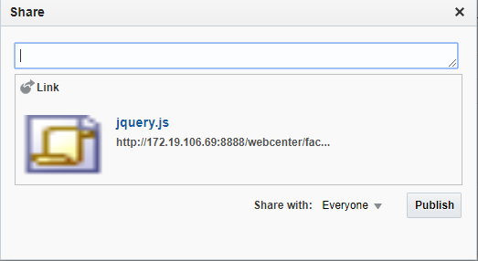

Developers & Contributors Tasks to Enable the Service

|  |  |  |
| --- | --- | --- |
| **Task** | **Application** | **Responsibility of** |
| Create a Page and Add Message Board & Publisher service. | Webcenter Portal | Portal Contributor |
| Configure the Service for Portal. | Webcenter Portal | Portal Contributor |
| Publish the Page for Users | Webcenter Portal | Portal Contributor |

Updates Log