**functional requirements document**

|  |  |  |  |  |  |
| --- | --- | --- | --- | --- | --- |
| **Project Name** | : | MoSA Portal | **Date** | : | 30/Jun/2019 |
| **Requirement #** | : |  | **Created by** | : | Shakboua Zaid |

Requirement Title

Extranet - Links

Detailed Description

Links service allow adding an editable set of links, contributors can add, modify, or delete theses links directly (no need to access admin UI).

Links service is integrated to allow adding links for pages, content items, or external URLs.

Requirements

Links is a Webcenter Portal native service (OOTB service), it a set of links stored as data rows in Webcenter schema table and customization in MDS.

Use Cases

## Add Links - Page

|  |  |
| --- | --- |
| Task name | Add Links - page |
| Task owner | MOSA Extranet Portal Contributor |
| Description | The contributor will add links for existing page using the links Manager. |
| Task preconditions | * The user logs on to the system. * The user is an Extranet Portal contributor. |
| Input | The Links Manager for page link popup details and data. |
| Output | The page link created. |
| Task outcome | Ok, Cancel. |

|  |  |
| --- | --- |
| Task Main Flow | |
| # | **Actor action** | **System response** |
|  | Select “Page Link” from the dropdown control “Add Link” in the Links Manager | The system will prompt with the New Page Link dialog. |
|  | Enter name for the link and find & select the page path and click “ok” | The system will create a link for the selected page. |

|  |  |
| --- | --- |
| Task exceptional Flow | |
| # | **Actor action** | **System response** |
|  | If the user select “Cancel” in any stage in the main flow | Current changes will be ignored and the link will not be created. |

## Add Links – External Link

|  |  |
| --- | --- |
| Task name | Add Links – External Link |
| Task owner | MOSA Extranet Portal Contributor |
| Description | The contributor will add links for external link using the links Manager. |
| Task preconditions | * The user logs on to the system. * The user is an Extranet Portal contributor. * The URL for an external link must be added to valid-link-url.xml |
| Input | The Links Manager for external link popup details and data. |
| Output | The external link created. |
| Task outcome | Ok, Cancel. |

|  |  |
| --- | --- |
| Task Main Flow | |
| # | **Actor action** | **System response** |
|  | Select “External Link” from the dropdown control “Add Link” in the Links Manager | The system will prompt with the New External Link dialog. |
|  | Enter name for the link, the URL and click “ok” | The system will create a link for this URL. |

|  |  |
| --- | --- |
| Task exceptional Flow | |
| # | **Actor action** | **System response** |
|  | If the user select “Cancel” in any stage in the main flow | Current changes will be ignored and the link will not be created. |

## Add Links – Content Link

|  |  |
| --- | --- |
| Task name | Add Links – Content Link |
| Task owner | MOSA Extranet Portal Contributor |
| Description | The contributor will add links for external link using the links Manager. |
| Task preconditions | * The user logs on to the system. * The user is an Extranet Portal contributor. * A connection to the content repository is enabled for this portal. * The user has read privilege on the content to be added as link. |
| Input | The Links Manager for content link popup details and data. |
| Output | The content link created. |
| Task outcome | Ok, Cancel. |

|  |  |
| --- | --- |
| Task Main Flow | |
| # | **Actor action** | **System response** |
|  | Select “Content Link” from the dropdown control “Add Link” in the Links Manager | The system will prompt with the New Content Link dialog. |
|  | Enter name for the link and find from the content repository & select the content path and click “ok” | The system will create a link for the selected content. |

|  |  |
| --- | --- |
| Task exceptional Flow | |
| # | **Actor action** | **System response** |
|  | If the user select “Cancel” in any stage in the main flow | Current changes will be ignored and the link will not be created. |

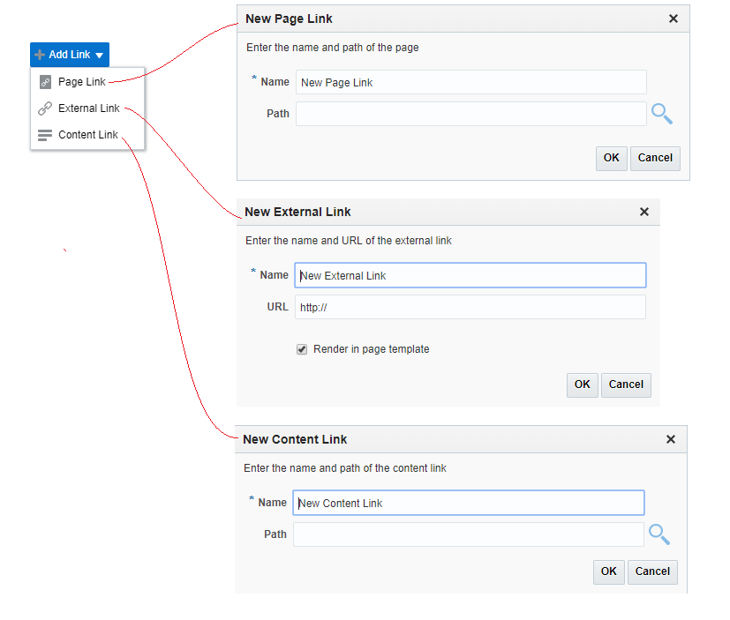

## Edit Links

|  |  |
| --- | --- |
| Task name | Edit links |
| Task owner | MOSA Extranet Portal Contributor |
| Description | The contributor will edit a link using the links Manager. |
| Task preconditions | * The user logs on to the system. * The user is an Extranet Portal contributor. * The link exist in the Links Manager. |
| Input | The link in the Links Manager. |
| Output | The link updated. |
| Task outcome | Ok, Cancel. |

|  |  |
| --- | --- |
| Task Main Flow | |
| # | **Actor action** | **System response** |
|  | Select edit icon next to the link to be edited in the Links Manager | The system will prompt with the edit Link dialog. |
|  | Edit the name, the path, or the URL and click “OK” | The system will update the link with the new values. |

|  |  |
| --- | --- |
| Task exceptional Flow | |
| # | **Actor action** | **System response** |
|  | If the user select “Cancel” in any stage in the main flow | Current changes will be ignored. |

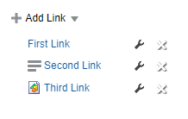

## Delete Links

|  |  |
| --- | --- |
| Task name | Delete links |
| Task owner | MOSA Extranet Portal Contributor |
| Description | The contributor will delete a link using the links Manager. |
| Task preconditions | * The user logs on to the system. * The user is an Extranet Portal contributor. * The link exist in the Links Manager. |
| Input | The link in the Links Manager. |
| Output | The link deleted. |
| Task outcome | Delete, Cancel. |

|  |  |
| --- | --- |
| Task Main Flow | |
| # | **Actor action** | **System response** |
|  | Select delete icon next to the link to be deleted in the Links Manager | The system will prompt with confirmation (Delete/Cancel) dialog. |
|  | Select “Delete” in the delete confirmation dialog. | The system will remove the link from the Links Manager. |

|  |  |
| --- | --- |
| Task exceptional Flow | |
| # | **Actor action** | **System response** |
|  | If the user select “Cancel” in any stage in the main flow | No changes and the link remains. |



Developers & Contributors Tasks to Enable the Service

|  |  |  |
| --- | --- | --- |
| **Task** | **Application** | **Responsibility of** |
| Create a Page and Add the Content Presenter for Poll | Webcenter Portal | Polls Contributor |
| Publish the Page for Users | Webcenter Portal | Polls Contributor |

Updates Log