

**MOSA Price Monitoring Module**

**Software Requirements Specification (SRS)**

|  |  |  |
| --- | --- | --- |
| شعار ملونDocument Details | | |
| Document Owner | Doc No | Document Type |
| AL DAR | MOSA Price Monitoring SRS –1.0 | SRS |
|  |  |  |

**Revision History**

|  |  |  |  |
| --- | --- | --- | --- |
| **Approvals** | | | |
| **Name** | **Title** | **Date** | **Signature** |
|  |  |  |  |
|  |  |  |  |

|  |  |  |  |
| --- | --- | --- | --- |
| **Changes Records** | | | |
| **Date** | **Author** | **Version** | **Change Reference** |
| 25/11/2018 | Osama Zgool | 1.0 |  |
| 26/11/2018 | Saad Jaradat | 1.0 | Review Changes |
| 25/12/2018 | Osama Al Zgool | 1.1 | MOSA IT Team Review |

# Acceptance History

|  |  |  |  |  |
| --- | --- | --- | --- | --- |
| # | Name | Department | Date | Signature |
|  |  |  |  |  |
|  |  |  |  |  |
|  |  |  |  |  |
|  |  |  |  |  |

Contents

Acceptance History 2

1 Introduction 8

1.1 Product Overview 8

1.2 Intended Audience 8

1.3 Terms and Abbreviations 8

1.3.1 Terms 8

1.3.2 Abbreviations 9

2 Price Comparison Screens (مقارنة الاسعار) 10

2.1 Description 10

2.2 Process identification card 10

2.3 Process preconditions 10

2.4 Process input 10

2.5 Process output 10

2.6 Process model 11

2.7 Functional requirements 11

2.8 Use Cases 12

2.8.1 Price Comparison and Send Items to Inspection Table 12

2.8.2 Task screens and fields 14

3 Price Monitoring Screens (مراقبة الاسعار) 18

3.1 Description 18

3.2 Process identification card 18

3.3 Process preconditions 18

3.4 Process input 19

3.5 Process output 19

3.6 Process model 19

3.7 Functional requirements 19

3.8 Use Cases 20

3.8.1 Item Price Monitoring Actions 20

4 Item General Details (معلومات عامة لسلعة) 28

4.1 Description 28

4.2 Process identification card 28

4.3 Process preconditions 28

4.4 Process input 28

4.5 Process output 29

4.6 Process model 29

4.7 Functional requirements 29

4.8 Use Cases 30

4.8.1 Get General Information about Specific Item 30

4.8.2 Task screens and fields 32

5 Item Price Change within Period (مراقبة سعر سلعة خلال مده زمنية) 36

5.1 Description 36

5.2 Process identification card 36

5.3 Process preconditions 36

5.4 Process input 36

5.5 Process output 36

5.6 Process model 37

5.7 Functional requirements 37

5.8 Use Cases 37

5.8.1 Item Price Change within period of time 37

5.8.2 Task screens and fields 39

6 Item Price Average within Period (متوسط سعرسلعة خلال مدة زمنية) 45

6.1 Description 45

6.2 Process identification card 45

6.3 Process preconditions 45

6.4 Process input 45

6.5 Process output 45

6.6 Process model 46

6.7 Functional requirements 46

6.8 Use Cases 46

6.8.1 Item Price Average within period 46

6.8.2 Task screens and fields 48

7 Add Category Screen (اضافة قسم) 52

7.1 Description 52

7.2 Screen identification card 52

7.3 Screen output 52

7.4 Functional requirements 52

7.5 Use Cases 53

7.5.1 Add, Edit, Delete Category 53

7.5.2 Task screens and fields 55

8 Profit Margin Screen (هوامش الربح) 57

8.1 Description 57

8.2 Screen identification card 57

8.3 Screen output 57

8.4 Functional requirements 57

8.5 Use Cases 58

8.5.1 Create, Edit Delete Profit Margin 58

8.5.2 Task screens and fields 60

9 Manage Defined Items Screen (ادارة السلع المعرفة) 62

9.1 Description 62

9.2 Screen identification card 62

9.3 Screen output 62

9.4 Functional requirements 62

9.5 Use Cases 64

9.5.1 Define Items 64

9.5.2 Link Cooperatives items 66

9.5.3 Add/update/cancel union item 67

9.5.4 Task screens and fields 69

10 Manage Defined Providers Screen (ادارة الموردين المعرفين) 76

10.1 Description 76

10.2 Screen identification card 76

10.3 Screen output 76

10.4 Functional requirements 76

10.5 Use Cases 78

10.5.1 Define providers 78

10.5.2 Define Items 80

10.5.3 Link Cooperatives items 81

10.5.4 Task screens and fields 82

11 Item Price Inspection Orders (طلبات تفتيش السلع) 88

11.1 Description 88

11.2 Screen identification card 88

11.3 Screen output 88

11.4 Functional requirements 88

11.5 Use Cases 89

11.5.1 Add and Delete Items from Inspection Table. 89

11.5.2 Send Price Inspection Orders for Cooperatives 92

11.5.3 Task screens and fields 93

12 Item Details Screen (تفاصيل السلعة) 96

12.1 Description 96

12.2 Screen identification card 96

12.3 Screen output 96

12.4 Functional requirements 96

12.5 Use Cases 96

12.5.1 Display Item Details 96

12.5.2 Task screens and fields 97

13 Union Item Details Screen (تفاصيل سلعة اتحاد) 100

13.1 Description 100

13.2 Screen identification card 100

13.3 Screen output 100

13.4 Functional requirements 100

13.5 Use Cases 100

13.5.1 Display Item Details 100

13.5.2 Task screens and fields 101

14 Upload CSV File (Cooperatives Screen) (تحميل بيانات الجمعية) 103

14.1 Description 103

14.2 Screen identification card 103

14.3 Screen output 103

14.4 Functional requirements 103

14.5 Use Cases 103

14.5.1 Upload CSV File 103

14.5.2 Task screens and fields 104

15 CSV File Upload Status (حالة تحميل البيانات من قبل الجمعيات) 106

15.1 Description 106

15.2 Screen identification card 106

15.3 Screen output 106

15.4 Functional requirements 106

15.5 Use Cases 106

15.5.1 Search for CSV File Upload Status 106

15.5.2 Task screens and fields 108

16 Reports (التقارير) 110

17 Appendices 111

17.1 Forms and reports 111

# Introduction

## Product Overview

CO-OPs needed to automate the Processes of Price Monitoring on all cooperative’s super markets, to reduce the employee’s effort, protect the customers of all cooperative’s super markets, quickly capture all cooperative’s super markets contrary to law and to get useful reports helps the ministry in future decisions.

This Document describe in details the automation solution for price monitoring system, based on the previous Requirements have been gathered from the ministry side and highlighted in the business requirement document for Price Monitoring Module and below is the summery of the business functions:

1. The user will be able to compare similar Items prices details for different cooperatives.
2. The user will be able to search and monitor any item in any cooperative with various available search options.
3. The user will get general information about specific item (Highest/lowest selling price, number of providers, quantity available … etc.).
4. The user can manually create comparison tables for targeted items.
5. The user can track the price change for item within period in a cooperative.
6. The user can get the price average within period.
7. The user can define new categories to categorize targeted items.
8. The user can create a profit margin percentage for commodity group.
9. The user can manually link items that do not have a similar specs in different cooperatives.
10. The user can manually link items with a defined supplier.
11. The user can send items to be inspected.
12. The user can display all the required details for any item.
13. The user can track uploading csv file status for all cooperatives.
14. The cooperatives users can upload CSV file on the system.

## Intended Audience

This document is intended for both MOSA IT Technical team and Al Dar both top management and technical team.

## Terms and Abbreviations

### Terms

|  |  |  |
| --- | --- | --- |
| # | Item | Description |
|  | Cooperatives Item | Item in specific cooperative |
|  | CSV file | File with extension .csv |
|  | Cooperative user | User Account defined in the system for a responsible person in a cooperative. |
|  | Defined item | Item created in the system by the user used to link items from different cooperatives |
|  | Defined Provider | Provider created in the system by the user used to link items from different cooperatives to a specific supplier. |

### Abbreviations

|  |  |  |
| --- | --- | --- |
| # | Item | Description |
|  | MOSA | Ministry of Social Affairs |
|  | DB | Database |
|  |  |  |
|  |  |  |

# Price Comparison Screens (مقارنة الاسعار)

## Description

The comparison screen will let the user compare the items prices that has been defined by the user, compare items added from the union with the cooperative’s items have the same barcode and let the user to send inspections orders for specific cooperatives using the following search criteria:

1. Search by Barcode: The system display the Item has the barcode inserted.
2. Search by Item Name: The system will display all items related or close to the inserted text.

And the following Filters:

1. City: The system will display all cooperatives related to the city selected.
2. Category: Category already defined in add category screen, the system will display all items related to the category selected.
3. Cooperatives Selection: The user could determine the selected cooperatives for Search or filtered result on items.
4. Items select list: the list of Items that are manually Identified by the user and mapped to specific item in each cooperative in add items screen and the union items.

## Process identification card

|  |  |
| --- | --- |
| Process ID | PM - PM001 |
| Process name | Price Comparison. |
| Process purpose | Compare items prices from different cooperatives and send inspection orders for specific cooperatives. |
| Initiator user | Inspections Department users. |
| Process owner | The admin of this process |
| Process type | Main Process |

## Process preconditions

.CSV file uploaded on CO-OPs System.

## Process input

.CSV file uploaded on CO-OPs system.

## Process output

The user will be able to compare items from different Cooperatives and send inspections orders for specific cooperatives.

## Process model

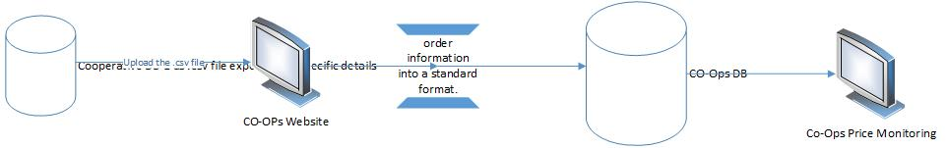

## Functional requirements

List of the functional requirements:

|  |  |  |  |
| --- | --- | --- | --- |
| REQ # | Requirement | Description | Notes |
| FR – PM - 001 | Search on cooperatives by City | The user selects a city, all cooperatives in the selected city should be included in the item search result and the user will be able to exclude or add more cooperatives. |  |
|  | Search on items by category that already identified and mapped | All items related to the selected category that already identified and mapped in add items screen should be displayed, based on the cooperative selected. |  |
|  | Search on items related to specific provider already identified. | All items related to the provider identified and mapped in add provider screen should be displayed, also the category and the items should be filtered based on the selected provider. |  |
|  | Search on items by barcode | The user can insert the item barcode to display the items details result for the selected cooperatives. |  |
|  | Search on items by Items Names | The user can insert the item name to display all related results for the selected cooperatives. |  |
|  | Search for items in specific cooperatives | The user can target items based on the cooperative’s selection. |  |
|  | Select Items Identified and mapped | A select list that have all Items identified and mapped for specific item in each cooperative by the user in add items screen. |  |
|  | Results display in table | the result for the search will display in a table and the table will have:   1. Item name 2. Measuring Unit 3. Provenance 4. Lowest selling price between all selected cooperatives for the targeted items. 5. Item Selling price. 6. Cooperative Name. |  |
|  | Results of the search should be based on specific date | Result for the searched Items should display based on the date inserted by the user. |  |
|  | Add Items to Inspection table | The user can mark specific Items to add it to the Items inspection table by clicking on Add to Inspection Table button. |  |

## Use Cases

### Price Comparison and Send Items to Inspection Table

|  |  |
| --- | --- |
| Use Case ID | PM -UC01 |
| Use Case Name | Price Comparison |
| Actors | Privileged users |
| Description | Compare items prices between selected cooperatives that manually mapped by the user or by automatic mapping using union items barcodes. |
| Preconditions | .CSV file uploaded to CO-OPs system for the selected date. |
| Post conditions | The user can compare the cooperatives items prices with the union items prices for the items have been provided by union, the user can also compare the items have been manually mapped and send specific items to the inspection table. |
| Business rules | 1. Union item price should display for the user for the items have prices from the union. 2. Results for the items should be displayed based on the search criteria inserted by the user. 3. Date should be inserted. 4. The user can not add the same items for the same cooperative to inspection table twice with the same date. 5. Each Item sent to the inspection table should be classified to specific cooperative. |

**Main Flow**

|  |  |  |
| --- | --- | --- |
| # | Actor Action | System Response |
| 1 | The privileged user navigates to price Comparison screen. | Price comparison screen displayed and all fields with the default value. |
| 2 | The user select the cooperatives targeted for comparison by selecting the city from select list or randomly cooperatives from shuttle field. | If a city selected all cooperatives in the selected city will be targeted for the search and the user able to add more cooperatives. If cooperatives selected from the shuttle field, the city select list will be disabled. |
| 3 | The user selects the category which the items belong to and the option to select all category is available. | Category selected. (optional step) |
| 4 | The user can select specific item or all items. | Items selected. (optional step) |
| 5 | The user selects a provider. | All categories and items are filtered to the selected provider. (Optional step) |
| 6 | The user insert the date for the targeted search. | Items details result should be displayed based on the selected date. |
| 7 | The user clicks on search button. | Results display in the table as it is described here. |
| 8 | Based on the result the user can select items to be added to the inspection table. | Items selected and user click on add to inspection table to send the items to inspection table. |

**Alternative Flows**

|  |  |  |
| --- | --- | --- |
| # | Actor Action | System Response |
| 1 | The user selects the cooperatives targeted for the search. | Cooperatives selected. |
| 2 | The user inserts the item barcode. | Category list, item list, search box should be disabled. |
| 3 | The user insert the date for the search. | Items details result should be displayed based on the date selected. |
| 4 | The user clicks on search button. | Item details displayed in the table. |
| Second flow | | |
| 1 | The user selects the cooperatives targeted for the search. | Cooperatives selected. |
| 2 | The user inserts the item name in search box. | Category list, item list, barcode text box should be disabled. |
| 3 | The user inserts the date for the search. | Items details result should be displayed based on the date selected. |
| 4 | The user clicks on search button. | Items related details displayed in the table. |
| Third flow | | |
| 1 | The user selects the cooperatives targeted for the search. | Cooperatives selected. |
| 2 | The user inserts the search date. | Date inserted. |
| 3 | The user clicks on search button. | Items details displayed in the table. |
|  |  |  |

**Exceptional Flows**

|  |  |  |
| --- | --- | --- |
| # | Actor Action | System Response |
| 1 | The user does not select the cooperatives targeted for the search. | Cooperatives selected. |
| 2 | The user inserts the search date. | Date inserted. |
| 3 | The user clicks on search button. | No Search result will display. |
|  |  |  |
|  |  |  |

**System Messages:**

|  |  |  |  |
| --- | --- | --- | --- |
| # | Actor Action | Message Type | System Response |
| 1 | The user does not select the cooperatives targeted for the search and click on search button. | Error Message | يرجى اختيار الجمعيات |
| 2 | The user does not insert the search date and click on search button. | Error Message | يرجى ادخال التاريخ |
| 3 | The user clicks on search button without insert any field. | Error Message | يرجى ادخال الحقول الالزاميه |
| 4 | The user insert data that does not display any search result. | Error Message | لا يوجد نتائج للبحث |
| 5 | The user Click on send to inspection table without selecting any Item | Error Message | يرجى اختيار السلع اللتي ترغب بارسالها لجدول التفتيش المباشر |
| 6 | The user select items that are already in inspection table and click on send to inspection table. | Error Message | لم يتم ارسال السلع الى جدول التفتيش المباشر السلع التاليه موجوده بالفعل في جدول التفتيش المباشر  (مع ذكر اسماء السلع) |
| 7 | The user select Items that are not mapped and click on search button. | Error Message in the table for each item that is not mapped with the cooperative. | لم يتم ربط السلعه مع الجمعيه المختاره |
| 8 | Missed detail for Item displayed in the table after search. | Error Message for each column | لم يتم تزويد المعلومات من قبل الجمعيه |
| 9 | The user select items and clicked on send to inspection table | Hint Message | تم ارسال السلع الى جدول التفتيش المباشر |

### Task screens and fields

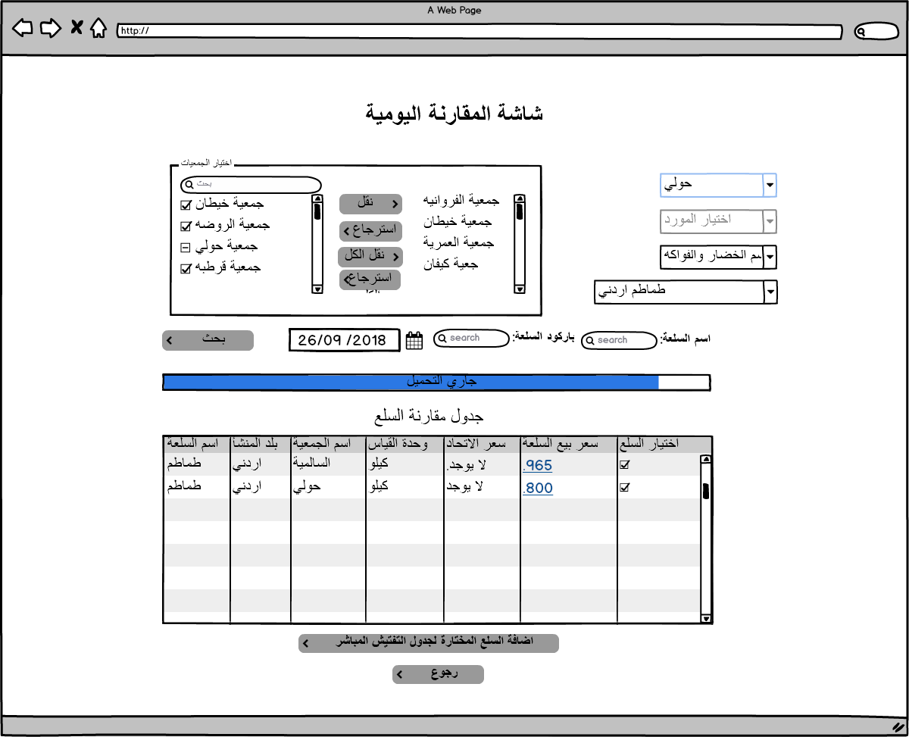

|  |  |  |  |  |  |  |
| --- | --- | --- | --- | --- | --- | --- |
| Price Comparison Mockups Fields Description | | | | | | |
| Field | Description | Type | Default value | Mandatory | Length | Notes |
| Cooperatives selection | Contain all cooperatives and the user can select the targeted cooperatives | Shutter field | Non-selected | Mandatory | N/A | Could be changed to popup and the user can mark the targeted cooperatives DB : MOSA_PORTAL_ENTITIES.PROFILE_NO_REF |
| Supplier list | Contain all defined suppliers have mapped items | Drop down list | Non-selected | Optional | N/A | DB : PMON_SUPPLIER.SUPPLIER_DESC_AR |
| City list | Contains all cooperatives in the city. | Drop down list | Non-Selected | Optional | N/A | 1. the user can select a city and add more or remove cooperatives  2.Could be changed to popup has a table with the same details DB : LOV.LOV_ID(PARENT_LOV_ID=12) |
| Category list | Category list will display already added categories in add category screen. | Drop down list | Non-Selected | Optional | N/A | DB:  PMON_ITEM_SECTIONS. SECTION_NAME_AR |
| Subcategory list | Category list will display already added categories in add category screen. | Drop down list | Non-Selected | Optional | N/A | PMON_ITEM_SECTIONS_DETALS. MSTR_SECTION_NAME_AR |
| Item list | To select items that already added and mapped in add item screen. | Drop down list | Non-Selected | Optional | N/A | Could be changed to popup has a table with the same details DB:  PMON_GENERAL_ITEMS. ITEM_DESC_AR |
| Item Name Search | To insert the item name targeted for search | Text field | Empty | Optional | 50 | Cooperatives or city selection becomes mandatory to be target specific cooperatives. DB:  PMON_GENERAL_ITEMS. ITEM_DESC_AR PMON_GENERAL_ITEMS. ITEM_DESC_EN |
| Barcode Search | To insert the barcode number for the targeted item. | Text field | Empty | Optional | 20 | Cooperatives or city selection becomes mandatory to be target specific cooperatives. DB:  PMON_GENERAL_ITEMS. ITEM_UNIV_BARCODE |
| Date of comparison | To insert the date of comparison and to get the Item details as per the date inserted. | Date | System Date | Mandatory | N/A |  |
| Search Action | To Get the result based on the inserted search criteria. | Button | Disabled | Mandatory | N/A | Button becomes enabled once the user inserts a correct search criteria. |
| Add to inspection table | To send the selected items to inspection table | Button | Enabled | Mandatory | N/A | Items add and classified in inspection details screen. DB: INSP_PRICE_INSPECTION |
| Back Button | To Back to Home Page of the price Monitoring | Button | Enabled | Mandatory | N/A |  |
| Search Result Table | | | | | | |
| Item Name | **Provenance** | **Cooperative Name** | **Measuring Unit** | **Union item price** | **Item Selling Price** | 1. Item Selling price result should be as a link redirect the user to Item Details screen. That will be described in item details screen.  2. Union Selling price result should be as a link redirect the user to union Item Details screen. That will be described in union item details screen. 3. a mark box should be displayed for each row to let the user mark one or multiple items |
| DB details PMON_GENERAL_ITEMS | | | | | | |
| PMON_GENERAL_ITEMS.ITEM_DESC_AR or PMON_GENERAL_ITEMS.ITEM_DESC_EN | PMON_UNION_RAWDATA.CountryOfOrigin | PMON_DET_RAWDATA.RAWDATA_MSTR_COOP_ID | PMON_UNION_RAWDATA.MEASURING_UNIT | PMON_UNION_RAWDATA. ITEM_COST_PRICE | PMON_DET_RAWDATA. RAWDATA_CSV_ITEM_SELL_PRICE |  |

# Price Monitoring Screens (مراقبة الاسعار)

## Description

The Monitoring screen will let the user monitor the items that exist in CO-OPs database, Map Items, build Comparison Items table manually and save it for later use, send inspection orders, Edit Profit Margin and using the following search criteria:

1. Search by Barcode: The system display the Item has the barcode inserted.
2. Search by Item Name: The system will display all items related or close to the inserted text.

And the following Filters:

1. City: The system will display all cooperatives related to the city selected and the user is able to add more cooperative.
2. Category: The system will display all items related to the category selected.
3. Cooperatives Selection: The user could determine the selected cooperatives for Search or filtered result on items.
4. Supplier: The system will display all the items that have been supplied by the supplier, if the supplier have similar specs in different cooperative.

And the following Search option:

1. Normal search will display all items based on the search criteria inserted.

Profit Margin Search will display all items selling with profit margin more than the expected based on MOSA Law.

## Process identification card

|  |  |
| --- | --- |
| Process ID | PM - PM002 |
| Process name | Price Monitoring. |
| Process purpose | Monitor items prices from different cooperatives. |
| Initiator user | Inspections Department users. |
| Process owner | The admin of this process |
| Process type | Main Process |

## Process preconditions

.CSV file uploaded on CO-OPs System.

## Process input

.CSV file uploaded on CO-OPs system.

## Process output

The user will be able to Monitor items for different Cooperatives and send inspection orders.

## Process model



## Functional requirements

List of the functional requirements:

|  |  |  |  |
| --- | --- | --- | --- |
| REQ # | Requirement | Description | Notes |
| FR – PM - 001 | Search on cooperatives by City | The user selects a city, all cooperatives in the selected city should be included in the item search result. |  |
|  | Search on items by category | All items related to the selected category should be displayed. |  |
|  | Search on Items by Supplier | All Items supplied by the supplier should be displayed. |  |
|  | Search on items by barcode | The user can insert the item barcode to display the items details result for the selected cooperatives. |  |
|  | Search on items by Items Names | The user can insert the item name to display all related results for the selected cooperatives. |  |
|  | Search for items in specific cooperatives | The user can target items based on the cooperative’s selection. |  |
|  | Results display in table | the result for the search will display in a table and the table will have the following column:   1. Item name. 2. Measuring Unit. 3. Supplier Name 4. Provenance 5. Quantity per unit 6. Quantity per package 7. Bill Number 8. Receiving Receipt Number 9. Selling Price per Item 10. Selling Price per Package 11. Buying Price per Item 12. Buying Price per Package 13. Date of receiving Item 14. Category 15. Item Barcode |  |
|  | Results of the search should be based on specific date | Result for the searched Items should display based on the date inserted by the user. |  |
|  | The user can build manual comparison table. | The user can select specific items and add them to the manual comparison table to be compared as per the end user point of view. |  |
|  | The user can save the comparison table for later use. | The user can save the table created in Manual comparison table’s screen for later use. |  |
|  | Edit profit margin related to MOSA law. | The user can edit or add profit margin for specific item or for group of items. |  |
|  | Map Selected Items to General Item already defined. | From price monitoring screen the user can link items from different cooperatives to general item already defined. |  |
|  | Map selected to Provider already defined | From price monitoring screen the user can link items from different cooperatives to provider already defined. |  |
|  | Add Items to the inspection table. | The user can mark multiple items and add them to the inspection table. |  |

## Use Cases

### Item Price Monitoring Actions

|  |  |
| --- | --- |
| Use Case ID | PM -UC02 |
| Use Case Name | Item Price Monitoring Actions |
| Actors | Privileged users |
| Description | 1. Monitor selected items prices and details between selected cooperatives. 2. Make comparisons tables for items. 3. Link item with defined item 4. Link Item with provider. 5. Send item to inspection table. 6. Edit profit Margin. |
| Preconditions | .CSV file uploaded to CO-OPs system for the selected date. |
| Post conditions | Profit Margin related to MOSA law could be added or edited, the user can map items to general Item or to provider, the user can add items to the inspection table, the user can manually build a comparison table and save it for later use. |
| Business rules | 1. Results for the items should be displayed based on the search criteria inserted by the user. 2. Date should be inserted. 3. The user can not add the same items for the same cooperative to inspection table twice with the same date. 4. Each Item sent to the inspection table should be classified to specific cooperative. |

**Main Flow**

|  |  |  |
| --- | --- | --- |
| # | Actor Action | System Response |
| 1 | The privileged user navigates to price monitoring screen. | Price monitoring screen displayed and all fields with the default value. |
| 2 | The user select the cooperatives targeted for Monitoring by selecting the city from select list or randomly cooperatives from shuttle field. | If a city selected all cooperatives in the selected city will be targeted for the search. If cooperatives selected from the shuttle field, the city select list will be disabled. |
| 3 | The user selects the category which the items belong to and the option to select all category is available. | Category selected. (optional step) |
| 4 | The user can select specific item or all items. | Items selected. (optional step) |
| 5 | The user selects the provider or all providers. | All items related to the selected provider should be included in the search (optional step) |
| 6 | The user clicks on search button. | Results display in the table as it is described here. |
| Search for items with selling price more than the expected based on MOSA law | | |
| 1 | The privileged user navigates to price monitoring screen. | Price monitoring screen displayed and all fields with the default value. |
| 2 | The user select the cooperatives targeted for Monitoring by selecting the city from select list or randomly cooperatives from shuttle field. | If a city selected all cooperatives in the selected city will be targeted for the search. If cooperatives selected from the shuttle field, the city select list will be disabled. |
| 3 | The user selects the category which the items belong to and the option to select all category is available. | Category selected. (optional step) |
| 4 | The user can select specific item or all items. | Items selected. (optional step) |
| 5 | The user selects the provider or all providers. | All items related to the selected provider should be included in the search (optional step) |
|  | The user clicks on search for items with invalid profit margin button. | Items have invalid selling price as per MOSA profit margin expected will display in price Monitoring table. |
|  |  |  |

**Alternative Flows**

|  |  |  |
| --- | --- | --- |
| # | Actor Action | System Response |
| 1 | The user selects the cooperatives targeted for the search. | Cooperatives selected. |
| 2 | The user inserts the item barcode. | Category list, item list, search box should be disabled. |
| 3 | The user inserts the date for the search. | Date inserted. |
| 4 | The user clicks on search button. | Item details displayed in the table. |
| Second flow | | |
| 1 | The user selects the cooperatives targeted for the search. | Cooperatives selected. |
| 2 | The user inserts the item name in search box. | Category list, item list, barcode text box should be disabled. |
| 3 | The user inserts the date for the search. | Date inserted. |
| 4 | The user clicks on search button. | Items related details displayed in the table. |

**Exceptional Flows**

|  |  |  |
| --- | --- | --- |
| # | Actor Action | System Response |
| 1 | The user selects the cooperatives targeted for the search. | Cooperatives selected. |
| 2 | The user inserts the search date. | Date inserted. |
| 3 | The user clicks on search button. | Items details displayed in the table. |
| Second Flow | | |
| 1 | The user select one or multiple Items that displayed based on any search result mentioned in the above flows. | Items selected. |
| 2 | The user click on add to comparison table | Items selected added to the comparison table. |
| 3 | The user can save the created table by clicking on save button. | Create manual popup table will be displayed and the user can insert a name and description for the table and will be saved in manual comparison tables screen as it is described her (Manual comparison tables screen). |
| Third flow | | |
| 1 | The user select one or multiple Items that displayed based on any search result mentioned in the above flows. | Items selected. |
| 2 | User click on Edit profit margin button | User select profit margin category from the list already identified in add profit margin screen. |
| 3 | User click on save button. | All items selected will have the new profit margin selected. |

**System Messages:**

|  |  |  |  |
| --- | --- | --- | --- |
| # | Actor Action | Message Type | System Response |
| 1 | The user does not select the cooperatives targeted for the search and click on search button. | Error Message | يرجى اختيار الجمعيات |
| 2 | The user does not insert the search date and click on search button. | Error Message | يرجى ادخال التاريخ |
| 3 | The user clicks on search button without insert any field. | Error Message | يرجى ادخال الحقول الالزاميه |
| 4 | The user insert data that does not display any search result. | Error Message | لا يوجد نتائج للبحث |
| 5 | The user Click on send to inspection table without selecting any Item | Error Message | يرجى اختيار السلع اللتي ترغب بارسالها لجدول التفتيش المباشر |
| 6 | The user select items that are already in inspection table and click on send to inspection table. | Error Message | لم يتم ارسال السلع الى جدول التفتيش المباشر السلع التاليه موجوده بالفعل في جدول التفتيش المباشر  (مع ذكر اسماء السلع) |
| 7 | The user select Items that are not mapped and click on search button. | Error Message in the table for each item that is not mapped with the cooperative. | لم يتم ربط السلعه مع الجمعيه المختاره |
| 8 | Missed detail for Item displayed in the table after search. | Error Message for each column | لم يتم تزويد المعلومات من قبل الجمعيه |
| 9 | The user select items and clicked on send to inspection table | Hint Message | تم ارسال السلع الى جدول التفتيش المباشر |

#### Task screens and fields

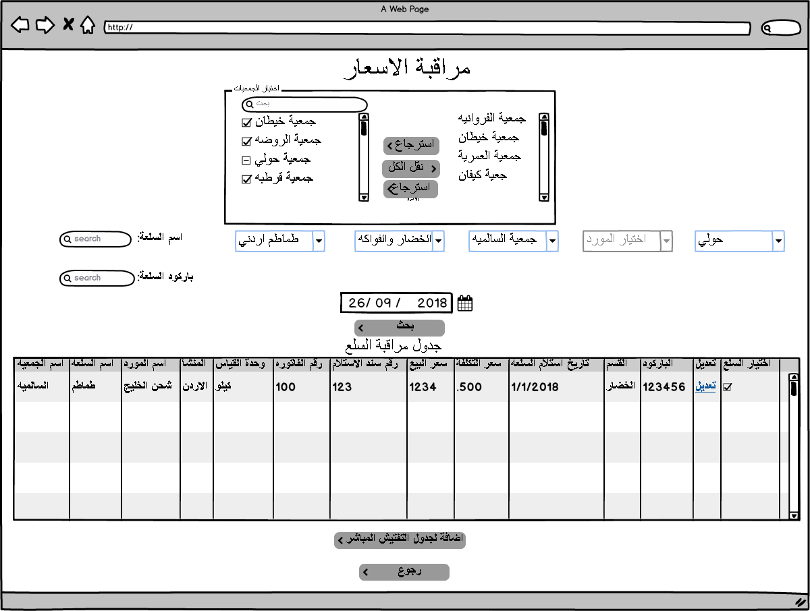

|  |  |  |  |  |  |  |  |  |
| --- | --- | --- | --- | --- | --- | --- | --- | --- |
| Price Monitoring Mockups Fields Description | | | | | | | | |
| Field | Description | | Type | Default value | Mandatory | | Length | Notes |
| Cooperatives selection | Contain all cooperatives and the user can select the targeted cooperatives | | Shutter field | Non-selected | Mandatory | | N/A | Could be changed to popup table and the user can mark the targeted cooperatives. This field becomes mandatory if the city is not selected.  DB:  MOSA_PORTAL_ENTITIES.PROFILE_NO_REF |
| City list | Contains all cooperatives in the city. | | Drop down list | Non-Selected | Optional | | N/A | Could be changed to popup have a table with all cities. DB:  LOV.LOV_ID(PARENT_LOV_ID=12) |
| Category list | To select targeted category. | | Drop down list | Non-Selected | Optional | | N/A | Could be changed to popup or faster solution DB:  PMON_DET_RAWDATA.RAWDATA_CSV_ITEM_CATEGORY |
| Item list | To select targeted Item. | | Drop down list | Non-Selected | Optional | | N/A | Could be changed to popup or faster solution DB:  PMON_DET_RAWDATA.RAWDATA_CSV_ITEM_NAME_AR |
| Item Name Search | To insert the item name targeted for search | | Text field | Empty | Optional | | 50 | Cooperatives or city selection becomes mandatory to be target specific cooperatives. |
| Barcode Search | To insert the barcode number for the targeted item. | | Text field | Empty | Optional | | 20 | Cooperatives or city selection becomes mandatory to be target specific cooperatives. |
| Date of Monitoring | To insert the date of monitoring and to get the Item details as per the date inserted. | | Date | System Date | Mandatory | | N/A |  |
| Search Action | To Get the result based on the inserted search criteria. | | Button | Disabled | Mandatory | | N/A | Button becomes enabled once the user inserts a correct search criteria. |
| Search for incorrect selling Price based on MOSA profit Margin | The user select one or many items click on edit button select one of the profit margin defined list and the system will display if it more than the expected profit margin or within in the last column. | | Button | Disabled | Mandatory | | N/A | Button becomes enabled once the user inserts a correct search criteria.  DB  Will display all items in  PMON_DET_RAWDATA  Selected by the user. |
| Edit the profit Margin. | To update the selected items profit margin that is related to MOSA law. | | Button | Enabled | Mandatory | | N/A | Table popup displayed to let the user select the profit margin category. Note: The table displayed same as it is defined in Add Profit Margin Screen. |
| Map Item to general item | To link the selected items to general item already defined in Add items screen. | | Button | Enabled | Optional | | N/A | This button displays when the user redirected to this page from Add Items screen. |
| Map Item to provider. | To link the selected items to provider already defined in Add provider screen. | | Button | Enabled | Optional | | N/A | This button displays when the user redirected to this page from Add provider screen. |
| Add to inspection table | To send the selected items to inspection table | | Button | Enabled | Optional | | N/A | Items added and classified in inspection details screen.  DB:  INSP_PRICE_INSPECTION |
| Back Button | To Back to Home Page of the price Monitoring | | Button | Enabled | Mandatory | | N/A |  |
| Search Result Table | | | | | | | | |
| Column Name | | **Column Description** | | | | **Notes** | | |
| Cooperative Name | | Name of the cooperative that item related to. | | | | MOSA_PORTAL_ENTITIES.PROFILE_NO_REF | | |
| Item Name | | Item Name. | | | | PMON_DET_RAWDATA.RAWDATA_CSV_ITEM_NAME_AR | | |
| Item Barcode | | Barcode of the Item. | | | | PMON_DET_RAWDATA.RAWDATA_CSV_ITEM_BARCODE | | |
| Category Name | | Category that the item related to. | | | | PMON_DET_RAWDATA.RAWDATA_CSV_ITEM_CATEGORY | | |
| Supplier Name | | Supplier who supplied the Item. | | | | PMON_DET_RAWDATA.RAWDATA_CSV_SUPPLIER_NAME | | |
| Provenance | | Item where it made. | | | | PMON_DET_RAWDATA.RAWDATA_CSV_ITEM_PROVENANCE | | |
| Selling Price per Item | | Selling price per unit. | | | | PMON_DET_RAWDATA.RAWDATA_CSV_ITEM_SELL_PRICE | | |
| Selling Price per Package | | Selling price per package. | | | | PMON_DET_RAWDATA.RAWDATA_CSV_PKG_SELL_PRICE | | |
| Buying Price per Item | | Buying price (Cost) per unit. | | | | PMON_DET_RAWDATA.RAWDATA_CSV_ITEM_COST_PRICE | | |
| Buying Price per Package | | Buying price (Cost) per package. | | | | PMON_DET_RAWDATA.RAW_DATA_CSV_PKG_COST_PRICE | | |
| Profit Margin on selling price. | | The formula is (Selling Price - Cost)/cost | | | | PMON_DET_RAWDATA.RAWDATA_MAP_PROFIT_PERCENT | | |
| Expected Profit Margin based on MOSA law | | Determined as per law. | | | | Temp value | | |
| Quantity per unit | | Quantity as per unit that exist in the cooperative super market. | | | | PMON_DET_RAWDATA.RAWDATA_CSV_QUANT_PER_INDV | | |
| Quantity per package | | Quantity as per package that exist in the cooperative super market. | | | | PMON_DET_RAWDATA.RAWDATA_CSV_QUANT_PER_PKG | | |
| Bill Number | | The number of the buying bill from the Provider as it is in the receiving receipt | | | | PMON_DET_RAWDATA.RAWDATA_CSV_ITEM_BILL_NO | | |
| Receiving Receipt Number | | Receiving Receipt Number for the item | | | |  | | |
| Date of receiving Item | | Date of Receiving Item Based on Receiving Receipt Details. | | | | PMON_DET_RAWDATA.RAWDATA_CSV_ITEM_RECEIVE_DATE | | |
| Check box | | To mark wanted items to send it to inspection table or map it or edit the profit margin | | | |  | | |

# Item General Details (معلومات عامة لسلعة)

## Description

The Item General Details screen will let the user to get General Information about specific item like: Average Selling price, Lowest and highest selling price, number of providers, total number of Cooperative that sell the item and Quantity available, and the user have the following search criteria available:

1. Search by Barcode: The system display the Item has the barcode inserted from mapped items.
2. Search by Item Name: The system will display all items related or close to the inserted text from mapped items.

And the following Filters:

1. Category: The system will display all categories available added by the user in add category screen from mapped items.
2. Item list Selection: The system will display all Items exists in the category selected and already defined in add item screen .

## Process identification card

|  |  |
| --- | --- |
| Process ID | PM - PM003 |
| Process name | Item General Details. |
| Process purpose | Get General Information about specific item. |
| Initiator user | Inspections Department users. |
| Process owner | The admin of this process |
| Process type | Main Process |

## Process preconditions

.CSV file uploaded on CO-OPs System.

## Process input

.CSV file uploaded on CO-OPs system.

## Process output

The user will get General Information about specific item.

## Process model



## Functional requirements

List of the functional requirements:

|  |  |  |  |
| --- | --- | --- | --- |
| REQ # | Requirement | Description | Notes |
| FR – PM - 001 | Search on items by category | All items related to the selected category which already defined in add category should be displayed. |  |
|  | Search on Items by Supplier | All Items supplied by the supplier which already defined in add provider screen should be displayed. |  |
|  | Search on items by barcode | The user can insert the item barcode to display the items details result for the selected cooperatives. |  |
|  | Search on items by Items Names | The user can insert the item name to display all related results for the selected cooperatives. |  |
|  | Items Select list | The user can select the item after select the category or the supplier which the items will be displayed based on the user selection. |  |
|  | Item Average Selling Price | The average selling price between all cooperatives that sell the item. |  |
|  | Lowest selling Price with cooperative name | The lowest selling price between all cooperatives that sell the item. |  |
|  | Highest Selling Price with cooperative name | The highest selling price between all cooperatives that sell the item. |  |
|  | Quantity per unit | The quantity available per unit between all cooperatives that sell the item. |  |
|  | Quantity per package | The quantity available per package between all cooperatives that sell the item. |  |
|  | Search result will display in the same screen | Results will display in labels. |  |
|  | The items displayed based on the search result will be detailed in a table | A table contains all items with cooperatives names that are included in the search result. |  |

## Use Cases

### Get General Information about Specific Item

|  |  |
| --- | --- |
| Use Case ID | PM -UC03 |
| Use Case Name | General Item Details |
| Actors | Privileged users |
| Description | Get General Information about selected item. |
| Preconditions | .CSV file uploaded to CO-OPs system for the selected date. |
| Post conditions | Lowest selling price, highest selling price, Quantity should be calculated. |
| Business rules | 1. Results for the items should be displayed based on the search criteria inserted by the user. 2. Date should be inserted. 3. All the items included in search result should be displayed in a detailed table. |

**Main Flow**

|  |  |  |
| --- | --- | --- |
| # | Actor Action | System Response |
| 1 | The privileged user navigates to Item general Details screen. | Item general Details screen displayed and all fields with the default value. |
| 2 | The user selects the category which the items belong to. | Category selected, supplier list disabled. |
| 3 | The user should select specific item. | Items selected. |
| 4 | The user inserts the date. | Date inserted. |
| 5 | The user clicks on search button. | Results display in the tables as it is shown in the mockup and items included in the search detailed in a table. |
| Second flow | | |
| 1 | The privileged user navigates to Item general Details screen. | Item general Details screen displayed and all fields with the default value. |
| 2 | The user selects the supplier which the items belong to. | Supplier selected, category list is disabled. |
| 3 | The user should select specific item. | Items selected. |
| 4 | The user inserts the date. | Date inserted. |
| 5 | The user clicks on search button. | Results display in the tables as it is shown in the mockup and items included in the search detailed in a table. |
|  |  |  |
|  |  |  |

**Alternative Flows**

|  |  |  |
| --- | --- | --- |
| # | Actor Action | System Response |
| 1 | The user inserts the item barcode. | Category list, item list, supplier list, search box should be disabled. |
| 2 | The user inserts the date for the search. | Date inserted. |
| 3 | The user clicks on search button. | Item details displayed. |
| Second flow | | |
| 1 | The user inserts the item name in search box. | Category list, item list, supplier list, barcode text box should be disabled and a popup table with all items related to the text inserted will display to let the user select the targeted item. |
| 2 | The user inserts the date for the search. | Date inserted. |
| 3 | The user clicks on search button. | Items related details displayed in the table. |
|  |  |  |
|  |  |  |
|  |  |  |

**Exceptional Flows**

|  |  |  |
| --- | --- | --- |
| # | Actor Action | System Response |
| 1 | The user clicks on search button. | No result displayed. |

**System Messages:**

|  |  |  |  |
| --- | --- | --- | --- |
| # | Actor Action | Message Type | System Response |
| 1 | The user does not insert the search date and click on search button. | Error Message | يرجى ادخال التاريخ |
| 2 | The user clicks on search button without insert any field. | Error Message | يرجى ادخال الحقول الالزاميه |
| 3 | The user insert data that does not display any search result. | Error Message | لا يوجد نتائج للبحث |
| 4 | The user select Items that are not mapped and click on search button. | Error Message in the table for each item that is not mapped with the cooperative. | لم يتم ربط السلعه مع سلع الجمعيات |
| 5 | Missed detail for Item displayed in the table after search. | Error Message for each column | لم يتم تزويد المعلومات من قبل الجمعيه |
| 6 | The user select items and clicked on send to inspection table | Hint Message | تم ارسال السلع الى جدول التفتيش المباشر |

### Task screens and fields

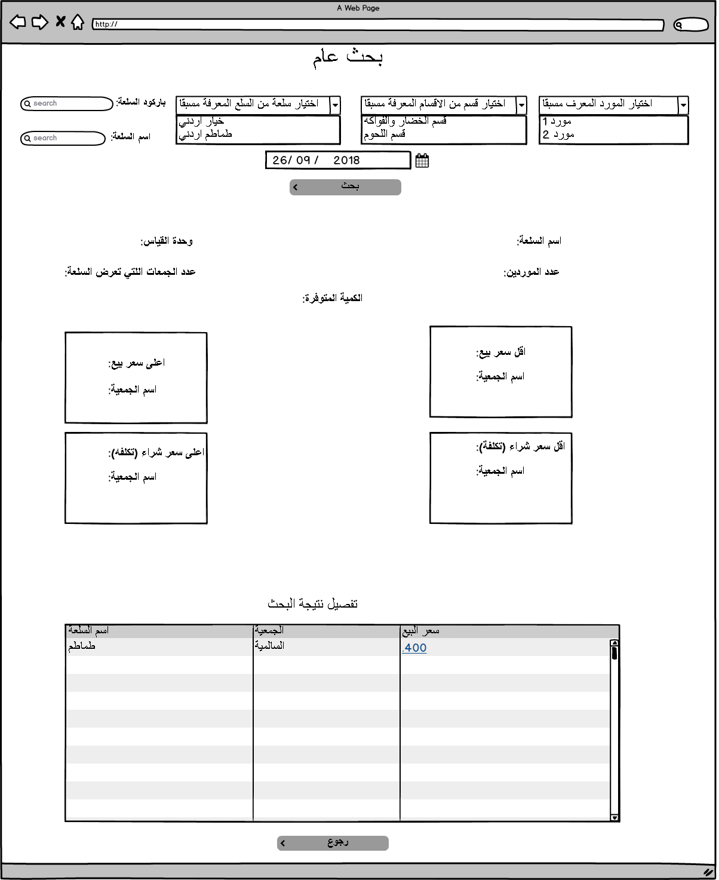

|  |  |  |  |  |  |  |  |  |
| --- | --- | --- | --- | --- | --- | --- | --- | --- |
| Item General Search Mockups Fields Description | | | | | | | | |
| Field | Description | | Type | Default value | Mandatory | | Length | Notes |
| Category list | To select targeted category which already defined in add category list. | | Drop down list | Non-Selected | Optional | | N/A | Could be changed to table popup. If it selected supplier list will be disabled. DB: PMON_ITEM_SECTIONS.MSTR_SECTION_NAME_AR |
| Subcategory list | Display subcategory based on the selected category | | Drop down list | Non-Selected | Optional | | N/A | DB:  PMON_ITEM_SECTIONS_DETALS.SECTION_NAME_AR |
| Supplier List | To select supplier of the item which already defined in add provider list. | | Drop down list | Non-Selected | Optional | | N/A | If selected category list will be disabled. DB:  PMON_SUPPLIER.SUPPLIER_DESC_AR |
| Item list | To select targeted Item. | | Drop down list | Non-Selected | Optional | | N/A | Could be changed to popup table  DB: PMON_GENERAL_ITEMS.ITEM_DESC_AR or PMON_GENERAL_ITEMS.ITEM_DESC_EN |
| Item Name Search | To insert the item name targeted for search | | Text field | Empty | Optional | | 50 | Supplier, Category, Item selections becomes disabled,  popup table displayed with all items related to text inserted to select the targeted item. DB:  PMON_GENERAL_ITEMS.ITEM_DESC_AR or PMON_GENERAL_ITEMS.ITEM_DESC_EN |
| Barcode Search | To insert the barcode number for the targeted item. | | Text field | Empty | Optional | | 20 | Supplier, Category, Items selection becomes disabled, popup table displayed with all items related to text inserted to select the targeted item.  DB:  PMON_GENERAL_ITEMS.ITEM_Code with reference to PMON_GEN_ITEM_RAWDATA.RAWDATA_BARCODE |
| Date of Monitoring | To insert the date of monitoring and to get the Item details as per the date inserted. | | Date | System Date | Mandatory | | N/A |  |
| Search Action | To Get the result based on the inserted search criteria. | | Button | Disabled | Mandatory | | N/A | Button becomes enabled once the user inserts a correct search criteria. |
| Back Button | To Back to Home Page of the price Monitoring | | Button | Enabled | Mandatory | | N/A |  |
| Search Result | | | | | | | | |
| Field name | | **Result as a label** | | | | **Notes** | | |
| Item Name | | Item Name. | | | | PMON_GENERAL_ITEMS.ITEM_DESC_AR or PMON_GENERAL_ITEMS.ITEM_DESC_EN | | |
| Lowest Selling Price per Item | | Selling price per unit. | | | | PMON_GENERAL_ITEMS.ITEM_Code with reference to PMON_GEN_ITEM_RAWDATA.RAWDATA_BARCODE with reference to PMON_DET_RAWDATA.RAWDATA_CSV_ITEM_SELLING_PRICE | | |
| Cooperative Name | | Name of the cooperative that item related to. | | | | PMON_GENERAL_ITEMS.ITEM_Code with reference to PMON_UNION_RAWDATA and PMON_DET_RAWDATA | | |
| Highest Selling Price per Item | | Selling price per unit. | | | | PMON_GENERAL_ITEMS.ITEM_Code with reference to PMON_GEN_ITEM_RAWDATA.RAWDATA_BARCODE with reference to PMON_DET_RAWDATA.RAWDATA_CSV_ITEM_SELLING_PRICE | | |
| Cooperative Name | | Name of the cooperative that item related to. | | | | PMON_GENERAL_ITEMS.ITEM_Code with reference to PMON_UNION_RAWDATA and PMON_DET_RAWDATA | | |
| Number of providers | | Total number of the providers for the item | | | | If supplier select list used in search the number will be one. | | |
| Number of cooperatives that sell the item | | Total number of the cooperative that sell the item and included in the search. | | | |  | | |
| Items included in the search table columns | | | | | | | | |
| Column Name | | Description | | | |  | | |
| Item Name | | Name of the Item | | | | PMON_DET_RAWDATA. RAWDATA_CSV_ITEM_NAME_AR with reference to PMON_UNION_RAWDATA and PMON_GENERAL_ITEMS.ITEM_Code | | |
| Cooperative Name | | Cooperative Name | | | | PMON_DET_RAWDATA. RAWDATA_MSTR_COOP_ID with reference to PMON_UNION_RAWDATA and PMON_GENERAL_ITEMS.ITEM_Code | | |
| Selling Price | | Selling Price for the Item | | | | The selling price will be as a link display Item Details screen once it is clicked from (PMON_DET_RAWDATA)  PMON_DET_RAWDATA.RAWDATA_CSV_ITEM_SELL_PRICE with reference to PMON_UNION_RAWDATA and PMON_GENERAL_ITEMS.ITEM_Code | | |

# Item Price Change within Period (مراقبة سعر سلعة خلال مده زمنية)

## Description

The Item price change within period will let the user to get the item price change during specific period in a specific cooperative with a total number of the price change for the item and a chart line for price changing during the start and end date, Add items to inspection table, the user has the following search criteria available:

1. Search by Barcode: The system display the Item has the barcode inserted.
2. Search by Item Name: The system will display all items related or close to the inserted text.

And the following Filters:

1. Cooperatives Selection: The user should determine a cooperative.
2. Category: The system will display all categories available based on the cooperative has been selected.
3. Item list Selection: The system will display all Items exists in the category selected.
4. The user should insert the start and end date for the search.

## Process identification card

|  |  |
| --- | --- |
| Process ID | PM - PM005 |
| Process name | The Item price change within period |
| Process purpose | Get the item price change during specific period |
| Initiator user | Inspections Department users. |
| Process owner | The admin of this process |
| Process type | Main Process |

## Process preconditions

.CSV file uploaded on CO-OPs System.

## Process input

.CSV file uploaded on CO-OPs system.

## Process output

The user will get the price change for specific item in within specific period.

## Process model



## Functional requirements

List of the functional requirements:

|  |  |  |  |
| --- | --- | --- | --- |
| REQ # | Requirement | Description | Notes |
| FR – PM - 001 | Cooperative Selection | All cooperatives in the system should be displayed. |  |
|  | Search on items by category | All Categories related to the cooperative selected should be displayed. |  |
|  | Search on Items by Supplier | All suppliers that exist in the cooperative selected should be displayed. |  |
|  | Search on items by barcode | The user can insert the item barcode to display the items details result for the selected cooperatives. |  |
|  | Search on items by Items Names | The user can insert the item name to display all related results for the selected cooperatives. |  |
|  | Items Select list | The user can select the item after select the category or the supplier. |  |
|  | Search result will display a table | Results will in a table contains the item name and the period inserted for the search and total number of the price changing. |  |
|  | The selling price for the item within the period should be detailed. | The system will display each price for each period within the start and end date inserted by the user. |  |
|  | Chart line for the price change | Chart line will be displayed for the price change within the period inserted by the user. |  |

## Use Cases

### Item Price Change within period of time

|  |  |
| --- | --- |
| Use Case ID | PM -UC04 |
| Use Case Name | Item Price Within Period of Time |
| Actors | Privileged users |
| Description | Get the price change within period for specific item in a specific cooperative. |
| Preconditions | .CSV file uploaded to CO-OPs system for the selected date. |
| Post conditions | Number of times the price for the item changed, chart line, dates that the item price has been changed, the user can add items to inspection table. |
| Business rules | 1. Results for the items should be displayed based on the search criteria inserted by the user. 2. Date should be inserted. |

**Main Flow**

|  |  |  |
| --- | --- | --- |
| # | Actor Action | System Response |
| 1 | The privileged user navigates to Item price change screen. | Item price change screen displayed and all fields with the default value. |
| 2 | The user selects the cooperative targeted for the search. | Cooperative selected, all category and suppliers list updated to the selected cooperative. (Mandatory step) |
| 3 | The user selects the provider or the category. | Option selected, and items list filtered based on the selection. |
| 4 | The user selects the item | Item selected. |
| 4 | The user inserts the start and end date. | Dates inserted. |
| 5 | The user clicks on search button. | Results display in the table. |
| 6 | The user clicks on total number of prices changing for the item link. | The user redirected to the second screen which have a detailed table and chart line for the price change. (Optional Step) |
| 7 | The user select items and click on send to inspection table button. | Items selected sent to the inspection table. |
|  |  |  |
|  |  |  |

**Alternative Flows**

|  |  |  |
| --- | --- | --- |
| # | Actor Action | System Response |
| 1 | The user inserts the item barcode. | Category list, item list, supplier list, search box should be disabled. |
| 2 | The user inserts the date for the search. | Date inserted. |
| 3 | The user clicks on search button. | Item details displayed. |
| Second flow | | |
| 1 | The user inserts the item name in search box. | Category list, item list, supplier list, barcode text box should be disabled. |
| 2 | The user inserts the date for the search. | Date inserted. |
| 3 | The user clicks on search button. | Items related details displayed in the table. |
|  |  |  |
|  |  |  |
|  |  |  |

**Exceptional Flows**

|  |  |  |
| --- | --- | --- |
| # | Actor Action | System Response |
| 1 | The user does not select the cooperatives targeted for the search. | Cooperatives not selected. |
| 2 | The user inserts the search date. | Date inserted. |
| 3 | The user clicks on search button. | No results and error message displayed. |
|  |  |  |
|  |  |  |

**System Messages:**

|  |  |  |  |
| --- | --- | --- | --- |
| # | Actor Action | Message Type | System Response |
| 1 | The user does not insert the search date and click on search button. | Error Message | يرجى ادخال التاريخ |
| 2 | The user clicks on search button without insert any field. | Error Message | يرجى ادخال الحقول الالزاميه |
| 3 | The user insert data that does not display any search result. | Error Message | لا يوجد نتائج للبحث |
| 5 | Missed detail for Item displayed in the table after search. | Error Message for each column | لم يتم تزويد المعلومات من قبل الجمعيه |
| 6 | The user select items and clicked on send to inspection table | Hint Message | تم ارسال السلع الى جدول التفتيش المباشر |

### Task screens and fields

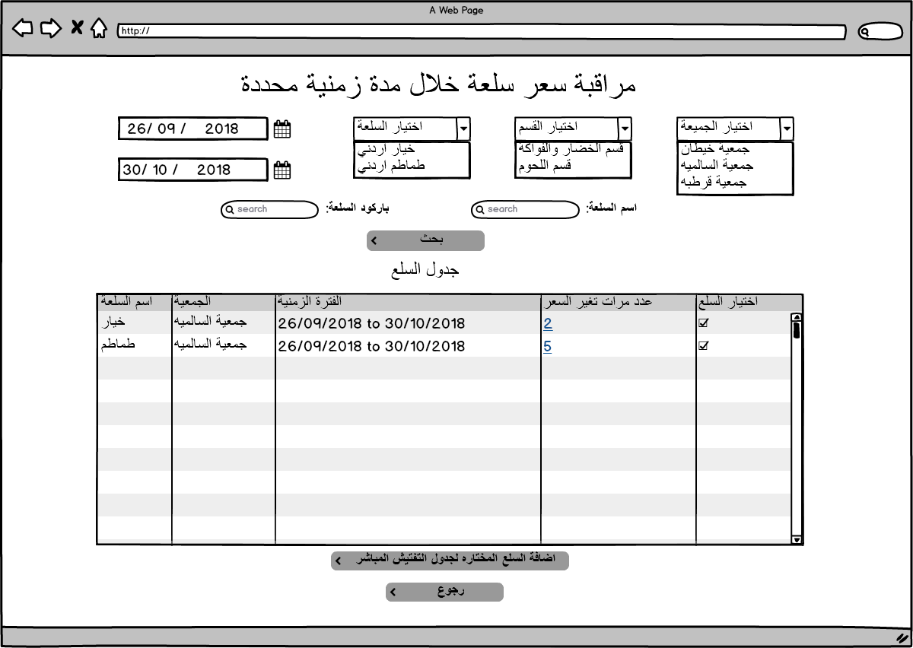

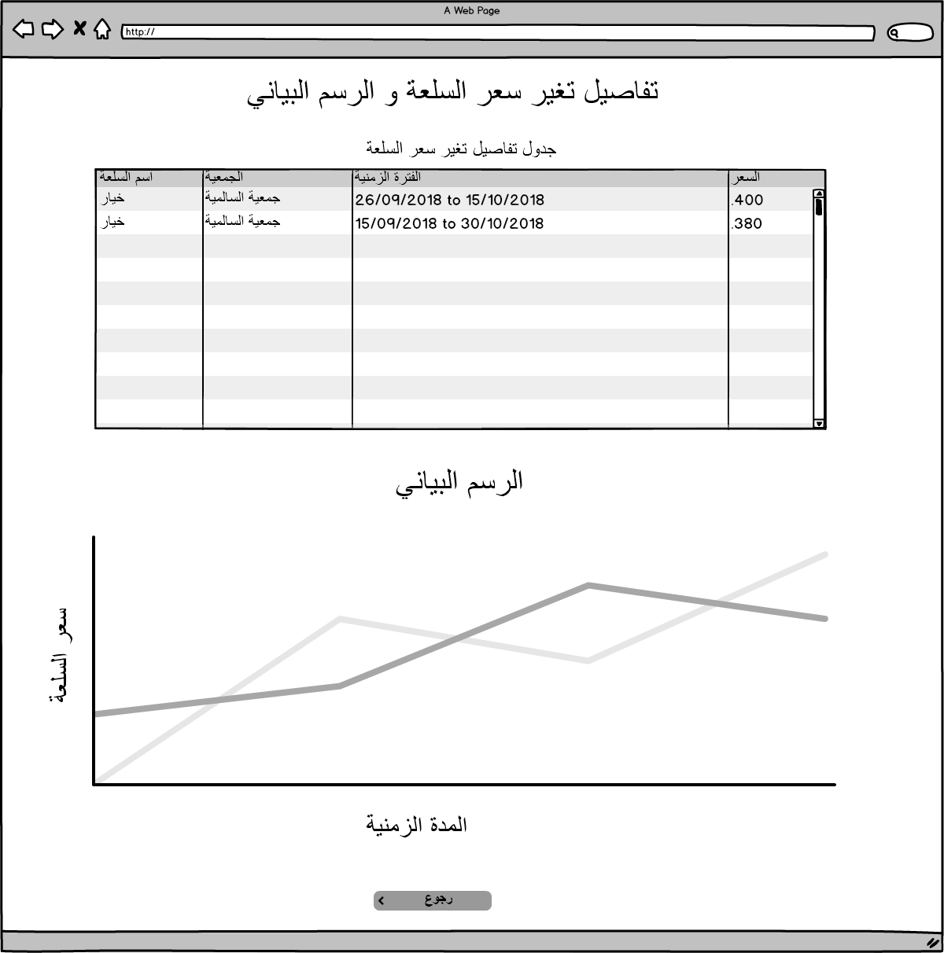

|  |  |  |  |  |  |  |  |  |
| --- | --- | --- | --- | --- | --- | --- | --- | --- |
| Item Price Monitoring within Period of Time. | | | | | | | | |
| Field | Description | | Type | Default value | Mandatory | | Length | Notes |
| Cooperative list | To select targeted cooperative. | | Drop down list | Non-Selected | Mandatory | | N/A | PMON_DET_RAWDATA.RAWDATA_MSTR_COOP_ID |
| Category list | All categories in the selected cooperative should be displayed. | | Drop down list | Non-Selected | Optional | | N/A | Could be changed to popup table. If it selected supplier list will be filtered to match the supplier in the selected category.  DB: PMON_DET_RAWDATA.RAWDATA_CSV_ITEM_CATEGORY |
| Supplier List | All suppliers in the selected cooperative should be displayed. | | Drop down list | Non-Selected | Optional | | N/A | If selected category list will be filtered to match the categories that the suppliers have items in.  DB:  PMON_DET_RAWDATA.RAWDATA_CSV_SUPPLIER_NAME |
| Item list | Items will be filtered based on the selection for the supplier and the category. | | Drop down list | Non-Selected | Optional | | N/A | Could be changed to popup table.  DB: PMON_DET_RAWDATA.RAWDATA_CSV_ITEM_NAME_AR |
| Item Name Search | To insert the item name targeted for search based on the cooperative, category and supplier if it selected. | | Text field | Empty | Optional | | 50 | Popup table displayed with all items related to the inserted text in search box.  Will search in PMON_DET_RAWDATA. RAWDATA_CSV_ITEM_NAME_AR or PMON_DET_RAWDATA. RAWDATA_CSV_ITEM_NAME_EN |
| Barcode Search | To insert the barcode number for the targeted item. | | Text field | Empty | Optional | | 20 | DB: PMON_DET_RAWDATA.RAWDATA_CSV_ITEM_BARCODE |
| Start date | To insert the start date of monitoring and to get the Item details as per the date inserted. | | Date | System Date | Mandatory | | N/A | Date should be less than the end date. |
| End date | To insert the end date for the period targeted for monitoring. | | Date | System Date | Mandatory | | N/A | Date should not be more than the system date. |
| Add to inspection table | To send the selected items from search result table to inspection table | | Button | Enabled | Optional | | N/A | Items added and classified in inspection details screen. Note: the details of the items sent to the inspection table in system date. DB: INSP_PRICE_INSPECTION |
| Search Action | To Get the result based on the inserted search criteria. | | Button | Disabled | Mandatory | | N/A | Button becomes enabled once the user inserts a correct search criteria. |
| Back Button | To Back to Home Page of the price Monitoring | | Button | Enabled | Mandatory | | N/A |  |
| Item Price Change Details and Chart Line Screen | | | | | | | | |
| Details Table | Highlight the price for the item for each time | | table | N/A | Mandatory | | N/A | Described in search result section. |
| Chart Line | Y axis is the price and X axis is the time | | Chart Line | N/A | Mandatory | | N/A | Described in search result section. |
| Search Result | | | | | | | | |
| Column Name | | **Column Description** | | | | **Notes** | | |
| Item Name | | Item Name. | | | | PMON_DET_RAWDATA.RAWDATA_CSV_ITEM_NAME_EN or PMON_DET_RAWDATA.RAWDATA_CSV_ITEM_NAME_AR | | |
| Cooperative Name | | Name of the cooperative that item related to. | | | | PMON_DET_RAWDATA.RAWDATA_MSTR_COOP_ID | | |
| Period inserted. | | The start and end date inserted. | | | | From date - to date | | |
| Number of times the price has changed. | | Total number of the price changed. As link if clicked redirect the user to details table and chart line (Item price change chart). | | | |  | | |
| Check box | | To let the user check the item and send it to inspection table. | | | |  | | |
| Item Price Change Details and Chart Line Screen | | | | | | | | |
| Column Name | | **Column Description** | | | | **Notes** | | |
| Item Name | | Item Name. | | | |  | | |
| Cooperative Name | | Name of the cooperative that item related to. | | | |  | | |
| The period with the same price | | The period that have the same price | | | |  | | |
| Item Price | | Item Selling Price | | | |  | | |

# Item Price Average within Period (متوسط سعرسلعة خلال مدة زمنية)

## Description

The Item price average within period will let the user to get the item defined price average during specific period for selected cooperatives with a chart column for the price average for the period inserted and the cooperatives included in the search, the user has the following search criteria available:

1. Search by Barcode: The system display the Item has the barcode inserted.
2. Search by Item Name: The system will display all items related or close to the inserted text.

And the following Filters:

1. Cooperatives Selection: The user should determine a cooperative.
2. Category: The system will display all categories added by the user in Add category screen.
3. Item list Selection: The system will display all Items added by the user in add items screen.
4. The user should insert the start and end date for the search.

## Process identification card

|  |  |
| --- | --- |
| Process ID | PM - PM005 |
| Process name | The Item average price change within period |
| Process purpose | Get the item average price change during specific period with a chart column |
| Initiator user | Inspections Department users. |
| Process owner | The admin of this process |
| Process type | Main Process |

## Process preconditions

.CSV file uploaded on CO-OPs System.

## Process input

.CSV file uploaded on CO-OPs system.

## Process output

The user will get the Item price average for specific item within specific period.

## Process model



## Functional requirements

List of the functional requirements:

|  |  |  |  |
| --- | --- | --- | --- |
| REQ # | Requirement | Description | Notes |
| FR – PM - 001 | Cooperative Selection | All cooperatives in the system should be displayed. |  |
|  | Search on items by category | All Categories added by the user in add category screen should be displayed. | (Note only mapped categories displayed and mapped cooperatives included in the search) |
|  | Search on Items by Supplier | All suppliers that exist in add supplier screen should be displayed. | (Note only mapped suppliers displayed and mapped cooperatives included in the search) |
|  | Search on items by barcode | The user can insert the item barcode to display the items details result for the selected cooperatives. |  |
|  | Search on items by Items Names | The user can insert the item name to display all related results for the selected cooperatives. |  |
|  | Items Select list | The user can select the item after select the category or the supplier which will display all items mapped to the supplier or to the category. | (Note only mapped Items displayed and mapped cooperatives included in the search) |
|  | Search result will display a table | Results will in a table contains the cooperative name, the item name and the item price average within the inserted period. |  |
|  | Chart column for the price Average with the cooperative | Chart column will be displayed for the price Average within the period inserted by the user as Y axis and a column for each cooperative included in the search on X axis. | Please refer to the mockup chart column for more details. |

## Use Cases

### Item Price Average within period

|  |  |
| --- | --- |
| Use Case ID | PM -UC06 |
| Use Case Name | Item Price Average within period |
| Actors | Privileged users |
| Description | Get the Item price Average in different cooperatives within period. |
| Preconditions | .CSV file uploaded to CO-OPs system for the selected date. |
| Post conditions | Item Average Price within Period, chart column. |
| Business rules | 1. Results for the items should be displayed based on the search criteria inserted by the user. 2. Date should be inserted. |

**Main Flow**

|  |  |  |
| --- | --- | --- |
| # | Actor Action | System Response |
| 1 | The privileged user navigates to Item Price Average within Period of Time | Item Price Average within Period screen displayed and all fields with the default value. |
| 2 | The user selects the provider or the category. | Option selected, items list filtered based on the selection and the mapped items in add category or add provider only displayed. (Cooperative shuttle field disabled.) |
| 3 | The user selects the item | Item selected. |
| 4 | The user inserts the start and end date. | Dates inserted. |
| 5 | The user clicks on search button. | Results display in the table. |
|  |  |  |
|  |  |  |

**Alternative Flows**

|  |  |  |
| --- | --- | --- |
| # | Actor Action | System Response |
| 1 | The user select the cooperatives targeted | Cooperatives selected. |
| 2 | The user inserts the item barcode. | Category list, item list, supplier list, search box should be disabled. |
| 3 | The user inserts the date for the search. | Date inserted. |
| 4 | The user clicks on search button. | Item details displayed. |
| Second flow | | |
| 1 | The user select the cooperatives targeted | Cooperatives selected. |
| 2 | The user inserts the item name in search box. | Category list, item list, supplier list, barcode text box should be disabled. |
| 3 | The user inserts the date for the search. | Date inserted. |
| 4 | The user clicks on search button. | Items related details displayed in the table. |
|  |  |  |
|  |  |  |
|  |  |  |

**Exceptional Flows**

|  |  |  |
| --- | --- | --- |
| # | Actor Action | System Response |
| 1 | The user does not select the cooperatives targeted for the search. | Cooperatives not selected. |
| 2 | The user inserts the search date. | Date inserted. |
| 3 | The user clicks on search button. | No results and error message displayed. |
|  |  |  |
|  |  |  |

**System Messages:**

|  |  |  |  |
| --- | --- | --- | --- |
| # | Actor Action | Message Type | System Response |
| 1 | The user does not insert the search date and click on search button. | Error Message | يرجى ادخال التاريخ |
| 2 | The user clicks on search button without insert any field. | Error Message | يرجى ادخال الحقول الالزاميه |
| 3 | The user insert data that does not display any search result. | Error Message | لا يوجد نتائج للبحث |
| 5 | Missed detail for Item displayed in the table after search. | Error Message for each column | لم يتم تزويد المعلومات من قبل الجمعيه |

### Task screens and fields

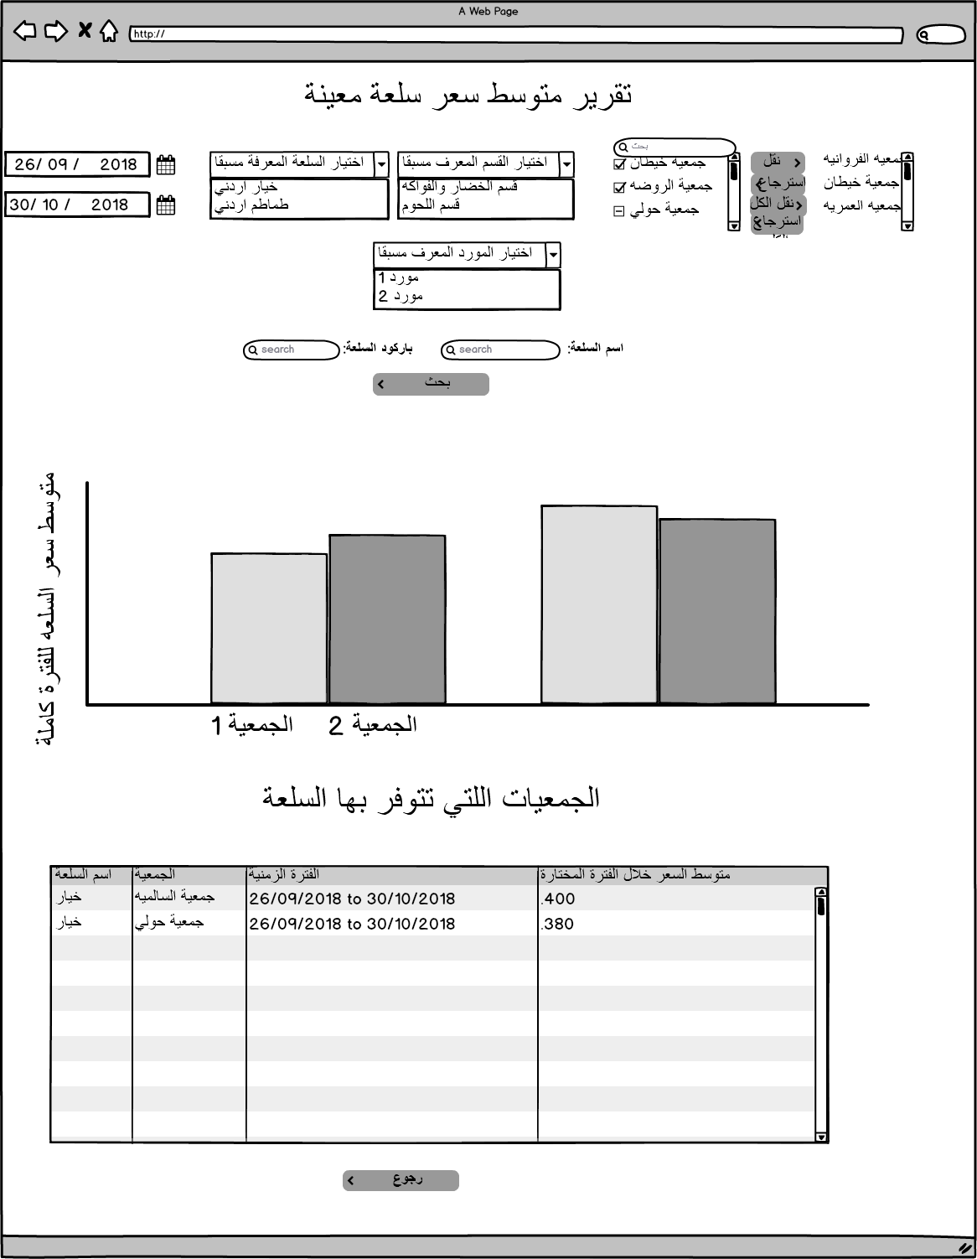

|  |  |  |  |  |  |  |  |  |
| --- | --- | --- | --- | --- | --- | --- | --- | --- |
| Item Price Average within Period of Time. | | | | | | | | |
| Field | Description | | Type | Default value | Mandatory | | Length | Notes |
| Cooperative list | To select targeted cooperative. | | Drop down list | Non-Selected | Mandatory | | N/A | Select distinct PMON_GEN_ITEM_RAWDATA .RAW_DATA_COOP_ID |
| Category list | Category list will display already added categories in add category screen. | | Drop down list | Non-Selected | Optional | | N/A | Only mapped cooperatives will be included in the search and cooperative shuttle field becomes disabled.  DB: Select PMON_ITEM_SECTIONS.MSTR_SECTION_NAME_AR FROM |
| subCategory list | Category list will display already added categories in add category screen. | | Drop down list | Non-Selected | Optional | | N/A | Only mapped cooperatives will be included in the search and cooperative shuttle field becomes disabled.  Select PMON_ITEM_SECTIONS_DETALS.SECTION_NAME_AR where PMON_ITEM_SECTIONS.MSTR_SECTION_NAME_AR = from value |
| Supplier List | Supplier list will display already added suppliers in add suppliers screen. | | Drop down list | Non-Selected | Optional | | N/A | Only mapped cooperatives will be included in the search and cooperative shuttle field becomes disabled.  Select PMON_SUPPLIER. SUPPLIER_DESC_AR from PMON_SUPPLIER; |
| Item list | Items will be filtered based items already defined in defined Items screen. | | Drop down list | Non-Selected | Optional | | N/A | Only mapped cooperatives will be included in the search and cooperative shuttle field becomes disabled.  Select PMON_GENERAL_ITEMS.ITEM_DESC_AR or PMON_GENERAL_ITEMS.ITEM_DESC_EN from PMON_GENERAL_ITEMS |
| Item Name Search | To insert the item name targeted for search based on the cooperative, category and supplier if it selected. | | Text field | Empty | Optional | | 50 | Popup table displayed with all items related to the inserted text in search box.  Cooperatives selection becomes mandatory. And search result display the items shared between the selected cooperatives.  DB: PMON_GENERAL_ITEMS.ITEM_DESC_AR or PMON_GENERAL_ITEMS.ITEM_DESC_EN |
| Barcode Search | To insert the barcode number for the targeted item. | | Text field | Empty | Optional | | 20 | PMON_GENERAL_ITEMS.ITEM_UNIV_BARCODE |
| Start date | To insert the start date of monitoring and to get the Item details as per the date inserted. | | Date | System Date | Mandatory | | N/A | Date should be less than the end date. |
| End date | To insert the end date for the period targeted for monitoring. | | Date | System Date | Mandatory | | N/A | Date should not be more than the system date. |
| Search Action | To Get the result based on the inserted search criteria. | | Button | Disabled | Mandatory | | N/A | Button becomes enabled once the user inserts a correct search criteria. |
| Back Button | To Back to Home Page of the price Monitoring | | Button | Enabled | Mandatory | | N/A |  |
| Item Price Change Details and Chart Line Screen | | | | | | | | |
| Details Table | Highlight the average price for the item for each period and each cooperative | | table | N/A | Mandatory | | N/A | Described in search result section. |
| Chart Column | Y axis is the price and X axis is the time | | Chart Line | N/A | Mandatory | | N/A | Described in search result section. |
| Search Result | | | | | | | | |
| Column Name | | **Column Description** | | | | **Notes** | | |
| Item Name | | Item Name. | | | |  | | |
| Cooperative Name | | Name of the cooperative that item related to. | | | |  | | |
| Period inserted. | | The start and end date inserted. | | | |  | | |
| Average Price within the period | | Total Prices for the item in the period / number of days | | | |  | | |
| Chart Column | | | | | | | | |
| Column Name | | **Column Description** | | | | **Notes** | | |
| Y axis | | Average Price | | | | Please refer to mockup for more details | | |
| X axis | | Cooperative Name | | | | Please refer to mockup for more details | | |

# Add Category Screen (اضافة قسم)

## Description

Add category screen will let the user to add General categories and subcategories to group related General items created by the user in it and to be used as a filter in monitoring screens.

## Screen identification card

|  |  |
| --- | --- |
| Process ID | PM - PM007 |
| Screen name | Add Category |
| Screen purpose | Add General Categories to group general items for mapping. |
| Initiator user | Inspections Department users. |
| Process type | Main Process |

## Screen output

General Categories created to be used as the category for the general items created and to be used as a search filter in Monitoring screens.

## Functional requirements

List of the functional requirements:

|  |  |  |  |
| --- | --- | --- | --- |
| REQ # | Requirement | Description | Notes |
| FR – PM - 001 | The user can add new category | The user can add a category and a description for the category. |  |
|  | The Added Category display in add item screen. | All Categories added by the user in add category screen should be displayed in add item screen in add category list. |  |
|  | The user can edit category. | The user can edit the name and the description for the category. |  |
|  | The user can delete category. | The user can delete a category. |  |
|  | The user created the category will be added to the category table. | The user Name will be added to the category created in each row in the table. |  |

## Use Cases

### Add, Edit, Delete Category

|  |  |
| --- | --- |
| Use Case ID | PM -UC07 |
| Use Case Name | Add Category and subcategory. |
| Actors | Privileged users |
| Description | Add, Edit and Delete category/subcategory. |
| Preconditions | Category not already created. |
| Post conditions | Category created and displayed in add item screen in category select list. |
| Business rules | 1. No Duplicate Names in Category table. |

**Main Flow**

|  |  |  |
| --- | --- | --- |
| # | Actor Action | System Response |
| 1 | The privileged user navigates to Add category Screen. | Add Category screen displayed. |
| 2 | The user clicks on add category button | Popup displayed with text fields for category name and category description. |
| 3 | The user inserts the category name and category description and click on OK button. | New Row in the Category table created. |
| 4 | The user adds subcategory | Subcategory added. |
| Second Flow | | |
| 1 | The user clicks on Edit link for any row in the category table. | Popup displayed with text fields for category name and category description. |
| 2 | The user updates the category name and category description and click on OK button. | The Row in the Category table updated. |
| Third Flow | | |
| 1 | The user clicks on Delete link for any row in the category table. | Popup Confirmation message displayed. (سيتم حذف القسم وجميع السلع المربوطه في شاشة اضافة سلعه،تأكيد الحذف)) |
| 2 | The user confirm. | The Row in the Category table Deleted. |
|  |  |  |

**Alternative Flows**

|  |  |  |
| --- | --- | --- |
| # | Actor Action | System Response |
|  |  |  |
|  |  |  |
|  |  |  |

**Exceptional Flows**

|  |  |  |
| --- | --- | --- |
| # | Actor Action | System Response |
| 1 | The privileged user navigates to Add category Screen. | Add Category screen displayed. |
| 2 | The user clicks on add category button | Popup displayed with text fields for category name and category description. |
| 3 | The user click on cancel button. | No New category added in the table. |
|  |  |  |
|  |  |  |

**System Messages:**

|  |  |  |  |
| --- | --- | --- | --- |
| # | Actor Action | Message Type | System Response |
| 1 | The user insert Category Name already exist in add or edit category. | Error Message | القسم معرف مسبقا يرجى ادخال قسم اخر |
|  |  |  |  |
|  |  |  |  |

### Task screens and fields

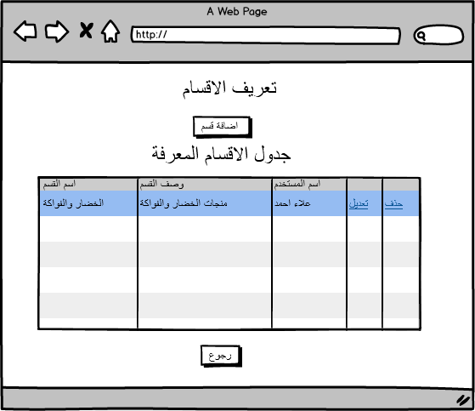

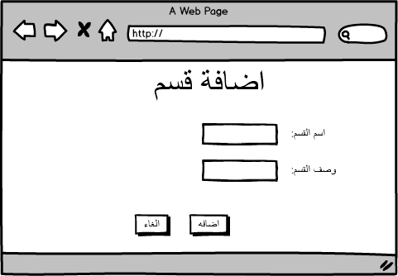

|  |  |  |  |  |  |  |  |  |
| --- | --- | --- | --- | --- | --- | --- | --- | --- |
| Add Category Screen | | | | | | | | |
| Field | Description | | Type | Default value | Mandatory | | Length | Notes |
| Add Category | To display add category popup | | Button | Enabled | Mandatory | | N/A |  |
| Add Category popup | | | | | | | | |
| Category Name | Category Name | | Text Field | Enabled | Mandatory | | 30 |  |
| Category Description | Description | | Text Field | Enabled | Mandatory | | 30 |  |
| Ok | Category will be added. | | Button | Enabled | Mandatory | | N/A |  |
| Cancel | Action Canceled | | Button | Enabled | Mandatory | | N/A |  |
| Categories Table | | | | | | | | |
| Column Name | | **Column Description** | | | | **Notes** | | |
| Category Name | | Category Name. | | | |  | | |
| Category Description | | Description | | | |  | | |
| Edit Link | | To Edit the Category Name and Category Description | | | | Link display with each row inserted.  Note: Same add Category popup displayed with exist name and description. | | |
| Delete Link | | To delete the category. | | | | Link displays with each row inserted.  Note:   1. on click Confirmation message displayed (سيتم حذف القسم وجميع السلع المربوطه في شاشة اضافة سلعه،تأكيد الحذف)) 2. All mapped Items to this category in add items screen will be deleted. | | |

# Profit Margin Screen (هوامش الربح)

## Description

Profit Margin screen will let the user to define the profit margin for commodity group.

## Screen identification card

|  |  |
| --- | --- |
| Process ID | PM - PM007 |
| Screen name | Profit Margins |
| Screen purpose | Create, Edit, Delete profit margin commodity group. |
| Initiator user | Inspections Department users. |
| Process type | Main Process |

## Screen output

Profit margin commodity group created to be used as the profit margin based on MOSA law for the cooperatives items and to be used as a search filter in Monitoring screens.

## Functional requirements

List of the functional requirements:

|  |  |  |  |
| --- | --- | --- | --- |
| REQ # | Requirement | Description | Notes |
| FR – PM - 001 | The user can create new profit margin commodity | The user can add a profit margin commodity group name its percentage value. |  |
|  | The Added profit margin commodity group display in all areas that the user can edit or add the profit margin | Profit Margin commodity group will display in all areas in the system have the option to edit or add profit margin. |  |
|  | The user can edit profit Margin commodity group name and it is percentage. | The user can edit profit Margin commodity group name and it is percentage as a select list. |  |
|  | The user can delete profit Margin commodity group. | The user can delete a profit Margin commodity group. |  |
|  | The user created the profit Margin commodity group will be added to the profit Margin commodity group table. | The user Name will be added to the profit Margin commodity group created in each row in the table. |  |

## Use Cases

### Create, Edit Delete Profit Margin

|  |  |
| --- | --- |
| Use Case ID | PM -UC07 |
| Use Case Name | Profit Margin Commodity Group |
| Actors | Privileged users |
| Description | Create, Edit and Delete profit Margin commodity group. |
| Preconditions | Profit Margin commodity group not already created. |
| Post conditions | Profit Margin commodity group created and displayed in areas the user can edit the profit margin as a select list. |
| Business rules | 1. No Duplicate Names in profit Margin commodity group table. |

**Main Flow**

|  |  |  |
| --- | --- | --- |
| # | Actor Action | System Response |
| Create profit margin commodity group | | |
| 1 | The privileged user navigates to Profit Margin Screen. | Profit Margin screen displayed. |
| 2 | The user clicks on add Profit Margin button | Popup displayed with text fields for commodity group name and profit margin. |
| 3 | The user inserts the commodity group and profit margin and click on OK button. | New Row in the profit margin commodity group table created. |
| Edit profit margin commodity group | | |
| 1 | The user clicks on Edit link for any row in the profit margin commodity group table. | Popup displayed with text fields for commodity group name and profit margin. |
| 2 | The user updates the commodity group name and profit margin and click on OK button. | The Row in the profit margin commodity table updated. |
| Delete profit margin commodity group | | |
| 1 | The user clicks on Delete link for any row in the profit margin commodity table. | Popup Confirmation message displayed. (سيتم حذف المجموعة السلعية من جميع السلع المعرف لها هامش ربح،تأكيد الحذف)) |
| 2 | The user confirms. | The Row in the profit margin commodity table Deleted. |
|  |  |  |

**Alternative Flows**

|  |  |  |
| --- | --- | --- |
| # | Actor Action | System Response |
|  |  |  |
|  |  |  |
|  |  |  |

**Exceptional Flows**

|  |  |  |
| --- | --- | --- |
| # | Actor Action | System Response |
| 1 | The privileged user navigates to profit margin Screen. | Profit margin screen displayed. |
| 2 | The user clicks on add profit margin button | Popup displayed with text fields for commodity group name and profit margin. |
| 3 | The user click on cancel button. | No New profit margin added in the table. |
|  |  |  |
|  |  |  |

**System Messages:**

|  |  |  |  |
| --- | --- | --- | --- |
| # | Actor Action | Message Type | System Response |
| 1 | The user insert profit margin commodity group Name already exist in add or edit profit margin commodity table. | Error Message | المجموعة السلعية معرفة مسبقا يرجى ادخال مجموعة اخرى |
|  |  |  |  |
|  |  |  |  |

### Task screens and fields

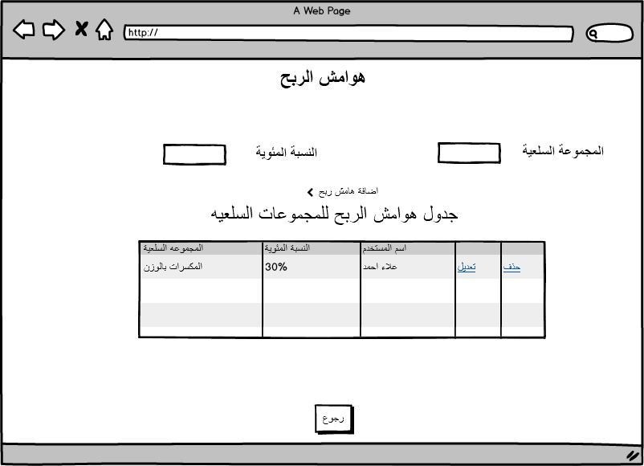

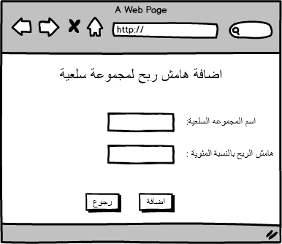

|  |  |  |  |  |  |  |  |  |
| --- | --- | --- | --- | --- | --- | --- | --- | --- |
| Profit Margin Screen | | | | | | | | |
| Field | Description | | Type | Default value | Mandatory | | Length | Notes |
| Add profit Margin | To display add profit margin popup | | Button | Enabled | Mandatory | | N/A |  |
| Add Category popup | | | | | | | | |
| Profit margin commodity group Name | Profit margin commodity group Name | | Text Field | Enabled | Mandatory | | 30 |  |
| Profit Margin | Profit margin in percentage | | Number | Enabled | Mandatory | | 30 |  |
| Ok | Profit margin commodity group will be added. | | Button | Enabled | Mandatory | | N/A |  |
| Cancel | Action Canceled | | Button | Enabled | Mandatory | | N/A |  |
| Profit margin commodity group Table | | | | | | | | |
| Column Name | | **Column Description** | | | | **Notes** | | |
| Profit margin commodity group Name | | Profit margin commodity group Name. | | | |  | | |
| Profit Margin percentage | | Profit Margin percentage | | | |  | | |
| Edit Link | | To Edit the Profit margin commodity group Name and value | | | | Link displays with each row inserted.  Note: Same add profit margin popup displayed with exist name and value. | | |
| Delete Link | | To delete the profit margin commodity group. | | | | Link displays with each row inserted.  Note:   1. on click Confirmation message displayed (سيتم حذف المجموعه السلعيه من جميع السلع المعرف لها هامش ربح،تأكيد الحذف)) 2. All Items have this group of profit margin will be removed | | |

# Manage Defined Items Screen (ادارة السلع المعرفة)

## Description

Manage and Define Items screen will let the user to define new Items and link it with the category and items in different cooperatives, also will let the user to add/update/cancel union items after referring to (formal letters from the union).

## Screen identification card

|  |  |
| --- | --- |
| Process ID | PM - PM008 |
| Screen name | Manage Defined Items Screen |
| Screen purpose | Define new Items, link it with defined categories and link with items in different cooperatives, add/update/cancel union item and link it with cooperatives items. |
| Initiator user | User have permission. |
| Process type | Main Process |

## Screen output

General Items created, linked with defined categories and different cooperatives to be used in price monitoring screen, add/update/cancel union item and auto link union item with the cooperative’s items.

## Functional requirements

List of the functional requirements:

|  |  |  |  |
| --- | --- | --- | --- |
| REQ # | Requirement | Description | Notes |
| FR – PM - 001 | The user can define new Item | The user can add new item with provenance, measuring unit, category and profit margin. |  |
|  | The user can add new union items based on official letter from the union | The user can add union item have the details of : Item name, item barcode, package size, measuring unit, provenance, category, circular number, brand, official circular number, official circular date, supplier name, package cost, item selling price. |  |
|  | The user can link the item in different cooperatives | The user links the defined item with single item in each cooperative. | The user will use Price Monitoring screen to link the items cooperatives. |
|  | The system will auto link union item. | The system will auto link union item with the cooperatives items. |  |
|  | The user can edit the defined item. | The user can edit the name, provenance, measuring unit, category and profit margin. |  |
|  | The user can edit the union item. | By referring to the official letter from the union the user will be able update the item details. |  |
|  | The user can remove the defined Item. | The user can remove defined item and the table of the linked items will be removed also. |  |
|  | The user can cancel union item. | The user will be able to cancel union item by referring to official letter from the union. |  |
|  | The user can delete item linked from cooperative | The user can delete item from a cooperative linked to defined item. | Only the link between the defined item and the item from a cooperative will be removed. |
|  | The user will not be able to manually link union item. | Union item will be linked automatically to cooperatives items. |  |
|  | Defined Items and union items display in a table | A table have Item Name, provenance, measuring unit, category, User Name, Edit and Delete links, item type. |  |
|  | All items linked from cooperatives with defined item or union item display in a table | The user selects the defined item/ union item all linked items from different cooperatives will display in a separate table. |  |
|  | The user defined the Item will be added to the defined Items table. | The user Name will be added to the defined Items table in each row in the table. |  |
|  | The user can search in define table items. | The user can search in define table items by Item Name, provenance, measuring unit, item type, barcode, User name. |  |

## Use Cases

### Define Items

|  |  |
| --- | --- |
| Use Case ID | PM -UC08 |
| Use Case Name | Define Items |
| Actors | Privileged users |
| Description | Add, Edit and Delete Defined items. |
| Preconditions | 1. Item not defined before.  2. Category Needed already defined.  3. Profit Margin list already defined. |
| Post conditions | 1. Defined Item created in Define Item Table. 2. User created the item displays in define Item table. 3. The user can link cooperatives items to the defined item. 4. The user can select the defined item to display all linked items from cooperatives. 5. The user can edit or delete defined item. |
| Business rules | 1. No Duplicate Names in define item table. 2. Provenance, measuring unit, category, user name and profit margin displayed in define item table after creation. 3. If the user delete the defined item all linked items from cooperatives will be deleted. |

**Main Flow**

|  |  |  |
| --- | --- | --- |
| # | Actor Action | System Response |
| 1 | The privileged user navigates to Add and link Items Screen. | Add and link Items screen displayed. |
| 2 | The user clicks on add Item button | Popup displayed with Item Name, provenance, measuring unit and category profit margin. |
| 3 | The user inserts the Name, provenance, measuring unit and category profit margin and click on OK button. | New Row in the Defined items table created. |
| Second Flow | | |
| 1 | The user clicks on Edit link for any row in the defined items table. | Popup displayed Name, provenance, measuring unit and category profit margin. |
| 2 | The user updates the Name, provenance, measuring unit and category profit margin and click on OK button. | The Row in the defined items table updated. |
| Third Flow | | |
| 1 | The user clicks on Delete link for any row in the defined items table. | Popup Confirmation message displayed. (سيتم حذف السلعه وجميع السلع المربوطه فى جدول السلع المرتبطه ،تأكيد الحذف)) |
| 2 | The user confirm. | The Row in the defined item table Deleted. |
|  |  |  |

**Alternative Flows**

|  |  |  |
| --- | --- | --- |
| # | Actor Action | System Response |
|  |  |  |
|  |  |  |
|  |  |  |

**Exceptional Flows**

|  |  |  |
| --- | --- | --- |
| # | Actor Action | System Response |
| 1 | The privileged user navigates to Add and link items Screen. | Add and link items screen displayed. |
| 2 | The user clicks on add item button | Popup displayed with Name, provenance, measuring unit and category profit margin. |
| 3 | The user clicks on cancel button. | No New category added in the table. |
|  |  |  |
|  |  |  |

**System Messages:**

|  |  |  |  |
| --- | --- | --- | --- |
| # | Actor Action | Message Type | System Response |
| 1 | The user inserts or edit Item Name already exist in defined items table. | Error Message | السلعه معرفه مسبقا يرجى ادخال سلعه اخرى |
| 2 | The user does not insert a mandatory field | Error Message | يرجى ادخال الحقول الالزاميه |
|  |  |  |  |

### Link Cooperatives items

|  |  |
| --- | --- |
| Use Case ID | PM -UC09 |
| Use Case Name | Link cooperatives Items to defined items |
| Actors | Privileged users |
| Description | 1. Link and delete link between defined item and cooperatives items. |
| Preconditions | 1.Cooperatives Items inserted to MOSA DB  2. Item Already defined by the user. |
| Post conditions | 1. Defined Item created in Define Item Table. 2. User created the item displays in define Item table. 3. The user can link cooperatives items to |
| Business rules | 1. The user can link from any cooperative only one item to the defined item. 2. The cooperative items could not be linked for more than one defined item. |

**Main Flow**

|  |  |  |
| --- | --- | --- |
| # | Actor Action | System Response |
| 1 | The privileged user navigates to Add and link Items Screen. | Add and link Items screen displayed. |
| 2 | The user click on link item from cooperative button | Price monitoring screen displayed, only search options and link item button is enabled. |
| 2 | The user search for any item as it is described in price monitoring use case. | Items displayed in the table based on the search criteria used. |
| 3 | The user select item\s from different cooperative\s. | Items selected. |
|  | The user click on link item to defined item button. | All items selected are added to the cooperatives items table. |
| Second Flow | | |
| 1 | The user clicks on Delete link for any row in the cooperatives items table. | Popup Confirmation message displayed. (سيتم حذف السلعه تأكيد الحذف) |
| 2 | The user confirm. | The Row in the cooperatives items table Deleted. |
|  |  |  |

**Alternative Flows**

|  |  |  |
| --- | --- | --- |
| # | Actor Action | System Response |
|  | The user navigates to price monitoring screen and search for items. | Items displayed in price monitoring table. |
|  | The user select items. | Items selected |
|  | The user click on link items button | Defined items table displayed to select the targeted item. |
|  | The select the targeted defined item. | Items added to the cooperatives items table in add and link items screen. |

**Exceptional Flows**

|  |  |  |
| --- | --- | --- |
| # | Actor Action | System Response |
| 1 | The privileged user navigates to Add and link Items Screen. | Add and link Items screen displayed. |
| 2 | The user clicks on link item from cooperative button | Price monitoring screen displayed, only search options and link item button is enabled. |
| 3 | The user clicks on cancel button. | No Items added to cooperatives items screen. |

**System Messages:**

|  |  |  |  |
| --- | --- | --- | --- |
| # | Actor Action | Message Type | System Response |
| 1 | The user select item from a cooperative already linked. | Error Message | تم اضافة هذه السلعه مسبقا. |
| 2 | The user clicks on link item button in price monitoring screen without selecting any item. | Error Message | يرجى اختيار السلع المراد ربطها |

### Add/update/cancel union item

|  |  |
| --- | --- |
| Use Case ID | PM -UC08 |
| Use Case Name | Add/update/cancel union item |
| Actors | Privileged users |
| Description | Add, update and cancel union items. |
| Preconditions | 1. Item not defined before.  2. official letter from the union provided for add/update/delete. |
| Post conditions | 1. Added union Item created in Define Item Table. 2. User created the item displays in define Item table. 3. The system will auto link the union item with the cooperatives items in cooperatives items table. 4. The user can select the union item to display all linked items from cooperatives. 5. The user can edit or cancel union item. 6. The user can display the full details for the union item. |
| Business rules | 1. No Duplicate Names in define item table. 2. No duplicate barcodes for the union item. 3. Provenance, measuring unit, category, user name, details link, item type. displayed in define item table after creation. 4. If the user cancels the unoin item, the union item changed to canceled and this detail will be displayed in union item details screen. |

**Main Flow**

|  |  |  |
| --- | --- | --- |
| # | Actor Action | System Response |
| 1 | The privileged user navigates to Add and link Items Screen. | Add and link Items screen displayed. |
| 2 | The user clicks on add union Item button | Popup displayed with Item name, item barcode, package size, measuring unit, provenance, category, circular number, brand, official circular number, official circular date, supplier name, package cost, item selling price. |
| 3 | The user inserts the details click on OK button. | New Row in the Defined items table created with type union item. |
| Second Flow | | |
| 1 | The user clicks on Edit link for any union item in the defined items table. | Popup displayed Item name, item barcode, package size, measuring unit, provenance, category, circular number, brand, official circular number, official circular date, supplier name, package cost, item selling price. |
| 2 | The user updates the needed details and click on OK button. | The union item details in the defined items table updated. |
| Third Flow | | |
| 1 | The user clicks on cancel link for any union item in the defined items table. | Popup Confirmation message displayed. (سيتم الغاء السلعه وتحويل حالة السلعة الى ملغي ،تأكيد الالغاء)) |
| 2 | The user confirm. | The Row in the defined item table canceled. |
|  |  |  |

**Alternative Flows**

|  |  |  |
| --- | --- | --- |
| # | Actor Action | System Response |
| 1 | The user can click on upload Union file button | Brows popup will display. |
| 2 | The user selects the union CSV file | CSV file selected. |
| 3 | The user clicks on update button. | CSV records migrated to the system and will auto link and update union items. |

**Exceptional Flows**

|  |  |  |
| --- | --- | --- |
| # | Actor Action | System Response |
| 1 | The privileged user navigates to Add and link items Screen. | Add and link items screen displayed. |
| 2 | The user clicks on add union item button | Popup displayed with name, item barcode, package size, measuring unit, provenance, category, circular number, brand, official circular number, official circular date, supplier name, package cost, item selling price. |
| 3 | The user clicks on cancel button. | No New item added in the table. |
|  |  |  |
|  |  |  |

**System Messages:**

|  |  |  |  |
| --- | --- | --- | --- |
| # | Actor Action | Message Type | System Response |
| 1 | The user inserts or edit Item Name already exist in defined items table. | Error Message | السلعه معرفه مسبقا يرجى ادخال سلعه اخرى |
| 2 | The user does not insert a mandatory field | Error Message | يرجى ادخال الحقول الالزاميه |
|  |  |  |  |

### Task screens and fields

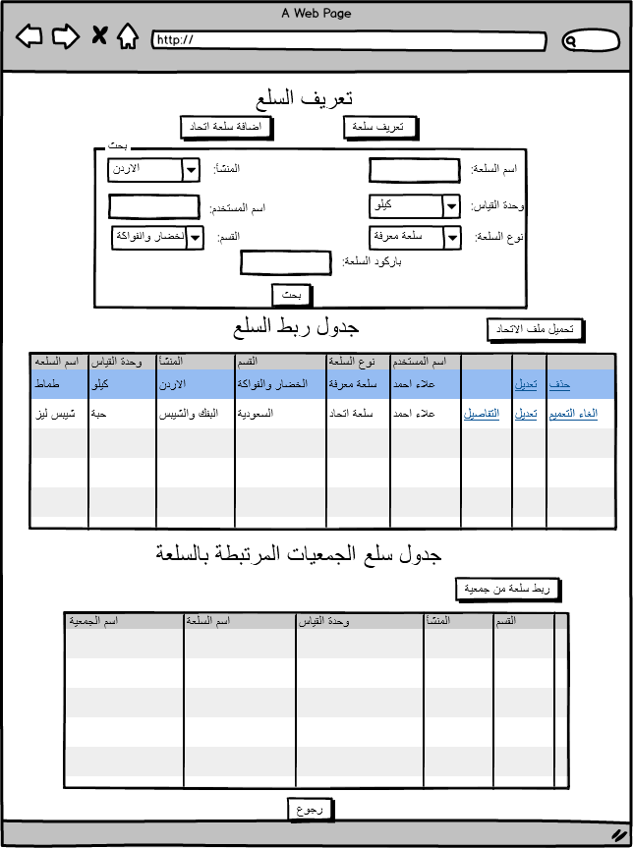

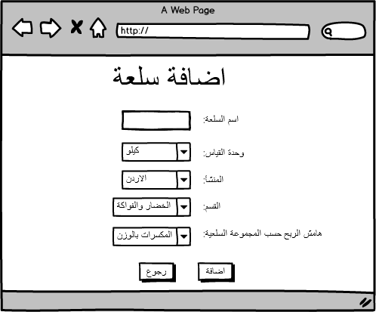

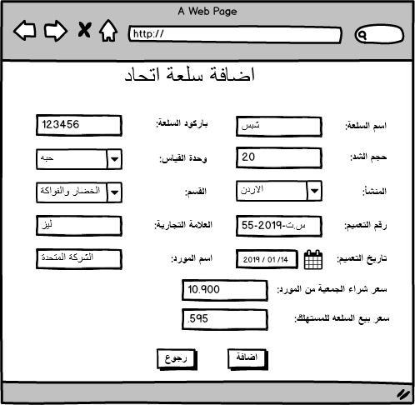

|  |  |  |  |  |  |  |  |  |
| --- | --- | --- | --- | --- | --- | --- | --- | --- |
| Add and Link Item Screen | | | | | | | | |
| Field | Description | | Type | Default value | Mandatory | | Length | Notes |
| define Item | To display define Item popup | | Button | Enabled | Mandatory | | N/A |  |
| Add union item | To display add union Item popup | | Button | Enabled | Mandatory | | N/A |  |
| Link defined item with cooperatives items | To Display Price Monitoring screen. | | Button | Enabled | Mandatory | | N/A | Price Monitoring screen displayed and only Link item button and search options are enabled. |
| Upload Union File | To display browse popup to select CSV file | | Button | Enabled | Mandatory | | N/A | Once the user selected the union CSV file the system will automatically insert and update the union items details and link cooperatives items. |
| Search Filters | | | | | | | | |
| Item Name | Search for item name | | Text Field | Enabled | Optional | | 30 | Search in defined item table |
| Provenance | To Select country | | Select list | Enabled | Optional | | N/A |  |
| Category | To Select Category | | Select list | Enabled | Optional | | N/A |  |
| Measuring Unit | To Select Measuring Unit | | Select list | Enabled | Optional | | N/A |  |
| User Name | To insert user name | | Text Field | Enabled | Optional | | N/A |  |
| Barcode | To insert barcode | | Text Field | Enabled | Optional | | N/A |  |
| Item Type | To select item type | | Select list | Enabled | Optional | | N/A |  |
| Tables | | | | | | | | |
| Defined item table | Defined item details | | Table | Enabled | Mandatory | | N/A | Table described below. |
| Link defined Item with cooperative items | cooperatives items details | | Table | Enabled | Mandatory | | N/A | Table described below. |
| define item popup | | | | | | | | |
| Item Name | Item Name | | Text Field | Enabled | Mandatory | | 30 |  |
| Category | All categories in categories table from add category screen. | | Select list | Enabled | Mandatory | | N/A |  |
| Measuring Unit | Measuring Unit | | Select list | Enabled | Mandatory | | N/A |  |
| Provenance | All countries | | Select list | Enabled | Mandatory | | N/A |  |
| Profit Margin | All Profit Margin in Profit Margin table from profit margin screen. | | Select list | Enabled | Mandatory | | N/A |  |
| User Name | The user logged in to the system. | | Text field | Hidden | Mandatory | | N/A |  |
| Ok | Defined item added to defined item table. | | Button | Enabled | Mandatory | | N/A |  |
| Cancel | Close the popup | | Button | Enabled | Mandatory | | N/A |  |
| Add Union Item | | | | | | | | |
| Item name | To insert union item Arabic name | | Select list | Enabled | Mandatory | | N/A |  |
| item Description | To insert union item Description | | Select list | Enabled | Mandatory | | N/A |  |
| English Item Name | To insert union item English name | |  |  |  | |  |  |
| item barcode | To insert union item barcode | | Select list | Enabled | Mandatory | | N/A |  |
| package size | To insert union item package size | | Select list | Enabled | Mandatory | | N/A |  |
| measuring unit | To insert union item measuring unit | | Select list | Enabled | Mandatory | | N/A |  |
| provenance | To insert union item provenance | | Select list | Enabled | Mandatory | | N/A |  |
| category | To insert union item category | | Select list | Enabled | Mandatory | | N/A |  |
| brand | To insert union item brand | | Select list | Enabled | Mandatory | | N/A |  |
| official circular number | To insert union item official circular number | | Select list | Enabled | Mandatory | | N/A |  |
| official circular date | To insert union item official circular date | | Select list | Enabled | Mandatory | | N/A |  |
| Supplier Name | To insert union item supplier name | | Select list | Enabled | Mandatory | | N/A |  |
| package cost | To insert union item package cost | | Select list | Enabled | Mandatory | | N/A |  |
| item selling price. | To insert union item selling price | | Select list | Enabled | Mandatory | | N/A |  |
| Defined Items Table | | | | | | | | |
| Column Name | | **Column Description** | | | | **Notes** | | |
| Item Name | | As it added from the add item popup | | | |  | | |
| Measuring unit | | As it added from the add item popup | | | |  | | |
| Provenance | | As it added from the add item popup | | | |  | | |
| Category | | As it added from the add item popup | | | |  | | |
| Item Type | | To display item type union or defined | | | |  | | |
| User name | | As it added from the add item popup | | | |  | | |
| Edit Link | | To Edit the defined item details | | | | Link displays with each row inserted.  Note: Same add item popup displayed with exist Item name, measuring unit, provenance, category, user name. | | |
| Details link | | To display union item details screen. | | | | This link display only for union items. | | |
| Delete Link | | To delete the defined item | | | | Link displays with each row inserted.  Note:   1. on click Confirmation message displayed (سيتم حذف السلعه وجميع السلع المربوطه في شاشة اضافة سلعه،تأكيد الحذف)) 2. All linked Items to this item in link items table will be deleted. | | |
| Linked cooperatives Item Table | | | | | | | | |
| Column Name | | **Description** | | | | **Notes** | | |
| Cooperative Name | | Item cooperative name | | | |  | | |
| Item Name | | Item name | | | |  | | |
| Measuring Unit | | Cooperative Measuring unit for the item | | | |  | | |
| provenance | | Cooperative Provenance for the item | | | |  | | |
| category | | Cooperative category | | | |  | | |
| Details | | Details for the cooperative item. | | | | This Link will display Item details screen for the selected item | | |
| Delete | | Will delete the cooperative item. | | | | on click Confirmation message displayed (هل ترغب بحذف السلعه من الربط) | | |

# Manage Defined Providers Screen (ادارة الموردين المعرفين)

## Description

Add and link Providers screen will let the user to define new Provider and link it with the category and items in different cooperatives to let the user get valid information about the total number of items in the cooperatives for each provider, to know every item for which provider belongs, to improve the search in for items in the cooperatives in the system.

## Screen identification card

|  |  |
| --- | --- |
| Process ID | PM - PM008 |
| Screen name | Add and link Items |
| Screen purpose | Define new provider, link providers with items in different cooperatives through defined items lists. |
| Initiator user | Inspections Department users. |
| Process type | Main Process |

## Screen output

General providers linked with defined items and different cooperatives items to be used in different monitoring screen and to know the total number of items for the provider in each cooperative and in all cooperatives.

## Functional requirements

List of the functional requirements:

|  |  |  |  |
| --- | --- | --- | --- |
| REQ # | Requirement | Description | Notes |
|  | The user can add and edit providers. | The user can add new provider with provider Name commercial license number and the user can edit created providers. |  |
|  | The user can link the defined item with different cooperatives items | The user links the defined item with single item in each cooperative. | The user will use defined items for search and link. |
|  | The user can edit the defined item. | The user can edit the provider name, measuring unit, and category. |  |
|  | The user can remove the defined Item. | The user can remove defined item and the table of the linked items will be removed also. |  |
|  | The user can delete item linked from cooperative | The user can delete item from a cooperative linked to defined item. | Only the link between the defined item and the item from a cooperative will be removed. |
|  | Defined provider display in a table | A table have provider Name, Commercial license, User Name, Edit and Delete links. |  |
|  | Defined Items display in a table | A table have Item Name, measuring unit, total number of items in cooperatives, Username, Edit and Delete links. |  |
|  | All items defined linked with a provider | The user selects the provider then all linked defined items will display in a separate table. |  |
|  | All items linked from cooperatives with defined item display in a table | The user selects the defined item then all linked items from different cooperatives will display in a separate table. |  |
|  | The user defined the Item will be added to the defined Items table. | The username will be added to the defined Items table in each row in the table. |  |
|  | The user defined the provider will be added to the defined provider table. | The username will be added to the defined provider table in each row in the table. |  |
|  | The user linked cooperative item with the defined Item table will be added to the cooperative’s items for the same provider | The username will be added to the linked cooperatives Items for the same provider table in each row in the table. |  |
|  | The user can search in define items table. | The user can search in define items table by Item Name, measuring unit, category, subcategory, provenance, User name. |  |

## Use Cases

### Define providers

|  |  |
| --- | --- |
| Use Case ID | PM -UC08 |
| Use Case Name | Define providers |
| Actors | Privileged users |
| Description | Add, Edit and Delete Defined providers. |
| Preconditions | 1. Provider not defined before. |
| Post conditions | 1. Defined provider created in Define provider Table. 2. User created the provider displays in defined provider table. 3. The user can link defined items to the defined provider. 4. The user can select the defined provider to display all linked defined items. 5. The user can edit or delete defined provider. |
| Business rules | 1. No Duplicate Names in defined provider table. 2. Provider name, commercial License, username displayed in defined provider table after creation. 3. If the user deletes the defined item all linked defined items and cooperatives items will be deleted. |

**Main Flow**

|  |  |  |
| --- | --- | --- |
| # | Actor Action | System Response |
| 1 | The privileged user navigates to Add and link providers Screen. | Add and link providers screen displayed. |
| 2 | The user clicks on add provider button | Popup displayed with provider Name, Commercial license text field displayed. |
| 3 | The user inserts the provider Name, Commercial License and click on OK button. | New Row in the Defined provider table created. |
| Second Flow | | |
| 1 | The user clicks on Edit link for any row in the defined providers table. | Popup displayed provider Name, Commercial license. |
| 2 | The user updates the provider Name, Commercial license and click on OK button. | The Row in the defined Provider table updated. |
| Third Flow | | |
| 1 | The user clicks on Delete link for any row in the defined providers table. | Popup Confirmation message displayed. (سيتم حذف المورد والسلعه المعرفه في جدول سلع المورد وجميع السلع المربوطه فى جدول الجمعيات من نفس المورد ،تأكيد الحذف)) |
| 2 | The user confirms. | The Row in the defined provider, defined provider items, linked cooperatives items from the same provider tables Deleted. |
|  |  |  |

**Alternative Flows**

|  |  |  |
| --- | --- | --- |
| # | Actor Action | System Response |
|  |  |  |
|  |  |  |
|  |  |  |

**Exceptional Flows**

|  |  |  |
| --- | --- | --- |
| # | Actor Action | System Response |
| 1 | The privileged user navigates to Add and link items Screen. | Add and link items screen displayed. |
| 2 | The user clicks on add provider button | Popup displayed with Provider Name, commercial license. |
| 3 | The user clicks on cancel button. | No New provider added in the table. |
|  |  |  |
|  |  |  |

**System Messages:**

|  |  |  |  |
| --- | --- | --- | --- |
| # | Actor Action | Message Type | System Response |
| 1 | The user inserts or edit provider Name already exist in providers table. | Error Message | المورد معرف مسبقا يرجى ادخال مورد اخر |
| 2 | The user does not insert a mandatory field | Error Message | يرجى ادخال الحقول الالزاميه |
|  |  |  |  |

### Define Items

|  |  |
| --- | --- |
| Use Case ID | PM -UC08 |
| Use Case Name | Define Provider Items |
| Actors | Privileged users |
| Description | Add, Edit and Delete Defined Provider items. |
| Preconditions | The provider has item mapped in defined items screen. |
| Post conditions | 1. Defined Items linked, created in Define Item Table in suppliers screen. 2. User created the Provider item displays in define Provider Item table. 3. The user can link cooperatives items for the same provider to the defined Provider item. 4. The user can select the defined Provider item to display all linked items from cooperatives for the same Provider. 5. The user can edit or delete defined Provider items. |
| Business rules | 1. Item Name, measuring unit, category, username displayed in defined Provider item table after creation. 2. If the user delete the defined Provider item all linked items from cooperatives will be deleted. |

**Main Flow**

|  |  |  |
| --- | --- | --- |
| Third Flow | | |
| 1 | The user clicks on Delete link for any row in the defined Provider items table. | Popup Confirmation message displayed. (سيتم حذف السلعه وجميع السلع المربوطه فى جدول السلع المرتبطه ،تأكيد الحذف)) |
| 2 | The user confirm. | The Row in the defined Provider item table Deleted. |
|  |  |  |

**Alternative Flows**

### Link Cooperatives items

|  |  |
| --- | --- |
| Use Case ID | PM -UC09 |
| Use Case Name | Link cooperatives Items to defined Provider |
| Actors | Privileged users |
| Description | 1. Link and delete link between defined Provider item and cooperatives items. |
| Preconditions | 1.Cooperatives Items inserted to MOSA DB  2. defined items are already mapped. |
| Post conditions | 1. Defined Items created in Define Provider Item Table. 2. User linked the cooperative item with defined items and mapped to selected supplier. 3. The user can link cooperatives items to defined provider item from. |
| Business rules | 1. The user can link from any cooperative only one item to the defined provider item. 2. The cooperative items could not be linked for more than one defined provider item. |

**Main Flow**

|  |  |  |
| --- | --- | --- |
| # | Actor Action | System Response |
| 1 | The privileged user navigates to Add and link provider Screen. | Add and link provider screen displayed. |
| 2 | The user selects provider. | Link button displayed. |
| 3 | The user click on link button. | Defined items screen displayed. |
| 4 | The user search for any defined item and select it. | Separate Mapped items table displayed with check boxes. |
| 5 | The user selects item\s from different cooperative\s. | Items selected. |
| 6 | The user clicks on link button. | The user redirected to provider screen and defined item displayed the defined items table and the cooperatives items displayed also in separate table. |
| Second Flow | | |
| 1 | The user clicks on Delete link for any row in the cooperative’s items from same providers table. | Popup Confirmation message displayed. (سيتم حذف السلعه تأكيد الحذف) |
| 2 | The user confirms. | The Row in the cooperative’s items from same provider Deleted. |
|  |  |  |

**Exceptional Flows**

|  |  |  |
| --- | --- | --- |
| # | Actor Action | System Response |
| 1 | The privileged user navigates to Add and link provider Screen. | Add and link provider screen displayed. |
| 2 | The user clicks on link button. | Defined items screen displayed. |
| 3 | The user clicks on cancel button. | No Items added to cooperatives items . |

**System Messages:**

|  |  |  |  |
| --- | --- | --- | --- |
| # | Actor Action | Message Type | System Response |
| 1 | The user select item from a cooperative already linked. | Error Message | تم اضافة هذه السلعه مسبقا. |
| 2 | The user clicks on link button in defined items screen without selecting any item. | Error Message | يرجى اختيار السلع المراد ربطها |

### Task screens and fields

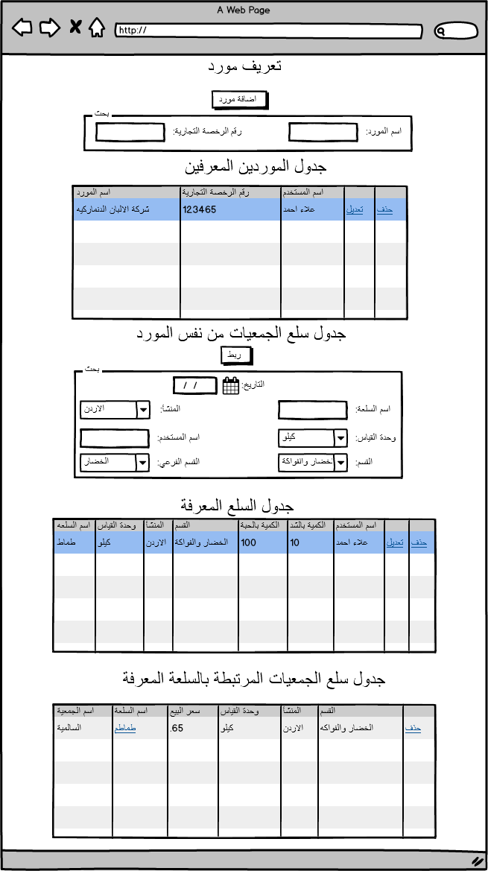

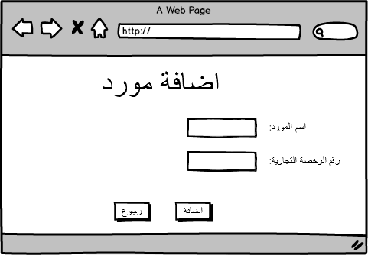

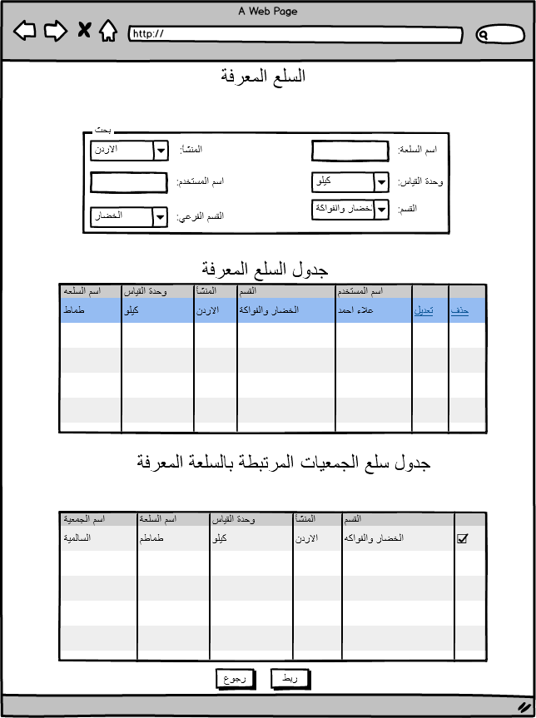

|  |  |  |  |  |  |  |  |  |
| --- | --- | --- | --- | --- | --- | --- | --- | --- |
| Add Provider Screen | | | | | | | | |
| Field | Description | | Type | Default value | Mandatory | | Length | Notes |
| Add Provider | To display add provider popup | | Button | Enabled | Mandatory | | N/A | DB: PMON_SUPPLIER |
| Link | To defined items screen. | | Button | Enabled | Mandatory | | N/A | Defined items screen displayed without any action button as it shows in the mockup above. |
| Search Filters for provider table PMON_SUPPLIER | | | | | | | | |
| Supplier name | To insert supplier name | | Text Field | Enabled | Optional | | N/A |  |
| License Number | To insert License Number | | Text Field | Enabled | Optional | | N/A |  |
| Search Filters for provider item table PMON_GEN_ITEM_RAWDATA | | | | | | | | |
| Date | To insert the date to retrieve the data | | Date | Enabled | Mandatory | | N/A | Sysdate default |
| Item Name | Search for item name | | Text Field | Enabled | Optional | | 30 | Search in defined item table |
| Category | To Select Category | | Select list | Enabled | Optional | | N/A |  |
| Subcategory | To select subcategory | | Select list | Enabled | Optional | | N/A |  |
| Measuring Unit | To Select Measuring Unit | | Select list | Enabled | Optional | | N/A |  |
| Profit Margin Type | To Select Profit Margin | | Select list | Enabled | Optional | | N/A |  |
| Username | To insert username | | Text Field | Enabled | Optional | | N/A |  |
| Provenance | To select provenance | | Select list | Enabled | Optional | | N/A |  |
| Tables | | | | | | | | |
| Defined Provider table | Defined Provider details | | Table | Enabled | Mandatory | | N/A | Table described below. |
| Defined Items | Based on the cooperatives items mapped from defined items | | Table | Enabled | Mandatory | | N/A | Table described below. |
| cooperative items | Based on the items mapped from defined items. | | Table | Enabled | Mandatory | | N/A | Table described below. |
| Add Provider popup PMON_SUPPLIER | | | | | | | | |
| Provider Name | provider Name | | Text Field | Enabled | Mandatory | | 30 |  |
| License Name | license Name | | Text Field | Enabled | Mandatory | | 30 |  |
| Ok | Defined Provider added to defined Provider table. | | Button | Enabled | Mandatory | | N/A |  |
| Cancel | Close the popup | | Button | Enabled | Mandatory | | N/A |  |
| Defined Provider Table  PMON_SUPPLIER | | | | | | | | |
| Provider Name | | As it added from the add item popup | | | |  | | |
| License Number | | As it added from the add item popup | | | |  | | |
| User name | | As it added from the add item popup | | | |  | | |
| Edit Link | | To Edit the defined item details | | | | Link displays with each row inserted.  Note: Same add Provider item popup displayed with exist Item name, measuring unit, provenance, category, user name. | | |
| Delete Link | | To delete the defined item | | | | Link displays with each row inserted.  Note:   1. on click Confirmation message displayed (سيتم حذف السلعه وجميع السلع المربوطه ،تأكيد الحذف))   All linked Items to this item in link items table will be deleted. | | |
| Defined Items table displayed based on mapped items Select Distinct from PMON_GEN_ITEM where barcode in PMON_GEN_ITEM_RAWDATA and supplier code = selected supplier | | | | | | | | |
| Item Name | | As it added defined item table | | | |  | | |
| Measuring unit | | As it added defined item table | | | |  | | |
| Provenance | | As it added defined item table | | | |  | | |
| Category | | As it added defined item table | | | |  | | |
| Subcategory | | As it added defined item table | | | |  | | |
| Total Quantity per Item | | Sum quantity for the selected item | | | |  | | |
| Total Quantity Package | | Sum quantity for the selected item | | | |  | | |
| Mapped Items Table PMON_DET_RAWDATA with reference to PMON_GEN_ITEM_RAWDATA and date inserted in search | | | | | | | | |
| Column Name | | **Description** | | | | **Notes** | | |
| Cooperative Name | | Item cooperative name | | | |  | | |
| Item Name | | Item name | | | | Link: This Link will display Item details screen for the selected item | | |
| Item Price | | Selling price | | | |  | | |
| Measuring Unit | | Cooperative Measuring unit for the item | | | |  | | |
| provenance | | Cooperative Provenance for the item | | | |  | | |
| category | | Cooperative category | | | |  | | |
| Total number of items exist in the cooperative | | Total number of items exist in the cooperative | | | |  | | |
| Delete | | Will delete the cooperative item. | | | | on click Confirmation message displayed (هل ترغب بحذف السلعه من الربط) | | |

# Item Price Inspection Orders (طلبات تفتيش السلع)

## Description

Item price Inspection orders screen will let the user to browse and send direct inspections orders for selected items in selected cooperatives.

## Screen identification card

|  |  |
| --- | --- |
| Process ID | PM - PM008 |
| Screen name | Item Price Inspections Orders |
| Screen purpose | Browse items added by the users for inspections and send inspections orders for the selected items. |
| Initiator user | Inspections Department users. |
| Process type | Main Process |

## Screen output

Cancel and send inspection orders for selected items in selected cooperatives.

## Functional requirements

List of the functional requirements:

|  |  |  |  |
| --- | --- | --- | --- |
| REQ # | Requirement | Description | Notes |
| FR – PM - 001 | The user can add new Item for inspections | The user can add new items for Cooperatives inspections orders table. | The user will use Price Monitoring screen to add items. |
|  | The user can send the selected items to inspections orders. | The user can send not sent items to inspection. |  |
|  | The user can remove the Items from inspection order in the cooperative. | The user can remove selected item in a cooperative from the inspection order. |  |
|  | The user can delete cooperative and the related items from inspections orders | The user can remove a cooperative and its items from inspection order. |  |
|  | Cooperatives targeted for inspections display in a table | A table have cooperative name, city, date, and inspection status, send to inspection link and delete link. |  |
|  | All items from cooperative targeted for inspection display in a table | The user selects a cooperative and all cooperative items display in a table have Item name, Date and Time, user name, Item details link and delete link. |  |
|  | The user can search in Cooperative inspection table. | The user can search in Cooperative inspection table by Cooperative Name, Order inspection Status, Start and End Date. |  |

## Use Cases

### Add and Delete Items from Inspection Table.

|  |  |
| --- | --- |
| Use Case ID | PM -UC08 |
| Use Case Name | Add and Delete Items from inspection table. |
| Actors | Privileged users |
| Description | Add and Delete Items from inspection table. |
| Preconditions | 1. For Adding Item - Cooperatives items not already in inspection table.  2. For Adding Item - Items not sent to inspection in the same date.  3. For Deleting Item – Inspection order status not sent. |
| Post conditions | For adding item:   1. Item details added to cooperative inspection table with cooperative details. 2. User can delete the added item from the cooperative table. 3. The user can send inspection order for the cooperative with all added items.   For deleting:   1. Item removed from the cooperative table. |
| Business rules | 1. No Duplicate Item for the same cooperative in the same date. 2. The user can not add items to send inspection orders. 3. If the user wants to send inspection order for cooperative has added item with previous dates confirmation message should display for the user. 4. The user cannot delete cooperative or cooperative item from inspection table with inspection order status sent. 5. If the user add items from different cooperatives each item will be added to its cooperative. And if the cooperative not exist or the status is inspection order sent new row will be created. |

**Main Flow**

|  |  |  |
| --- | --- | --- |
| # | Actor Action | System Response |
|  | **Add Item Flow** | |
| 1 | The privileged user navigates to Item Price Inspection Orders Screen. | Item Price Inspection orders screen displayed. |
| 2 | The user clicks on add Item button | Price monitoring screen displayed, only search options and add to inspection table button is enabled. |
|  | The user search for any item as it is described in price monitoring use case. | Items displayed in the table based on the search criteria used. |
|  | The user selects item\s from different cooperative\s. | Items selected. |
|  | The user clicks on add to inspection table button. | The selected items added to the cooperative table if the cooperative exist in cooperative inspection table and the status is not sent or A new row for the cooperative created in cooperative inspection table and the selected items added to cooperative table. |
| Delete Item Flow | | |
| 1 | The privileged user navigates to Item Price Inspection Orders Screen. | Item Price Inspection orders screen displayed. |
| 2 | The user selects the cooperative from cooperative inspection table. | Cooperative selected and its table items displayed. |
| 3 | The user select the targeted item from Cooperative items table and click on Delete link | Item Removed from the table. |

**Alternative Flows**

|  |  |  |
| --- | --- | --- |
| # | Actor Action | System Response |
| Add Item Flow | | |
|  | The user navigates to price monitoring screen and search for items. | Items displayed in price monitoring table. |
|  | The user selects items. | Items selected |
|  | The user clicks on add to inspection table. | Items added to the inspection tables based on the rules discussed above. |
|  | | |
| 1 | The privileged user navigates to Item Price Inspection Orders Screen. | Item Price Inspection orders screen displayed. |
| 2 | The user selects the cooperative from cooperative inspection table. | Cooperative selected and its table items displayed. |
| 3 | The user click on Delete link | Cooperative and its Items Removed from the table. |

**Exceptional Flows**

|  |  |  |
| --- | --- | --- |
| # | Actor Action | System Response |
| 1 | The privileged user navigates to Item Price Inspection Orders Screen. | Item Price Inspection Orders screen displayed. |
| 2 | The user clicks on add item button | Price monitoring screen displayed. |
| 3 | The user clicks on cancel button. | No Item added. |
|  |  |  |
|  |  |  |

**System Messages:**

|  |  |  |  |
| --- | --- | --- | --- |
| # | Actor Action | Message Type | System Response |
| 1 | The user add Item already exist in inspections table and the status for inspection order sent with the same date. | Error Message | السلعه مضافه لجداول التفتيش يرجى اختيار سلعه اخرى |
| 2 | The user Delete cooperative from cooperative inspection table. | Confirmation Message | سيتم حذف جميع السلع التابعه للجمعيه هل انت متأكد |
|  |  |  |  |

### Send Price Inspection Orders for Cooperatives

|  |  |
| --- | --- |
| Use Case ID | PM -UC09 |
| Use Case Name | Send Price Inspection orders for cooperatives |
| Actors | Privileged users |
| Description | Send Price Inspection orders for cooperatives |
| Preconditions | 1. Cooperatives and its items added to the cooperative inspection table.  2. The status for the cooperative inspection order is not sent to inspection. |
| Post conditions | 1. Inspection order is sent for the cooperative with all items in item cooperative table. 2. Status for the inspection order is changed to inspection order sent. |
| Business rules | 1. The user can not send inspection order already sent. |

**Main Flow**

|  |  |  |
| --- | --- | --- |
| # | Actor Action | System Response |
| 1 | The privileged user navigates to Item Price Inspection Orders Screen. | Item Price Inspection orders screen displayed. |
| 2 | The user selects the cooperative from cooperative inspection table. | Cooperative selected and its table items displayed. |
| 3 | The user clicks on send inspection order link | Order sent, and the status changed to inspection order sent. |

**System Messages:**

|  |  |  |  |
| --- | --- | --- | --- |
| # | Actor Action | Message Type | System Response |
| 1 | When the user sends inspection order | Information Message | تم ارسال امر التفتيش. |

### Task screens and fields

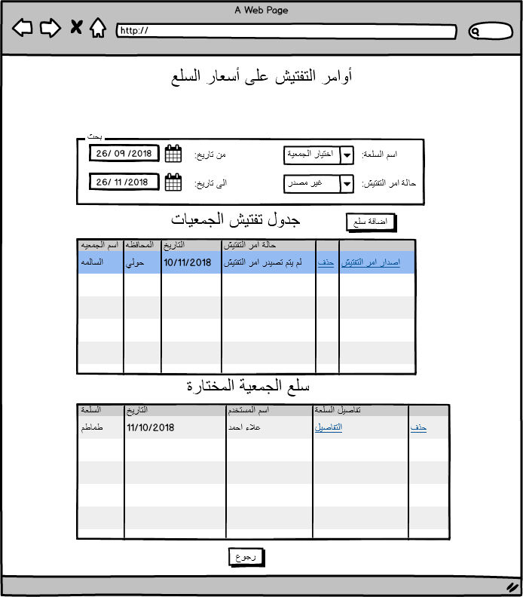

|  |  |  |  |  |  |  |  |  |
| --- | --- | --- | --- | --- | --- | --- | --- | --- |
| Item Price Inspection Orders Screen | | | | | | | | |
| Field | Description | | Type | Default value | Mandatory | | Length | Notes |
| Add Item | To Display Price Monitoring screen. | | Button | Enabled | Mandatory | | N/A | Price Monitoring screen displayed and only add to inspection table button and search options are enabled. |
| Search Filters | | | | | | | | |
| Cooperative Name | To select cooperative | | Select List | Enabled | Optional | | N/A | To display the selected cooperative inspection orders in cooperative inspection table. |
| Inspection order status | To Select status | | Select list | Enabled | Optional | | N/A | Sent inspection order / Not sent |
| Start Date | To insert the start of the period | | Date | Enabled | Optional | | N/A | The user can insert the start and end date with the same date to display the result for that day inserted. |
| End date | To insert the end the period | | Date | Enabled | Optional | | N/A | The user can insert the start and end date with the same date to display the result for that day inserted. |
| Tables | | | | | | | | |
| Cooperatives inspection orders table | To display the added cooperatives. | | Table | Enabled | Mandatory | | N/A | Table described below. |
| Cooperative items | To display the items for the selected cooperative from cooperative inspection orders table | | Table | Enabled | Mandatory | | N/A | Table described below. |
| Cooperative inspection orders table | | | | | | | | |
| Column Name | | **Column Description** | | | | **Notes** | | |
| Cooperative Name | | Cooperative name | | | | As per the item added from price Monitoring screen | | |
| City | | the city of the cooperative | | | |  | | |
| Date | | Date of the row created. | | | |  | | |
| Send to inspection link | | Link to send the cooperative items for inspection. | | | | Status changed to inspection order sent | | |
| Delete | | Delete the cooperative and its items. | | | | The user cannot delete cooperative with status sent to inspection table.  Confirmation message displays. | | |
| Cooperatives Item Table | | | | | | | | |
| Column Name | | **Description** | | | | **Notes** | | |
| Item Name | | Item name | | | |  | | |
| Date and Time | | Date and time for adding the item | | | |  | | |
| User Name | | User added the item | | | |  | | |
| Item Details Link | | Item details | | | | This Link will display Item details screen for the selected item | | |
| Delete Link | | Remove the item from the table | | | |  | | |

# Item Details Screen (تفاصيل السلعة)

## Description

Item Details screen will let the user display the full details for any item in any cooperative and send it to inspection table.

## Screen identification card

|  |  |
| --- | --- |
| Process ID | PM - PM007 |
| Screen name | Item Details Screen |
| Screen purpose | Display the full details for any item in any cooperative and send it to inspection table. |
| Initiator user | Inspections Department users. |
| Process type | Sub Process |

## Screen output

The full details for any item and the user is able to send it to inspection table.

## Functional requirements

List of the functional requirements:

|  |  |  |  |
| --- | --- | --- | --- |
| REQ # | Requirement | Description | Notes |
| FR – PM - 001 | The user Display the full details for any item from any cooperative. | To display the full details for any item in any cooperative. |  |
|  | The user can send item to inspection table from item details | The user can send the item displayed to inspection table |  |

## Use Cases

### Display Item Details

|  |  |
| --- | --- |
| Use Case ID | PM -UC07 |
| Use Case Name | Display Item Details |
| Actors | Privileged users |
| Description | Display Item details and the user have the option to send it to inspection table. |
| Preconditions | Item already exist in the system database. |
| Post conditions | The user can display the full details for the item and can send it to inspection table. |
| Business rules | 1. The user can not add item to inspection table already added in the same date. |

**Main Flow**

|  |  |  |
| --- | --- | --- |
| # | Actor Action | System Response |
| 1 | The privileged user click on Item Details link to display the full details for the item in all mentioned areas in the document which the user needs to display the item details. | Item Details Screen display. |
| 2 | The user clicks on send to inspection table. | Item sent to inspection table (Optional Step) |

**System Messages:**

|  |  |  |  |
| --- | --- | --- | --- |
| # | Actor Action | Message Type | System Response |
| 1 | Information detail for the item that is not exist in the system. | Error Message | لم يتم تزويد المعلومات من قبل الجمعيه |
| 2 | The user send item to inspection table already exist with the same date. |  | تم اضافة السلعه لجدول التفتيش مسبقا يرجى اختيار سلعه اخرى. |

### Task screens and fields

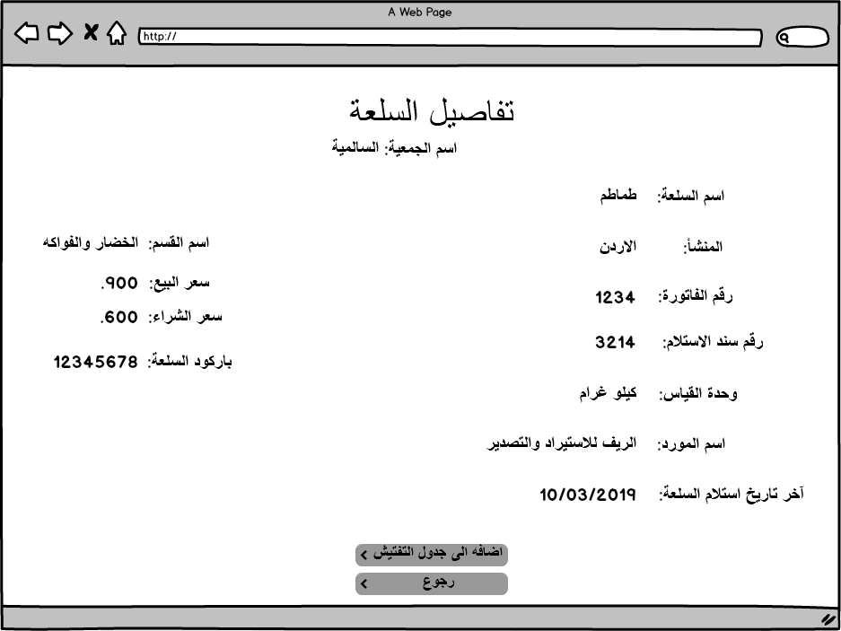

|  |  |  |  |  |  |  |
| --- | --- | --- | --- | --- | --- | --- |
| Item Details Screen | | | | | | |
| Field | Description | Type | Default value | Mandatory | Length | Notes |
| Send to inspection table | To add the item to the inspection table. | Button | Enabled | Mandatory | N/A |  |
| Item Details  Note: All information based on the cooperative that the item related to Any detail is not exist from the cooperative error message will display. PMON_DET_RAWDAtA | | | | | | |
| Cooperative Name | Cooperative Name based on the item cooperative | Label | Disabled | Mandatory | 50 |  |
| Item Name | Item Name based on the item cooperative | Label | Disabled | Mandatory | 50 |  |
| Provenance | Provenance based on the item cooperative | Label | Disabled | Mandatory | 50 |  |
| Category Name | Category Name based on the item cooperative | Label | Disabled | Mandatory | 50 |  |
| Item Barcode | Item Barcode based on the item cooperative | Label | Disabled | Mandatory | 50 |  |
| Bell Number | Bell Number based on the item cooperative | Label | Disabled | Mandatory | 50 |  |
| Selling Price | Selling Price based on the item cooperative | Label | Disabled | Mandatory | 50 |  |
| Receipt Number | Receipt Number based on the item cooperative | Label | Disabled | Mandatory | 50 |  |
| Measuring Unit | Measuring Unit based on the item cooperative | Label | Disabled | Mandatory | 50 |  |
| Item Cost (Buying Price) | Item Cost (Buying Price) based on the item cooperative | Label | Disabled | Mandatory | 50 |  |
| Provider Name | Provider Name based on the item cooperative | Label | Disabled | Mandatory | 50 |  |
| Date of receiving the item | Date of receiving the item based on the item cooperative | Label | Disabled | Mandatory | 50 |  |

# Union Item Details Screen (تفاصيل سلعة اتحاد)

## Description

Item Details screen will let the user display the full details for any union item.

## Screen identification card

|  |  |
| --- | --- |
| Process ID | PM - PM007 |
| Screen name | Union Item Details Screen |
| Screen purpose | Display the full details for any union item. |
| Initiator user | Inspections Department users. |
| Process type | Sub Process |

## Screen output

The full details for any union item.

## Functional requirements

List of the functional requirements:

|  |  |  |  |
| --- | --- | --- | --- |
| REQ # | Requirement | Description | Notes |
| FR – PM - 001 | The user Display the full details for any union item. | To display the full details for any union item. |  |

## Use Cases

### Display Item Details

|  |  |
| --- | --- |
| Use Case ID | PM -UC07 |
| Use Case Name | Display union Item Details |
| Actors | Privileged users |
| Description | Display union Item. |
| Preconditions | Item already exist in the system database. |
| Post conditions | The user can display the full details for the union item. |
| Business rules | The user can display this screen from Manage define items screen and from price comparison screen for the items have union price monitoring. |

**Main Flow**

|  |  |  |
| --- | --- | --- |
| # | Actor Action | System Response |
| 1 | The privileged user clicks on union Item Details link to display the full details for the item in all mentioned areas in the document which the user needs to display the union item details. | Union Item Details Screen display. |

**System Messages:**

|  |  |  |  |
| --- | --- | --- | --- |
| # | Actor Action | Message Type | System Response |
| 1 | Information detail for the union item that is not exist in the system. | Error Message | لم يتم تزويد المعلومات من قبل الاتحاد |

### Task screens and fields

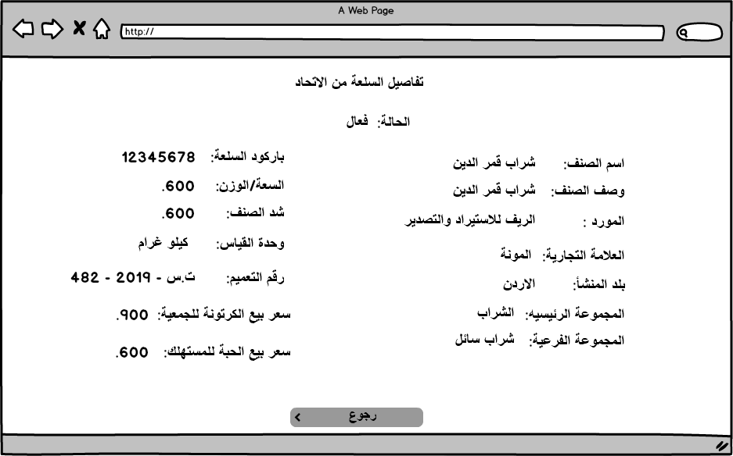

|  |  |  |  |  |  |  |
| --- | --- | --- | --- | --- | --- | --- |
| Item Details Screen | | | | | | |
| Field | Description | Type | Default value | Mandatory | Length | Notes |
| Send to inspection table | To add the item to the inspection table. | Button | Enabled | Mandatory | N/A |  |
| Item Details  Note: All information based on the Union item details Any detail is not exist from the union error message will display. PMON_UNION_RAWDATA | | | | | | |
| Item Status | Active/Inactive | Label | Disabled | Mandatory | 50 |  |
| Item name | Item Name based on the item cooperative | Label | Disabled | Mandatory | 50 |  |
| item Description | Item Description | Label | Disabled | Mandatory | 50 |  |
| English Item Name | English Item Name | Label | Disabled | Mandatory | 50 |  |
| item barcode | item barcode | Label | Disabled | Mandatory | 50 |  |
| package size | package size | Label | Disabled | Mandatory | 50 |  |
| measuring unit | measuring unit | Label | Disabled | Mandatory | 50 |  |
| provenance | provenance | Label | Disabled | Mandatory | 50 |  |
| category | category | Label | Disabled | Mandatory | 50 |  |
| brand | brand | Label | Disabled | Mandatory | 50 |  |
| official circular number | official circular number | Label | Disabled | Mandatory | 50 |  |
| official circular date | official circular date | Label | Disabled | Mandatory | 50 |  |
| Supplier Name | Supplier Name | Label | Disabled | Mandatory | 50 |  |
| package cost | package cost | Label | Disabled | Mandatory | 50 |  |
| item selling price. | item selling price. | Label | Disabled | Mandatory | 50 |  |

# Upload CSV File (Cooperatives Screen) (تحميل بيانات الجمعية)

## Description

This Screen will let the cooperatives users to upload the CSV file contain all the details needed for all cooperative items.

## Screen identification card

|  |  |
| --- | --- |
| Process ID | PM - PM007 |
| Screen name | Upload CSV file |
| Screen purpose | To let the cooperatives users to upload the csv file that contain all cooperative items. |
| Initiator user | Inspections Department users. |
| Process type | Main Process |

## Screen output

Upload CSV file to the MOSA Database.

## Functional requirements

List of the functional requirements:

|  |  |  |  |
| --- | --- | --- | --- |
| REQ # | Requirement | Description | Notes |
| FR – PM - 001 | The Cooperatives users can upload CSV file to MOSA System | The cooperatives users can upload the csv file to MOSA system. |  |
|  | The cooperatives users can login to MOSA System to upload the csv file. | Access to CSV upload screen will be for privileged cooperatives users only. |  |

## Use Cases

### Upload CSV File

|  |  |
| --- | --- |
| Use Case ID | PM -UC07 |
| Use Case Name | Upload CSV File |
| Actors | Privileged users |
| Description | To let the cooperatives users upload the csv file that contain all cooperative items into MOSA system. |
| Preconditions | 1. Privileged Cooperatives users logged to MOSA system 2. The file format is .csv |
| Post conditions | The CSV file inserted to MOSA Database and the user can browse the data on Price Monitoring screens. |
| Business rules | 1. Privileged Cooperatives users only can login and display Upload CSV file screen. 2. File extension type is .csv |

**Main Flow**

|  |  |  |
| --- | --- | --- |
| # | Actor Action | System Response |
| 1 | The privileged cooperative user login to MOSA System. | Upload CSV file Screen display. |
| 2 | The user click on browse to select the csv file | Csv file selected. |
|  | The user click on upload button. | CSV file uploaded and inserted to MOSA Database. |

**System Messages:**

|  |  |  |  |
| --- | --- | --- | --- |
| # | Actor Action | Message Type | System Response |
| 1 | The file extension is not .csv | Error Message | يرجى اختيار ملف .csv |
| 2 | The .csv file have missed or extra column or invalid column name | Error Message | يحتوي الملف المحمل على تفاصيل ناقصه او اضافيه يرجى تعديل الملف |
| 3 | The CSV file is empty | Error Message | لايحتوي الملف المرفق على التفاصيل المطلوبه يرجى اضافة البيانات المطلوبه في الملف المرفق |
| 4 | CSV file is uploaded and inserted to the system properly | Confirmation Message | تم تحميل الملف |

### Task screens and fields

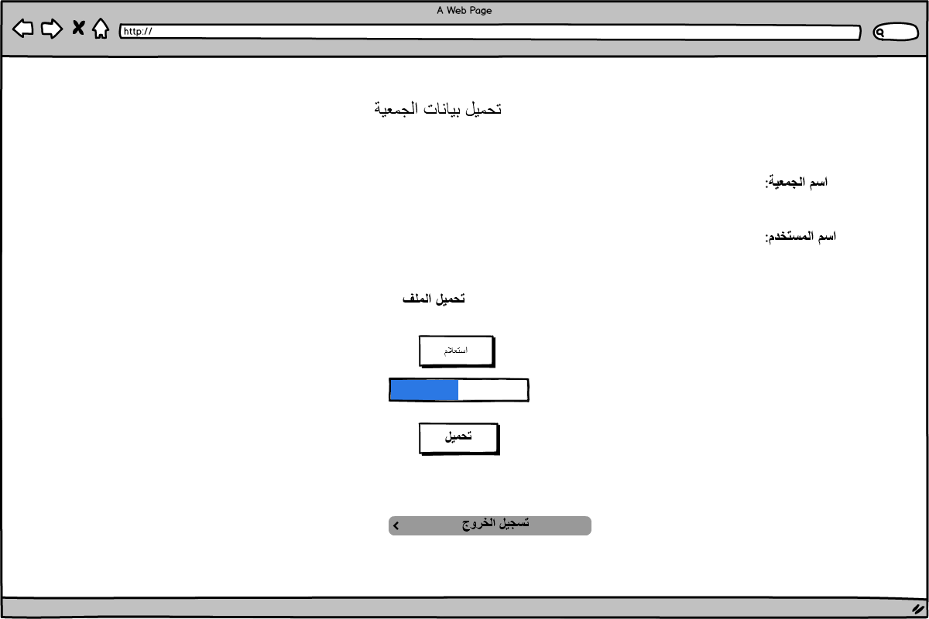

|  |  |  |  |  |  |  |
| --- | --- | --- | --- | --- | --- | --- |
| Upload CSV File Screen | | | | | | |
| Field | Description | Type | Default value | Mandatory | Length | Notes |
| Browse | To select the file from the PC | Button | Enabled | Mandatory | N/A |  |
| Upload | To insert the csv file to MOSA database | Button | Enabled | Mandatory | N/A |  |
| User Details | | | | | | |
| Cooperative Name | Cooperative Name based on the user account | Label | Disabled | Mandatory | 50 |  |
| User Name | User Name based on the user account | Label | Disabled | Mandatory | 50 |  |

# CSV File Upload Status (حالة تحميل البيانات من قبل الجمعيات)

## Description

This Screen will let the user to display the upload status for all cooperatives in specific dates.

## Screen identification card

|  |  |
| --- | --- |
| Process ID | PM - PM007 |
| Screen name | CSV file upload status |
| Screen purpose | Display the upload status for CSV file to any or all cooperatives in specific period. |
| Initiator user | Inspections Department users. |
| Process type | Main Process |

## Screen output

CSV file upload status for any cooperative in any period of time.

## Functional requirements

List of the functional requirements:

|  |  |  |  |
| --- | --- | --- | --- |
| REQ # | Requirement | Description | Notes |
| FR – PM - 001 | The user can Select any or all cooperative for the search. | The user can select any or all cooperatives to display CSV uploading status. |  |
|  | CSV upload status search displays in a table. | The result will display in a table having the columns: Cooperative name, User Name, Date and Time, Status, Number of failed uploads. |  |
|  | The user can search using period of time and cooperative. | The user can edit the name and the description for the category. |  |

## Use Cases

### Search for CSV File Upload Status

|  |  |
| --- | --- |
| Use Case ID | PM -UC07 |
| Use Case Name | Search for CSV file upload status. |
| Actors | Privileged users |
| Description | Search for CSV file upload status for any or all cooperatives. |
| Preconditions | Cooperatives users uploaded the csv file. |
| Post conditions | Cooperatives uploaded and did not upload the CSV file are highlighted. |
| Business rules | Only one success upload is allowed for the cooperatives users in a day. |

**Main Flow**

|  |  |  |
| --- | --- | --- |
| # | Actor Action | System Response |
| 1 | The privileged user navigates to CSV upload status Screen. | CSV upload status screen displayed. |
| 2 | The user selects the cooperative targeted or all cooperatives. | Cooperatives selected. |
| 3 | The user inserts the start and end date for the period. | Date inserted. |
| 4 | The user click on search button. | Results display CSV file status table. |

**System Messages:**

|  |  |  |  |
| --- | --- | --- | --- |
| # | Actor Action | Message Type | System Response |
|  |  |  |  |
|  |  |  |  |

### Task screens and fields

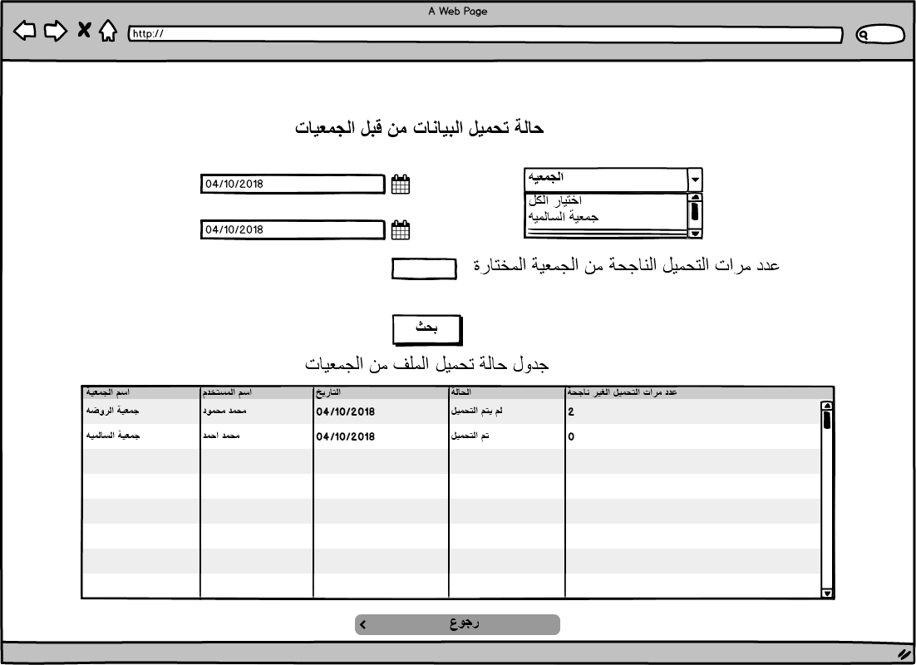

|  |  |  |  |  |  |  |  |  |
| --- | --- | --- | --- | --- | --- | --- | --- | --- |
| CSV Upload Status Screen | | | | | | | | |
| Field | Description | | Type | Default value | Mandatory | | Length | Notes |
| Search | To display search result | | Button | Enabled | Mandatory | | N/A |  |
| Number of success uploads | Total number of success uploads | | Label | 0 | Mandatory | | N/A | Total number of success uploads for the selected cooperative/s |
| Search Filters | | | | | | | | |
| Cooperative Name | All cooperatives | | Select List | All Cooperatives | Mandatory | | N/A |  |
| Start Date | To insert the beginning of the period | | Date | Sys Date | Mandatory | | N/A | Less than end date. |
| End Date | To insert the end of period | | Date | Sys Date | Mandatory | | N/A | No future date accepted. |
| Categories Table | | | | | | | | |
| Column Name | | **Column Description** | | | | **Notes** | | |
| Cooperative Name | | Cooperative Name. | | | |  | | |
| User Name | | User uploaded the CSV. | | | |  | | |
| Date and Time | | Date and time for uploading the csv | | | | Link displays with each row inserted.  Note: Same add Category popup displayed with exist name and description. | | |
| status | | Uploaded/ not uploaded. | | | | تم التحميل/لم يتم التحميل | | |
| Number of failed uploads | | Total number of failed uploads | | | |  | | |

# Reports (التقارير)

|  |  |  |  |
| --- | --- | --- | --- |
| # | Report name | Description | Notes |
|  | Price Comparison | The items search result in comparison table. |  |
|  | Price Monitoring | Items search result in price monitoring table. |  |
|  | Item General Details | The general information for Targeted Item details. |  |
|  | Item Price change within period. | The price change with chart line for Targeted Item details. |  |
|  | Item Price Average within period | The average price change with chart line for Targeted Item details. |  |
|  | Categories Created | Categories Created as it described in the SRS. |  |
|  | Profit Margin Created | Profit Margin Created as it described in the SRS. |  |
|  | Linked items | Linked items as it described in the SRS. |  |
|  | Linked providers | Linked providers as it described in the SRS. |  |
|  | Manual Comparison Tables created | Manual Comparison Tables created by the user as it described in the SRS. |  |
|  | Item Price Inspection orders | Item Price Inspection orders as it described in the SRS. |  |
|  | Item Details | Item Details as it described in the SRS. |  |
|  | CSV file upload status | CSV file upload status as it described in the SRS. |  |
|  |  |  |  |

# Appendices

## Forms and reports

Not Available.